Independent Hospital Pricing Authority

**Development of the Australian National Subacute and Non-Acute Patient Classification Version 5.0**

Consultation paper

April 2021

Subtitle

Development of the Australian National Subacute and Non-Acute Patient Classification Version 5.0 – Consultation paper – April 2021

© Independent Hospital Pricing Authority 2021

This publication is available for your use under a [Creative Commons BY Attribution 3.0 Australia](http://creativecommons.org/licenses/by/3.0/au/deed.en) licence, with the exception of the Independent Hospital Pricing Authority logo, photographs, images, signatures and where otherwise stated. The full licence terms are available from [the Creative Commons website](http://creativecommons.org/licenses/by/3.0/au/legalcode).



Use of Independent Hospital Pricing Authority material under a [Creative Commons BY Attribution 3.0 Australia](http://creativecommons.org/licenses/by/3.0/au/deed.en) licence requires you to attribute the work (but not in any way that suggests that the Independent Hospital Pricing Authority endorses you or your use of the work).

*Independent Hospital Pricing Authority material used 'as supplied'.*

Provided you have not modified or transformed Independent Hospital Pricing Authority material in any way including, for example, by changing Independent Hospital Pricing Authority text – then the Independent Hospital Pricing Authority prefers the following attribution:

*Source: The Independent Hospital Pricing Authority*

# Contents

Contents 3

Glossary 4

1. Introduction 5

2. Overview of AN-SNAP V4 6

2.1 AN-SNAP V4 structure 6

3. Developing AN-SNAP V5 9

3.1 Project objectives and overview 9

3.2 Project governance 9

3.3 Decision principles 10

3.4 Data sources 10

3.5 Optimising the existing AN-SNAP variables 11

3.6 Exploring potential new AN-SNAP variables 11

4. The draft AN-SNAP V5 classification 16

4.1 Overview 16

4.2 The AN-SNAP V5 admitted classes 18

4.3 Performance of the overall proposed AN-SNAP V5 model 30

5. Next Steps 31

Appendix A - Subacute Care Working Group 32

Appendix B - Data Sources 33

Appendix C - Method to explore potential new variables 34

Appendix D - Incorporating a measure of frailty 37

Appendix E - End class characteristics 48

# Glossary

ABF Activity-based funding

AN-SNAP Australian National Subacute and Non-Acute Patient Classification

AROC Australasian Rehabilitation Outcomes Centre

CCI Charlson Comorbidity Index

FIMTM Functional Independence Measure

GEM Geriatric evaluation and management

HoNOS Health of the Nation Outcome Scale

ICD-10-AM The International Statistical Classification of Diseases and Related Health Problems, 10th Revision, Australian Modification

IHPA Independent Hospital Pricing Authority

LOS Length of stay

MMT Major multiple trauma

NHCDC National Hospital Cost Data Collection

PCOC Palliative Care Outcomes Collaboration

RID Reduction in deviance

RUG-ADL Resource Utilisation Groups - Activities of Daily Living

SCWG IHPA’s Subacute Care Working Group

# Introduction

Under the *National Health Reform Agreement 2011*, the Independent Hospital Pricing Authority (IHPA) is responsible for determining the activity based funding (ABF) system for public hospital subacute care services. The classification system used for subacute care in Australia is the Australian National Subacute and Non-Acute Patient (AN-SNAP) classification.

AN-SNAP has been refined a number of times since it was first developed in 1997. Currently version four (V4) is used for ABF for admitted subacute care. The purpose of this consultation process is to:

* outline the proposed fifth version of the classification (V5)
* provide an opportunity for interested stakeholders to comment about the major changes proposed for V5 of the classification.

|  |
| --- |
| **Have your say**  Submissions close at 5pm AEDT on Monday, 10 May 2021  Submissions should be emailed to IHPA Secretariat at [submissions.ihpa@ihpa.gov.au](mailto:submissions.ihpa@ihpa.gov.au).  All submissions will be published on [IHPA’s website](https://www.ihpa.gov.au/) unless respondents specifically identify sections that they believe should be kept confidential due to commercial or other reasons. |

IHPA is committed to supporting anyone with an interest engaging in this consultation process. If you or your organisation would like further information or resources about any aspects of the process, please contact IHPA at [enquiries.ihpa@ihpa.gov.au](mailto:enquiries.ihpa@ihpa.gov.au)

The [IHPA website](https://www.ihpa.gov.au/) also provides up-to-date information on the AN-SNAP classification, including links to various key documents referred to in this consultation paper.

# Overview of AN-SNAP V4

Subacute care is defined as:

…specialised multidisciplinary care in which the primary need for care is optimisation of the patient’s functioning and quality of life. A person’s functioning may relate to their whole body or a body part, the whole person, or the whole person in a social context, and to impairment of a body function or structure, activity limitation and/or participation restriction.[1]

This focus on optimising function is fundamentally different to the primary objectives of acute care. It means that the approach to classification for acute care, which is based around patient diagnoses and procedures, is not appropriate for subacute care.

AN-SNAP is a casemix classification made up of four subacute care types: rehabilitation, palliative care, geriatric evaluation and management (GEM) and psychogeriatric care; and one non-acute care type: maintenance. These five care types within AN-SNAP recognise that subacute and non-acute services are provided in a specialised multidisciplinary context in which the primary need for care relates to the optimisation of the patient’s functioning and quality of life.

## AN-SNAP V4 structure

AN-SNAP was first developed in 1997 and has been progressively refined since then. The most recent version, AN-SNAP V4, was released in May 2015 and has been used to price admitted subacute and non-acute care since 1 July 2016.

Like all ABF classification systems, AN-SNAP sorts patient episodes of care into groups (called classes). This is done using variables, which can be categorical (describing a ‘quality’ or ‘characteristic’ of something) or numeric (describing a measurable quantity as a number). The variables are applied to the groups in a particular order to progressively break the groups down into meaningful sets, with each step in this process called a ‘split’. If a numeric variable is used to split a group it does this using set numbers as upper and/or lower thresholds for the group.

In the current AN-SNAP V4, the episodes are first grouped using a categorical variable (episode type). The next step is to split those two groups into smaller groups using another categorical variable: care types (rehabilitation, palliative care, GEM, psychogeriatric care and non-acute care). There are then several further splits of the care type episodes using a mix of (categorical and numeric) variables listed in Table 1.

Table . AN-SNAP V4 variables

|  |  |
| --- | --- |
| **Care Type** | **Variables** |
| Rehabilitation | * Functional Independence Measure (FIMTM) Cognition score * FIMTM Motor score (weighted) * Impairment type * Age |
| Palliative care | * Palliative care phase (stage of illness) * Resource Utilisation Groups – Activities of Daily Living (RUG-ADL) total score * Age |
| GEM | * FIMTM Motor score * Dementia and/or delirium flag (International Statistical Classification of Diseases and Related Health Problems, Tenth Revision, Australian Modification (ICD-10-AM) diagnosis codes) |
| Psychogeriatric | * Length of stay (Long term care > 91) * Health of the Nation Outcome Scale (HoNOS) 65+ (Overactive Behaviour, Activities of Daily Living (ADL) and total) |
| Non-acute | * Length of stay (Long term care > 91) * Age * RUG -ADL |

As summarised in Figure 1, AN-SNAP V4 has 130 classes across two main branches - admitted and non-admitted.

The admitted branch contains 83 classes for overnight subacute episodes/phases, six classes for subacute same-day admissions, six classes for non-acute, and seven error classes. The non-admitted branch (not used for ABF) has 35 classes.

Figure . AN-SNAP V4 structure

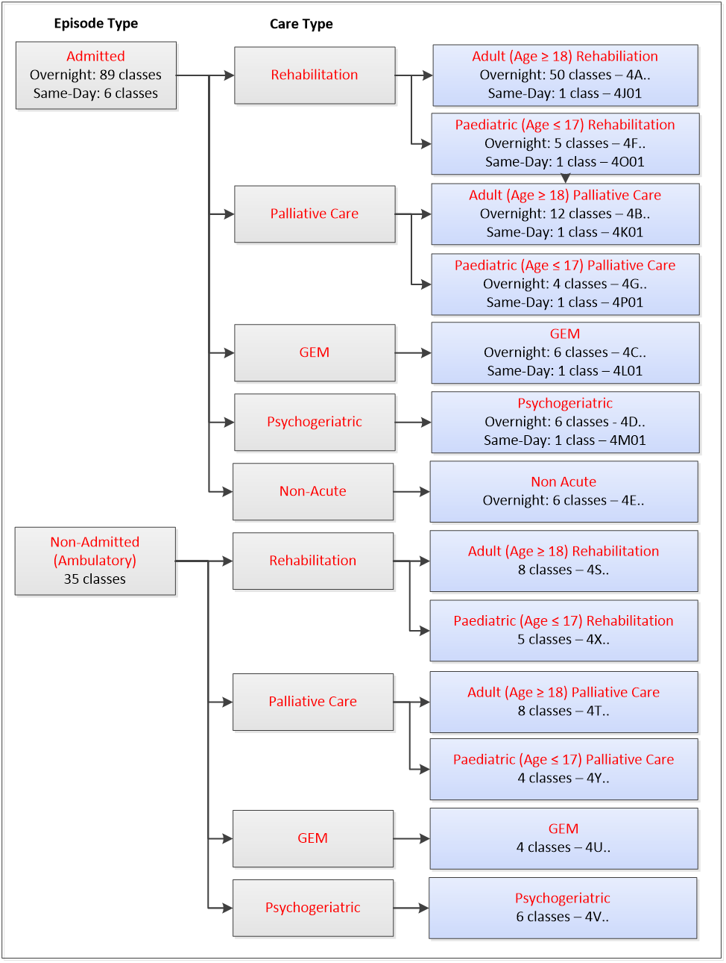

# Developing AN-SNAP V5

IHPA undertakes regular reviews of all ABF classifications to ensure that they reflect contemporary clinical practice and terminology; and provide the best possible statistical explanation of care costs.

## Project objectives and overview

IHPA started this review of AN-SNAP in 2018. Broadly, the scope of the project was to refine the AN-SNAP classification by:

* using the improved volume and coverage of subacute data collected since 2015 to assess the statistical performance of the current AN-SNAP V4 classification variables and recommend any changes to optimise the performance of the classification
* working with clinical and other experts in the IHPA committee structures to identify other variables that could be added to the classification; and test the statistical impact of these using national data
* developing a draft AN-SNAP V5 and consulting widely about its use
* providing the Pricing Authority with a set of recommendations about the next version of the AN-SNAP classification.

Notably, the following was specifically excluded from the project:

* a review of the non-admitted branch of the AN-SNAP classification – non-admitted subacute care is priced through the [Tier 2 Non-Admitted Services Classification](https://www.ihpa.gov.au/what-we-do/tier-2-non-admitted-care-services-classification) and is currently being reviewed as part of the development of a new [non-admitted care classification](https://www.ihpa.gov.au/what-we-do/non-admitted-care).

## Project governance

IHPA relies on a comprehensive [committee framework](https://www.ihpa.gov.au/consultation/committees-and-working-groups) to assist in providing expert advice during its work. The main advisory group for this project has been IHPA’s Subacute Care Working Group (SCWG), a group of expert representatives from each Australian jurisdiction, the private sector and subacute care clinicians and clinical bodies. Further details about the membership of the SCWG is at **Appendix A**.

At various points in the project IHPA has also consulted with the following additional specialist bodies:

* IHPA’s Clinical Advisory Committee
* IHPA’s Jurisdictional Advisory Committee
* Specialist, time-limited rehabilitation and geriatric evaluation and management (GEM) clinical subgroups.

## Decision principles

The proposed AN-SNAP V5 has been developed through robust statistical data analysis and consultation with clinical experts.

IHPA has made its decisions to accept, reject, or modify changes by balancing the broad range of decision principles outlined in Table 2, which have been refined for this project following their use in the development of AN-SNAP V4[2] and other ABF classifications.

Table . Decision principles

|  |  |
| --- | --- |
| Principle | Summary description |
| Comprehensive, mutually exclusive and consistent | The classification covers all possible cases (episodes) and the classes it creates are well defined, and mutually exclusive. |
| Resource use homogeneity | Patient episodes within a class have a similar level of resource utilisation, and there is a large variation in resource utilisation between classes. |
| Clinically coherent and meaningful | Patient episodes within a class have similar characteristics (with respect to impairments, patient functioning or interventions delivered) and make sense as a group to clinicians. |
| Progressively developed | Where possible, the classification is developed and refined progressively, recognising previous investments. |
| Administrative and operational feasibility | The benefits of the data collected for the classification should outweigh the administrative cost and burden of collection. |
| Classification soundness | The classification should have a manageable, balanced number of classes which are statistically robust and relatively stable. |
| Simple and transparent | A classification should have as many classes as is needed for its purpose but no more, and the grouping to classes should be transparent and clinically sensible. |
| Minimise undesirable and/or inadvertent consequences | The classification minimises using data elements that are susceptible to different interpretation and/or provide incentives to change reporting to optimise funding. |
| Capacity for improvement | Where possible, the structure and elements of the classification should allow for future improvements. |
| Useful beyond ABF, where possible | Where possible, the structure and elements of the classification should be useful for purposes other than funding. |

## Data sources

The main data source used to develop AN-SNAP V4 was public sector data from the Round 16 (2011–12) of the National Hospital Cost Data Collection (NHCDC). While it was the best available at the time, it was fundamentally limited by its low volume and coverage of episodes. This, in turn, limited the statistical analysis that could be conducted to investigate major structural changes for AN-SNAP V4.[3]

To develop AN-SNAP V5, IHPA has used patient activity and cost data from the:

* NHCDC (2015–16, 2016–17 and 2017–18)
* Admitted Patient Care (APC) collection (2015–16, 2016–17 and 2017–18).

There was also some targeted analysis of rehabilitation data from the private sector subacute dataset (Hospital Casemix Protocol) (2018–19).

Therefore a considerably larger volume and coverage of episodes was available for the development of AN-SNAP V5 compared to that available for AN-SNAP V4 development. Accordingly, the AN-SNAP V5 development process has allowed for robust statistical investigation of the classification’s performance.

Further details about the AN-SNAP V5 data sources is at **Appendix** **B**.

## Optimising the existing AN-SNAP variables

Given the limited data available during the AN-SNAP V4 development, IHPA’s first priority was to make use of the latest subacute data set to conduct detailed analysis of the characteristics and performance of the existing classification.

### Method

Broadly, this analysis involved IHPA using the improved volume and coverage of activity and cost data collected since AN-SNAP V4 was implemented to test how well the existing variables in each care type (as detailed in Table 1) explained resource use.

The focus was on understanding the extent to which changes to the thresholds applied to the existing variables could improve:

* the adequacy of how episodes were distributed within the splitting variable (episode volume)
* how well the variable explained cost of the episodes of care (cost prediction).

IHPA established specialist, time-limited rehabilitation and GEM clinical subgroups to advise during this initial investigation of the threshold settings.

### Summary of the outcome

This analysis was undertaken for rehabilitation, palliative care, GEM, psychogeriatric, and non-acute care types. Overall, it demonstrated that there was only marginal potential to improve the classification by adjusting the thresholds of the existing variables. This supported the decision to explore potential new variables.

## Exploring potential new AN-SNAP variables

The second part of the AN-SNAP V5 development process involved IHPA working with clinical specialists to identify new, clinically relevant variables, which could be introduced into the classification to improve its predictive performance and/or other characteristics.

IHPA prioritised two concepts to investigate as potential new variables on the basis of clinical advice and consideration of high volume and high average costs episodes:

* patient frailty (or risk of frailty) as a measure of complexity
* patient comorbidities.

Other variables considered for each care type but not progressed are noted in Chapter 4.

### Method

Investigating the new variables involved IHPA working closely with the SCWG (and other committees) to develop, discuss and validate options using both statistical analyses and clinical input. A high level summary of the method is illustrated in Figure 2.

Figure . Method to assess new variables for AN-SNAP V5



Further details about the steps and statistical approach used in the method are at **Appendix C**.

### Patient frailty

Frailty is a decline in multiple physiological systems that makes a person more vulnerable to poor outcomes from minor stressor events.[4] Early in the project to develop AN-SNAP V5, clinicians noted that subacute care had an increasing proportion of patients with frailty; they were complex, which was likely to be a significant cost driver; and that the current classification variables did not capture this well.

Despite significant interest across all Australian jurisdictions, clinicians acknowledged that frailty is difficult to conceptualise and measure consistently.[5] Given there is no frailty tool currently reported in national data sets, and there is no consensus about the most appropriate tool to measure frailty, IHPA conducted a literature search to see if there were other ways of incorporating the concept into the classification, with a particular focus on approaches which could use data already collected as a proxy for frailty.

Following the literature search, IHPA proposed further investigating the feasibility of adopting a method that had been reported in a 2018 observational study by Gilbert and colleagues: *Development and validation of a Hospital Frailty Risk Score focusing on older people in acute care settings using electronic hospital records: an observational study* (frailty study).[6]

The frailty study developed and validated a proxy approach of using International Statistical Classification of Diseases and Related Health Problems, Tenth Revision (ICD-10) codes as markers of frailty by:

* using cluster analysis to identify a distinct group of patients admitted to hospital with characteristics of frailty that could be identified on the basis of ICD-10 codes and resource use
* creating a Hospital Frailty Risk Score using ICD-10 codes that were overrepresented in that group
* demonstrating that the Hospital Frailty Risk Score predicted adverse outcomes after emergency admission; and had fair to moderate agreement with other frailty scores (which reflects the ‘normal’ sort of agreement between frailty measures).

The Hospital Frailty Risk Score was adapted to the Australian subacute care setting. IHPA mapped the ICD-10 codes identified in the Hospital Frailty Risk Score to the Australian Modification (ICD-10-AM). These 109 codes were then reviewed to identify and exclude:

* codes considered to provide additional or supplementary information to another code already assigned
* codes describing an ill-defined and/or transient condition of symptoms
* codes providing context rather than information critical to the clinical description of an episode of care.

This process (the Exclusion Review), used guiding principles established for other admitted care classifications[7]. Once the less defined and redundant ICD-10-AM codes were excluded, the remaining codes were the basis of calculating the Australian specific Frailty Risk Score.

The Frailty Risk Score was then applied to three years of national activity and cost data (2015–16 to 2017–18). The analysis demonstrated a considerable improvement in the explanatory power of the classification, when compared to the existing variables in AN-SNAP V4.

Further details about the Frailty Risk Score; the Exclusion Review; and the full list of final ICD-10-AM codes used to calculate the Frailty Risk Score are at **Appendix D.**

#### Summary of the outcome

IHPA considered incorporating the Frailty Risk Score into all the care types with a high proportion of episodes with patients aged 75 years and over - rehabilitation, psychogeriatric, GEM and non-acute care. Ultimately however, on the basis of a combination of clinical advice and detailed statistical analysis, IHPA is only proposing the Frailty Risk Score be adopted as a variable for GEM and non-acute care types in AN-SNAP V5, with further details of the reasoning outlined in the subsequent sections.

|  |
| --- |
| **Consultation questions**  Do you support IHPA’s proposed approach to use the Frailty Risk Score calculated from ICD-10-AM codes as proxy markers of frailty? If not, why not?  If the Frailty Risk Score is adopted for AN-SNAP V5, do you support IHPA’s proposed approach to exclude less defined and redundant codes from the score’s calculation? If not, why not?  For future work (i.e. beyond AN-SNAP V5), do you prefer any particular prospective frailty instrument being prioritised by IHPA for further investigation (including potentially being proposed for the admitted subacute and non-acute hospital care national best endeavours data set)? If so, why? Examples of the type of instruments include but are not limited to:   * the Rockwood Clinical Frailty Scale[8] * the Australian National Aged Care Classification (AN-ACC) assessment tool[9]. |

### Patient comorbidities

Patient comorbidities have been repeatedly identified as cost drivers across a range of subacute care types, including most recently during the development of AN-SNAP V4.[10] During the early stage of the AN-SNAP V5 development, stakeholders supported IHPA investigating the possibility of accounting for comorbidities in the next version of the classification.

IHPA conducted an investigative review of an extensive range of comorbidities using subacute and non-acute data from 2015–16 to 2017–18 financial years. The review was conducted across rehabilitation, palliative care, psychogeriatric, GEM and non-acute care types.

Two approaches were used: binary analysis (whether the comorbidity was present or not) and index analysis (grouping of selected comorbidities with weightings associated for each of them).

To select the comorbidities for binary analysis, IHPA relied on:

* comorbidities that were most prevalent in the national activity data and/or had high average cost (examples include depression, malnutrition and social factors)
* specific proposals from stakeholders about clinically significant diagnosis (examples include level of spinal cord of injury and prosthesis location in the body).

The index analysis used two internationally validated tools, the Hospital Frailty Risk Score and the Charlson Comorbidity Index (CCI).[11] The CCI includes a range comorbid conditions including heart, liver, kidney and vascular disease, cancer, diabetes and dementia.

IHPA conducted analysis applying the CCI to the stroke, brain dysfunction, amputation of limbs, orthopaedic fractures, major multiple trauma (MMT) and reconditioning rehabilitation impairment types, as well as the other subacute care types (palliative care, GEM, psychogeriatric) and the non-acute care type.

#### Summary of the outcome

Ultimately, the analysis did not provide statistical support for including comorbidities into AN-SNAP V5. Other variables such as the Frailty Risk Score and the existing AN-SNAP V4 variables were shown to have greater explanatory power.

# The draft AN-SNAP V5 classification

## Overview

IHPA considers this consultation draft AN-SNAP V5 to be a modest refinement of AN-SNAP V4, consistent with the iterative progressive development of the classification to-date.

Table 3 outlines the changes proposed for AN-SNAP V5.

Table . Summary of proposed change for AN-SNAP V5

| Feature | Summary of proposed change for AN-SNAP V5 |
| --- | --- |
| Overarching branches | |
| **Two overarching branches**  Admitted patient episodes (both overnight and same-day) and non-admitted episodes (outpatients and community)[12] | No change proposed |
| Care types | |
| **Five care types**  Rehabilitation, palliative care, geriatric evaluation and management (GEM), psychogeriatric, non-acute | No change proposed |
| Rehabilitation care type | |
| **Four variables**  Functional Impairment MeasureTM  (FIMTM ) Cognition score, FIMTM Motor score – weighted (WFIMTM), Impairment type, age | No change proposed |
| Within care type splits | 1. New impairment type group created    * Joint replacement activity removed from the *Orthopaedic conditions, all others* group to create a new group – *Orthopaedic conditions, replacement* 2. Revised set of impairment-specific weights applied to FIMTM Motor score, referred to as FIMTM Motor score – weighted (WFIMTM) 3. Change the splitting variables, the order of splitting variables, or the composition of groups, for seven impairment types 4. Change the thresholds used for splitting variables    * WFIMTM Motor score thresholds    * FIMTM Cognition thresholds    * Age thresholds |
| Palliative care type | |
| **Three variables**  Palliative care phase, Resource Utilisation Groups – Activities of Daily Living (RUG-ADL) total score, age | No changes proposed |
| Within care type splits | No changes proposed |
| GEM care type | |
| **Two variables**  FIMTM Motor score, Dementia and/or delirium flag (ICD-10-AM diagnosis) | 1. Dementia and/or delirium flag (ICD-10-AM diagnosis) removed 2. Frailty Risk Score introduced calculated using ICD-10-AM codes as proxy markers of frailty |
| Within care type splits | 1. Change the order of splitting variables    * Frailty Risk Score to be applied first followed by the FIMTM Motor score 2. Change the thresholds used for splitting variable    * FIMTM Motor score thresholds |
| Psychogeriatric care type | |
| **Two variables**  Length of stay - Long term care > 91, Health of the Nation Outcome Scale 65+ (HoNOS 65+) - Overactive Behaviour, Activities of Daily Living and Total Score | 1. HoNOS 65+ (Overactive Behaviour, Activities of Daily Living and total score) replaced with HoNOS 65+ total score only |
| Within care type splits | No changes proposed |
| Non-acute care type | |
| **Three variables**  Length of stay - Long term care > 91, Age, RUG-ADL | 1. RUG-ADL removed 2. Frailty Risk Score introduced (for Age group ≥ 65 years only) calculated using ICD-10-AM codes as proxy markers of frailty |
| Within care type splits | 1. Change the thresholds used for splitting variable    * Age thresholds splitting the Short Term Care group (Length of Stay ≤ 91 days) |

## The AN-SNAP V5 admitted classes

### Rehabilitation

In AN-SNAP V4, adult rehabilitation care type episodes are first split into either a very low Weighted FIMTM Motor (WFIMTM) (13 to 18) or higher WFIMTM Motor (over 18) group. The admitted overnight classes are then defined by grouping according to impairment type, WFIMTM Motor, age and FIMTM Cognition variables.

For paediatric rehabilitation care, overnight admitted episodes are grouped using age and then impairment types.

#### Changes considered

For the rehabilitation care type, the major changes considered for AN-SNAP V5 were:

* changes to existing order of variables and the thresholds used, including age, FIMTM Cognition, and WFIMTM Motor scores to improve the statistical performance
* reviewing the Frailty Risk Score, other selected comorbidities, and the CCI as potential new variables for the branch
* reviewing the same day rehabilitation class to determine if:
* the same day and overnight episode split should be retained or
* the same day episodes should be further split in order to improve homogeneity.

For paediatric rehabilitation care, IHPA’s initial analysis revealed that there were not enough paediatric episodes for robust statistical investigation, therefore no changes are proposed to the paediatric rehabilitation classes for AN-SNAP V5.

#### Proposed new variables

IHPA considered introducing the Frailty Risk Score as a new variable for the rehabilitation care type. However, on the basis of advice from the rehabilitation sector, IHPA is not proposing adopting this as a feature for AN-SNAP V5.

Rehabilitation clinicians and other experts from the sector have raised concerns about the appropriateness of the proposed tool and the Frailty Risk Score being derived retrospectively. Rehabilitation clinicians and the Australasian Rehabilitation Outcomes Centre (AROC) noted that it was currently common practice in the sector for providers to assign an AN-SNAP end class at the start of the patient’s episode of care. The proposed retrospective allocation of the Frailty Risk Score (using ICD-10-AM codes as a proxy for frailty) would therefore be inconsistent with this existing process, and would not be supported by clinicians.

Regarding the retention and/or splitting of the same day rehabilitation class, the initial analysis showed significant variation in same day rehabilitation episodes across jurisdictions. IHPA and clinicians agreed that this was most likely a reflection of different admission practices; that the same day and overnight episode split should therefore remain; and that it was not feasible to further separate same day episodes for AN-SNAP V5.

#### Proposed changes – splitting variables

IHPA is proposing to change the splitting variables, the order of splitting variables, or the composition of groups, for seven of the rehabilitation impairment types. The proposed changes and a summary of reasons set out in Table 4.

Table . Proposed changes for AN-SNAP V5 splitting variables for rehabilitation impairment types

| **Rehabilitation Impairment types** | **AN-SNAP V4** | | **AN-SNAP V5** | | **Summary of reasons** |
| --- | --- | --- | --- | --- | --- |
| **1st splitting variable** | **2nd splitting variable** | **1st splitting variable** | **2nd splitting variable** |
| Low WFIMTM 13-18: Brain dysfunction, Spinal cord dysfunction, MMT, **Burns\*** | Age | n/a | Age | n/a | Burns episodes moved from the ‘other impairment’ group into the group with Brain dysfunction, Spinal cord dysfunction, MMT due to the high average cost of a Burns episode in comparison to other impairment types. |
| Low WFIMTM 13 – 18: All other impairment types | Age | n/a | Age | n/a | Burns episodes removed. |
| Brain dysfunction | WFIMTM Motor score | FIMTM Cognition | FIMTM Cognition | WFIMTM Motor score | Switching the FIMTM Cognition and WFIMTM Motor scores provides better statistical performance with few number of end classes |
| Spinal cord dysfunction | Age | WFIMTM Motor score | WFIMTM Motor score | n/a | Age variable is removed due to poor statistical performance |
| Amputation of limb | Age | WFIMTM Motor score | n/a | n/a | The existing Age and WFIMTM splits are discontinued because they provide only marginal statistical improvement in comparison to no splits |
| Orthopaedic conditions, all others | WFIMTM Motor score | n/a | WFIMTM Motor score | n/a | Joint replacement activity removed to create the new impairment type group – *Orthopaedic conditions, replacement* |
| Orthopaedic conditions, replacement | n/a | n/a | WFIMTM Motor score | n/a | New impairment type group introduced due to improved explanatory power; distinct difference in average costs to *Orthopaedic conditions, all others;* and stakeholder support. |
| Major multiple trauma (MMT) | n/a | n/a | WFIMTM Motor score | n/a | Provide a further split for the MMT impairment type by WFIMTM Motor. |

A key change outlined in Table 4 is to remove joint replacement activity from its current grouping in *Orthopaedic conditions, all others* and establish a new *Orthopaedic conditions, replacement* impairment type group.

This proposal was supported by the rehabilitation clinicians on the SCWG from both the public and private sectors. It reflects analysis that:

* the vast majority of orthopaedic post-surgery rehabilitation activity was conducted in the private sector (45,479 episodes for the two years between 1 July 2017 and 30 June 2019 compared to 16,372 episodes over the same period in the public sector)
* a large proportion of the *Orthopaedic conditions: all others* episodes were related to hip and/or knee replacements (66.3 per cent in private sector and 45 per cent in the public sector)
* the average cost profile of episodes in a new impairment type group *Orthopaedic conditions, replacement* would be distinctly different to the average cost of episodes that would then remain in *Orthopaedic conditions, all other* (average cost $10,422 to $14,327 respectively)
* creating the new impairment type group and then adjusting the Weighted Functional Independence Measure (WFIMTM) Motor thresholds applied in a subsequent split could considerably improve explanatory power from the AN-SNAP V4, with the addition of three more end-classes.

|  |
| --- |
| **Consultation question**  Do you support IHPA’s proposal to establish a new impairment type group *Orthopaedic conditions, replacement* for knee, hip and shoulder replacement activity? |

#### Proposed changes - splitting thresholds

IHPA is proposing changes to thresholds used for splitting the following variables to improve the statistical performance of the classes:

* WFIMTM Motor score
* FIMTM Cognition score
* age.

#### Classes for the admitted adult rehabilitation care type

The proposed admitted adult rehabilitation care type overnight branch of AN-SNAP V5 will contain 48 classes. The same-day end class will be retained.

The proposed classification tree outlining the splitting variables is shown in Figure 3.

Figure . AN-SNAP V5 admitted adult rehabilitation care type

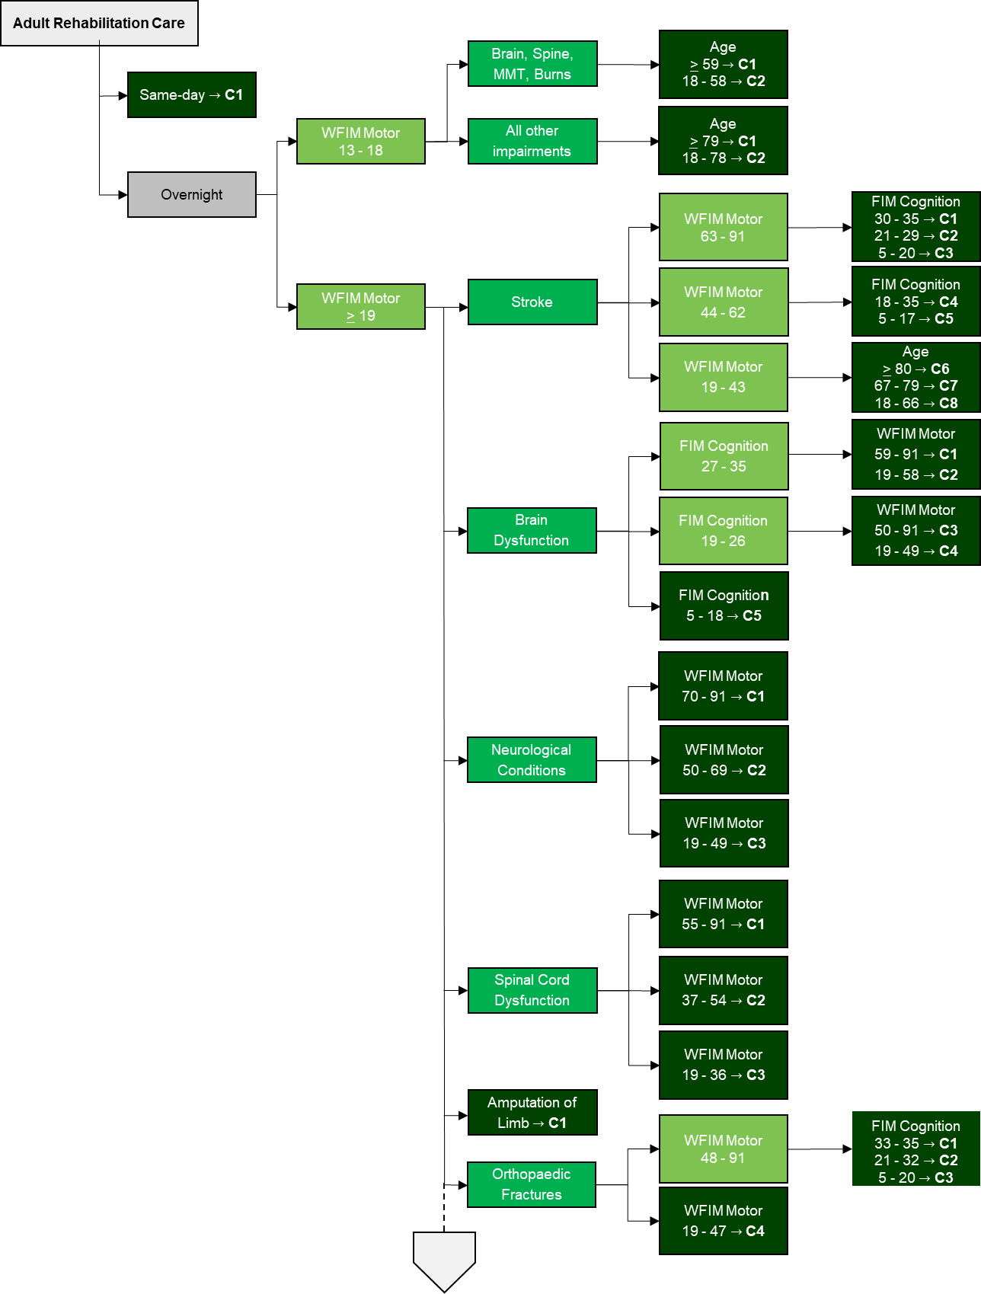

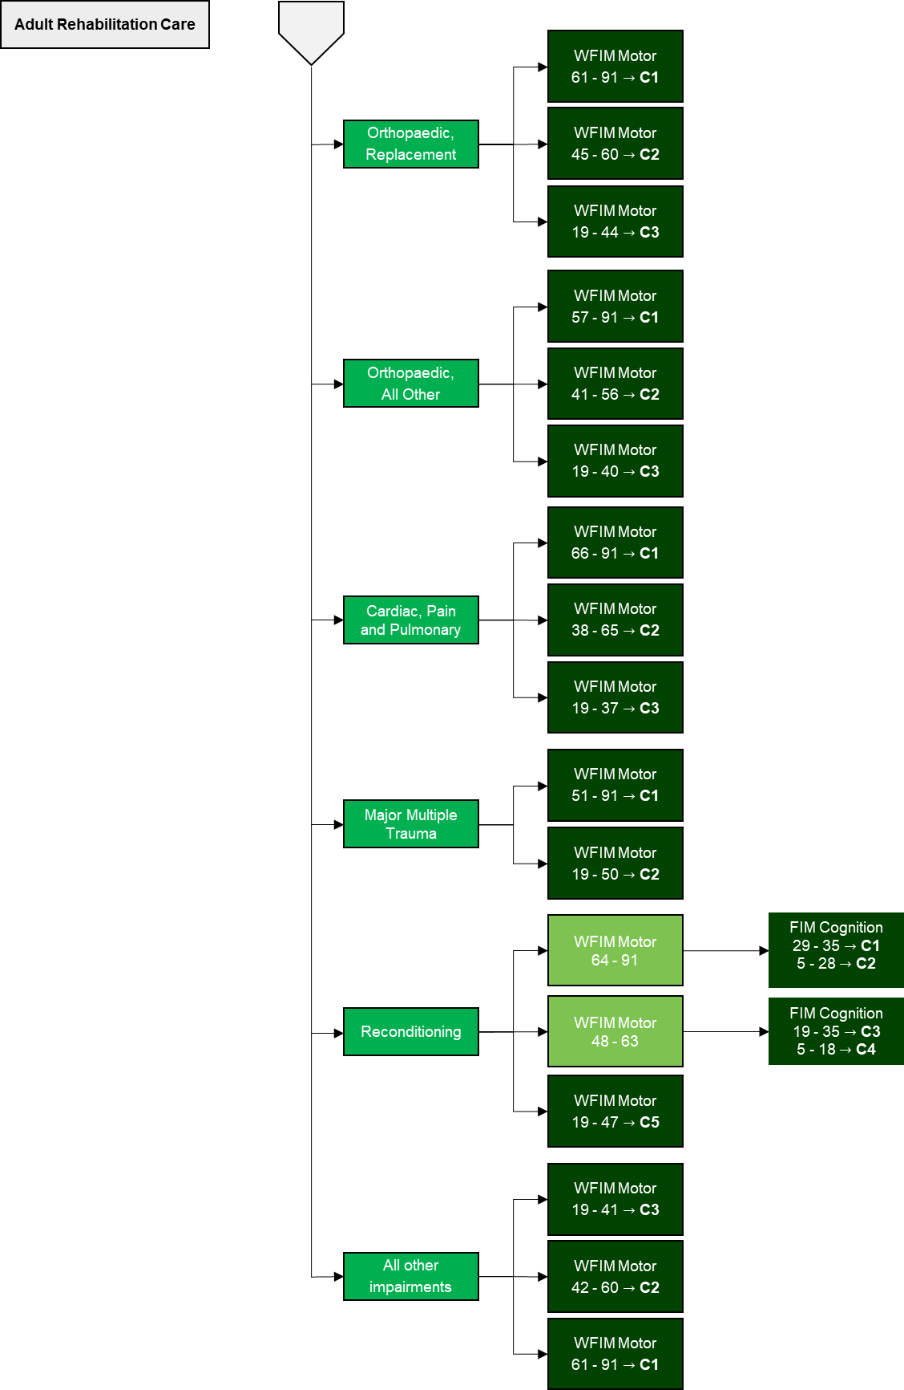

Note: ‘C’ designates Class

#### Issues identified for future work

IHPA will continue to explore the concept of frailty and the feasibility of integrating prospective frailty assessment tools (such as the Rockwood Clinical Frailty Scale[13]) in rehabilitation care, noting the challenges of:

* achieving consensus agreement on a wide range of tools used
* differing opinions on the reliability of different tools
* general concerns about the training requirements and administrative burden of adding new data to collect into the national datasets.

IHPA will continue to explore the Functional Independence Measure for children (WeeFIMTM) as a potential variable within the paediatric rehabilitation classes.

The Australian Rehabilitation Outcomes Centre (AROC) holds the Australian licence for the use of the WeeFIMTM tool and is the national certification and training centre for the tool. WeeFIMTM is not currently collected as part of the Admitted Subacute and Non-acute Hospital Care National Best Endeavours Dataset.

IHPA will continue to work with AROC in relation to provision of this data in order undertake this assessment in the future and consider the WeeFIMTM tool for a later version of AN-SNAP.

|  |
| --- |
| **Consultation questions**  Do you support a measure of frailty being introduced into the classification for adult admitted rehabilitation care, in principle? If so, do you have an approach you recommend?  Do you support IHPA continuing to explore the Functional Independence Measure for children (WeeFIMTM) as a potential variable within the paediatric rehabilitation classes? If not, why not?  Do you have any other suggestions for future work to refine the classification of adult or paediatric admitted rehabilitation care such as:   * care cost drivers which could be further investigated; and/or * data items to consider for national collection? |

### 

### Palliative care

In AN-SNAP V4, the variables used to define the adult palliative care classes are palliative care phase, the total score on the RUG-ADL tool, and age.

For paediatric palliative care, overnight admitted episodes are grouped using two phase of care groups for the first split; then an age split; then two different phase of care type for a third split.

#### Changes considered

For the adult palliative care type, the major changes considered for AN-SNAP V5 were:

* reviewing the RUG-ADL and age thresholds to improve statistical performance
* reviewing selected comorbidities, specialist palliative care tools and the CCI as variables for the branch.

For paediatric palliative care, IHPA’s initial analysis revealed that there were not enough paediatric episodes for robust statistical investigation, therefore no changes are proposed to the paediatric care classes for AN-SNAP V5.

#### Proposed new variables

IHPA’s analysis demonstrated that incorporating comorbidities could reduce the number of end classes and improve statistical performance. Despite this, IHPA is not proposing the introduction of comorbidity variables or other changes to the admitted adult palliative care type for AN-SNAP V5.

Stakeholders suggested that progressing these changes would pose an unacceptable risk to the stability of the classification for the anticipated predictive benefit. This reflects:

* feedback from stakeholders (including the Palliative Care Outcome Collaboration (PCOC)) that the RUG-ADL is a well-accepted and useful clinical tool and that replacing it with various different comorbidities under each phase type would likely be an unacceptable challenge to the clinical sensibility of the classification
* concern about the branch becoming too confusing because any improvements in the explanatory power would need the new comorbidities to be applied inconsistently across the different palliative care phases (because diagnosis information is recorded at episode level, not phase level).

Specialist palliative care tools such as the Symptom Assessment Scale and the Australian Modified Karnofsky Performance Scale tool were not further investigated given they are not collected as part of national data sets.

#### Classes for the admitted adult palliative care type

In light of the above, IHPA is proposing that the admitted adult palliative care type overnight branch of AN-SNAP V5 continue to be made up of 12 classes. The same-day end class will be retained.

The classification tree for the adult palliative care type is shown in Figure 4.

Figure . AN-SNAP V5 admitted adult palliative care type

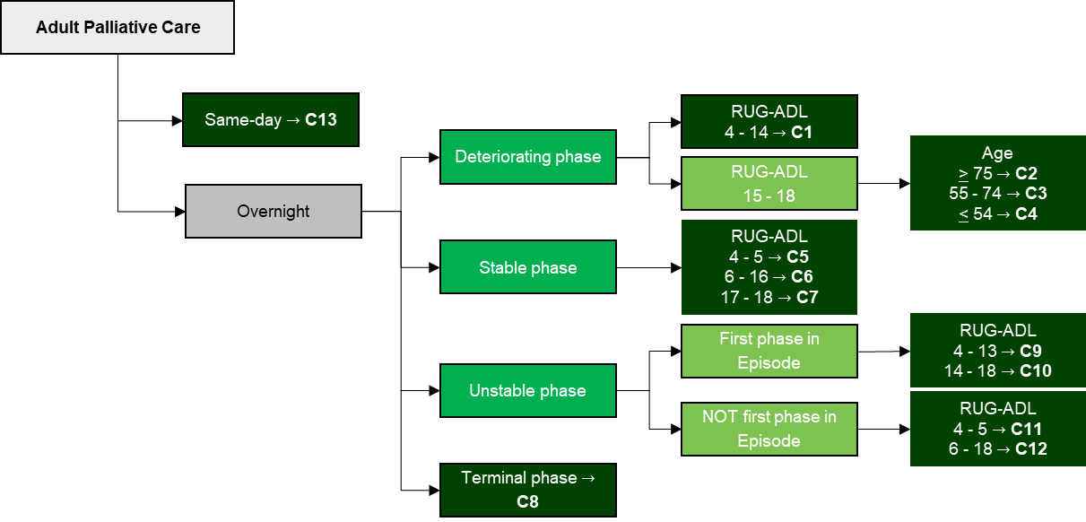

Note: ‘C’ designates Class

#### Issues identified for future work

Future AN-SNAP developments will consider the suitability of alternatives to the RUG-ADL tool for the palliative care type.

|  |
| --- |
| **Consultation question**  Do you have any suggestions for future work to refine the classification of adult or paediatric admitted palliative care such as:   * care cost drivers which could be further investigated; and/or * data items to consider for national collection? |

### 

### Geriatric Evaluation and Management (GEM)

The variables currently used in AN-SNAP V4 to group episodes into GEM classes are the FIMTM Motor score (the sum of the first 13 items of the FIMTM tool) and ICD-10-AM diagnoses codes of delirium or dementia.

#### Changes considered

For the GEM care type, the major changes considered for AN-SNAP V5 were:

* reviewing the existing FIMTM Motor and ICD-10-AM diagnoses codes of delirium or dementia variables and/or thresholds to improve statistical performance
* reviewing the Standardised Mini-Mental State Examination (SMMSE), Frailty Risk Score, and the CCI as potential new variables.

#### Proposed new variables

Standardised Mini-Mental State Examination

IHPA tested the impact of introducing the SMMSE tool as a variable during the analysis on the GEM care type.

While the tool demonstrated promising results IHPA is not proposing to introduce the SMMSE into AN-SNAP V5. This reflects:

* the Frailty Risk Score showing the greatest explanatory power (although SMMSE had superior explanatory power when compared to the explanatory power of the existing FIMTM Motor variable)
* there were only a small number of episodes available after data trimming for 2015–16 to 2017–2018 and they were heavily concentrated in a small number of jurisdictions.

Frailty Risk Score

IHPA’s initial analysis of the Frailty Risk Score in the GEM care type showed that a first split using Frailty Risk Score followed by a secondary split of FIMTM Motor outperformed the V4 structure splits of FIMTM Motor and ‘delirium or dementia’ status.

IHPA then applied the Exclusion Review to address concerns that the proposed approach to calculating the Frailty Risk Score might incentivise particular additional diagnoses being recorded (see **Appendix D**). The outcome continued to support including the Frailty Risk Score in the GEM care type due to predictive value. Accordingly, while acknowledging there are that some clinicians are concerned about excluding certain ICD-10-AM codes that describe falls from the Frailty Risk Score, IHPA is proposing it is adopted as a variable for GEM care.

|  |
| --- |
| **Consultation question**  Do you support IHPA’s proposal to introduce the Frailty Risk Score as a variable for the GEM care type? If not, why not? |

#### Proposed changes - splitting variables

IHPA is proposing to change the splitting variables and the order of the splitting variables in the GEM care type.

#### Classes for the admitted GEM care type

The new overnight admitted GEM care type of AN-SNAP V5 is proposed to comprise of six classes. The same-day end class will be retained.

The proposed classification tree for the GEM care type is shown in Figure 5.

Figure . AN-SNAP V5 admitted GEM branch

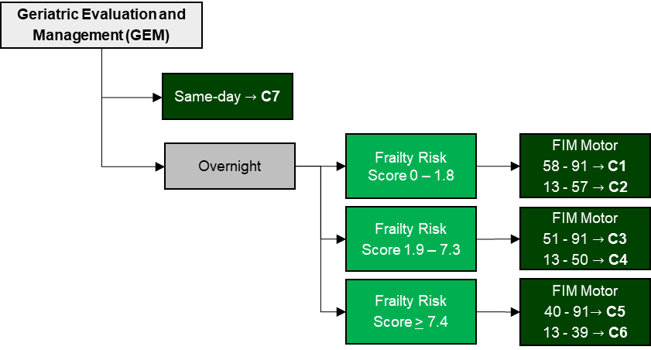

Note: ‘C’ designates Class

#### Issues identified for future work

Given the promising predictive qualities of the SMMSE, IHPA recommends that it continue to be collected by jurisdictions so that it can be re-examined for future versions.

IHPA will also continue to investigate the feasibility and benefits of using the Rockwood Clinical Frailty Scale and the CCI as potential variables for this branch.

|  |
| --- |
| **Consultation question**  Do you have any suggestions for future work to refine the classification of GEM care such as:   * care cost drivers which could be further investigated; and/or * data items to consider for national collection? |

### 

### Psychogeriatric care

In AN-SNAP V4, the variables used to define the psychogeriatric classes are length of stay (LOS) and scores from the Health of the Nation Outcomes Scale for people sixty five years and older (HoNOS 65+) tool.

The overnight episodes are split into two groups based on LOS. The shorter stay episodes are then split into three groups, based on the HoNOS 65+ item score for *Overactive behaviour* (item 1 of the HoNOS 65+ scale). Two of these groups are then split further, one using the HoNOS 65+ item score for *Problems with activities of daily living* (ADL - item 10 of the HoNOS 65+ scale) and the other using the HoNOS 65+ total score.

#### Changes considered

As part of the AN-SNAP V5 development, IHPA first consulted whether to retain the psychogeriatric care type in AN-SNAP V5, given:

* the overlap with the Australian Mental Health Care Classification
* significant variation between jurisdictions’ assignment of this care type, with episodes heavily concentrated in two jurisdictions (New South Wales and Western Australia)
* low volume of episodes for the care type.

Following stakeholder advice that the care type be retained, the major changes considered for AN-SNAP V5 were:

* reviewing the LOS and HONOS 65+ total and individual item score variables and/or thresholds to improve statistical performance
* reviewing the Frailty Risk Score or CCI as potential new variables.

#### Proposed new variables

Analysis demonstrated that while the introduction of the Frailty Risk Score had an improved explanatory power for those episodes with a HoNOS 65+ total score greater than 18, the statistical improvement was less than 1 per cent.

Given this marginal improvement and the disruptive impact of introducing a new non-mental health specific variable, IHPA did not further investigate the appropriateness of introducing the Frailty Risk Score as a new variable for AN-SNAP V5 for the psychogeriatric care type.

#### Proposed changes - splitting variables

IHPA’s analysis demonstrated that splitting the psychogeriatric short term care episodes into two classes, using a HoNOS 65+ total score, outperformed the current five classes resulting from a first split using HoNOS 65+ *Overactive Behaviours* and a second split using HoNOS 65+ *Problems with activities of daily living* and total scores.

Despite this improved predictive performance, some stakeholders expressed concern about changing the current approach as suggested by the analysis. Namely, their view was that the current splits appropriately focus the classes on the two individual item scores in the HONOS  65+ that are most relevant for clinical care and staffing (item 1: *Overactive behaviour* and item 10 *Problems with activities of daily living*).

IHPA is proposing to adopt the simpler and statistically better performing approach of using the HoNOS 65+ total score is used to split short stay overnight episodes in the psychogeriatric care type.

|  |
| --- |
| **Consultation question**  Do you support IHPA’s proposal to adopt the HoNOS 65+ total score to split short stay overnight episodes in the Psychogeriatric care type? |

#### Classes for the admitted psychogeriatric care type

The overnight admitted psychogeriatric care type of AN-SNAP V5 is proposed to comprise of three classes (with no change proposed to the long term care class). The same-day end class will be retained.

The proposed classification tree for the admitted psychogeriatric care type is shown in Figure 6.

Figure . AN-SNAP V5 admitted psychogeriatric care type

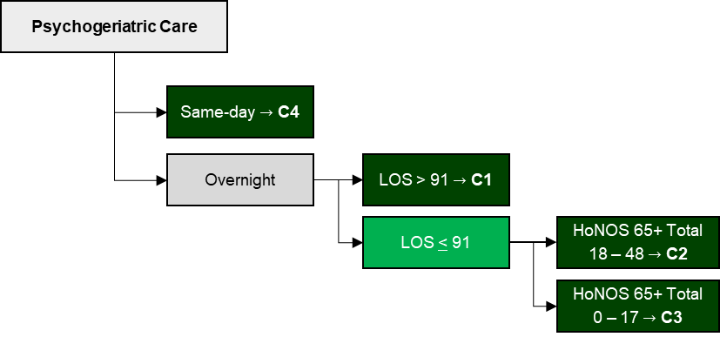

Note: ‘C’ designates Class

#### Issues identified for future work

Future work will continue to consider the appropriateness of the psychogeriatric care type being retained in the subacute classification rather than as part of the mental health care classification.

### Non-acute care

In AN-SNAP V4, the non-acute care type is first split by LOS. For those episodes with a short LOS (less than 91 days), the second split is age where those episodes for patients 60 years or older are further split based on their RUG-ADL score.

#### Changes considered

For the non-acute care type, the major changes considered for AN-SNAP V5 were:

* reviewing the LOS and age variables and/or thresholds to improve statistical performance
* reviewing the Frailty Risk Score, social factor comorbidities or the CCI as potential new variables.

#### Proposed new variables

In IHPA’s initial analysis, the Frailty Risk Score outperformed all variables. However, given the age split (and particularly the age less than or equal to 17 years class) was only recently introduced as part of V4, IHPA decided to retain the age variable as the second split (after LOS) and test the Frailty Risk Score applied as the third split only. The result was the Frailty Risk Score outperformed the RUG-ADL variable.

IHPA’s proposal is therefore for AN-SNAP V5 short term episodes in the non-acute care type to apply age as the first splitting variable and adopt the Frailty Risk Score as a secondary split to the older age group only (greater than 65 years of age). The proposal Frailty Risk Score would be calculated in the same way as for GEM care: with redundant, ill-defined or non-critical codes excluded as per the Exclusion Review (see **Appendix D**).

No changes are proposed to the long term care end class.

|  |
| --- |
| **Consultation question**  Do you support IHPA’s proposal to introduce the Frailty Risk Score as a variable for the non-acute care type? If not, why not? |

#### Proposed changes - splitting variables and thresholds

IHPA’s analysis supported the non-acute care type continuing to be initially split by LOS; and for the threshold to be kept at 91 days to distinguish between short and long term episodes of care.

#### Classes for the admitted non-acute care type

The admitted non-acute care type of AN-SNAP V5 is proposed to comprise of five classes.

The proposed classification tree for the admitted non-acute care type is shown in Figure 7.

Figure . AN-SNAP V5 admitted non-acute care type

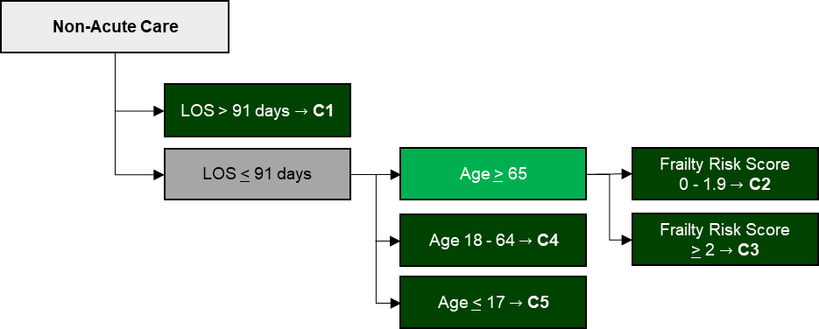

Note: ‘C’ designates Class

|  |
| --- |
| **Consultation question**  Do you have any suggestions for future work to refine the classification of non-acute care such as:   * care cost drivers which could be further investigated; and/or * data items to consider for national collection? |

## Performance of the overall proposed AN-SNAP V5 model

IHPA has calculated the overall statistical performance of the proposed AN-SNAP V5 using Reduction In Deviance (RID) – a measure how much of the classification explains variability in cost, expressed as a percentage. The higher the RID percentage value, the higher percentage of cost variation is explained by the classification.

According to the current proposal, the admitted branch of AN-SNAP V5 will have 95 end classes compared to 102 end classes for the admitted branch of V4.The current projection of overall RID for AN-SNAP V5 is 54.3 per cent, compared to 53.9 per cent for V4.

Expressed otherwise, the draft AN-SNAP V5 will improve the classification’s RID performance by 0.4 per cent (54.3 per cent to 53.9 per cent) with seven fewer end classes (95 to 102).

### End class characteristics

The variables, thresholds, and descriptive information about the end classes (episodes, average cost, average length of stay, coefficient of variation) calculated using three years of data (2015–16, 2016–17 and 2017–18) is at **Appendix E****.**

# Next Steps

IHPA will consider the responses received through this consultation and, where necessary, will conduct further analysis and expert consultation through the relevant advisory committees.

The final AN-SNAP V5 will then be reviewed by IHPA’s committees and considered by the Pricing Authority in late 2021.

# Appendix A - Subacute Care Working Group

Table . Independent Hospital Pricing Authority - Subacute Care Working Group

|  |
| --- |
| Organisation / jurisdiction |
| IHPA Clinical Advisory Committee member |
| Representatives from each Australian jurisdiction |
| Royal Australasian College of Physicians (RACP) rehabilitation specialists |
| RACP geriatrician specialists |
| RACP palliative care specialists |
| RACP paediatric specialists |
| Allied Health Professions Australia |
| Palliative Care Australia |
| Australasian Rehabilitation Nurses’ Association |
| Australian Health Services Research Institute, University of Wollongong |
| Royal Australian and New Zealand College of Psychiatrists |
| Australian Private Hospitals Association |
| Australian Health Service Alliance |
| Private Healthcare Australia |

# Appendix B - Data Sources

Table . Comparing volume and coverage of episode records available for analysis for AN-SNAP V4 and AN-SNAP V5.

|  |  |  |
| --- | --- | --- |
| **Care Type** | **AN-SNAP V4 Number of records1** | **AN-SNAP V5 Number of records2** |
| Rehabilitation | 14,356 | 213,709 |
| Palliative Care | 20,172 | 289,344 |
| GEM | 238 | 103,292 |
| Psychogeriatric | 1,712 | 4,246 |
| Non-Acute | 745 | 82,765 |
| **Total** | **37,223** | **693,356** |

1. Sourced from Green J, Gordon R, Blanchard M, Kobel C and Eager K. (2015), *Development of AN-SNAP Version 4: Final Report*, Centre for Health Service Development, University of Wollongong
2. For comparative purposes the AN-SNAP V5 Number of records reported here reflects overnight episodes excluding same-day or long-term episodes created by merging the National Hospital Cost Data Collection and Admitted Patient Care data for 2015–16, 2016–17, and 2017–18 not excluding trimmed episodes with missing cost, error records etc.

# Appendix C - Method to explore potential new variables

The Independent Hospital Pricing Authority (IHPA) used a four step method to explore the new variables considered for the fifth version (V5) of the Australian National Subacute and Non-Acute Patient (AN-SNAP) classification:

* **Step 1**: Identify new variables to investigate based on clinical advice and prevalence and average cost data.
* **Step 2**: Use the Classification and Regression Tree (CART) algorithm to short list potential variables for the classification based on their interactions and how well they explain cost.
* **Step 3**: With the potential variables, apply a set of threshold criteria and simulate possible scenarios to optimise and achieve the highest Reduction in Deviance (RID).
* **Step 4**: Determine the final end class selection with consideration of clinical advice.

**Step 1 – Identify new variables**

IHPA identified new variables using stakeholder suggestions and analysing subacute and non-acute data from 2015 –16 to 2017–18 financial years to identify high volume and average cost variables.

**Step 2 – Short list potential variables**

IHPA applied the CART algorithm to the combination of new and existing variables to assess:

* **Optimal Order**: The splitting order of the variables based of explanatory power with cost
* **Interaction**: How these variables interact.

The CART algorithm is a machine learning modelling technique for regression and classification problems. It provides a hierarchy decision tree with respect to an outcome variable (cost). Figure 8 demonstrates the decision tree results using an example of the AN-SNAP Reconditioning impairment type.

Figure . CART output for Reconditioning impairment type

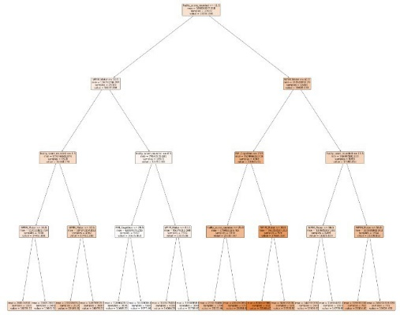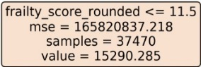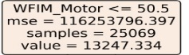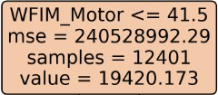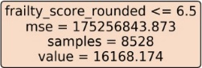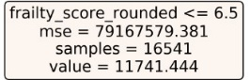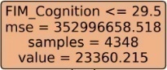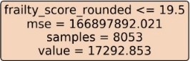

As demonstrated in the Figure 8 example, of those variables considered for the Reconditioning impairment type, the Frailty Risk Score was identified as the variable with the highest explanatory power for cost, followed by the Functional Impairment MeasureTM Motor score – weighted (WFIMTM). After the first Frailty Risk Score split, the second level splits both adopted WFIMTM Motor. Therefore, the CART algorithm helps determine the order and interaction of the top performing variables (i.e. Frailty Risk Score and WFIMTM Motor for the Reconditioning impairment type).

**Step 3 – Simulation and threshold criteria**

Continuing the example above, with the potential variables Frailty and WFIMTM Motor identified, the threshold criteria outlined in Table 7 are applied to identify the optimal threshold split simulations that achieved the highest RID.

Table . Threshold criteria

| **Criteria** | | **Optimum Threshold** | **Principle** |
| --- | --- | --- | --- |
| **1** | Minimum episodes per category of 200 per year | ✓ | Robust episode volume and total aggregated cost per end class for stability |
| **2** | Minimum cost per category of $1m per year | ✓ |
| **3** | Minimum percentage per category of 10% per year | ✓ |
| **4** | Minimum absolute change in mean cost of $2,000 between consecutive categories | Either Criteria 4 or Criteria 5 | Significant difference in average cost between end-classes |
| **5** | Minimum relative change in mean cost of 1.5 (or 1.5-1) between consecutive categories |
| **6** | Maximum coefficient of variation of 1.5 | ✓ | Satisfactory homogeneity of each end-class |
| **7** | Number of splits determined by the subsequent increase in RID. The minimum increase in RID must be greater than 1% to warrant an extra split. | ✓ | Significant RID improvement (i.e. 1%) to warrant an increase in the number of end classes. |

**Step 4 – Final end class selection**

Based on the simulations that met the threshold criteria outlined in Table 7, the following additional factors were considered for final end class selection:

* **RID performance:** From all simulations that met the threshold criteria, the simulations with the highest RID was proposed
* **Clinically Coherence:** The proposed selection was also assessed with respects to clinically coherency (i.e. do the proposed measures make clinical sense?)
* **Stability**: the relatively stable to the previous classification (i.e. do the proposed changes create potential instability within the classification?).

# Appendix D - Incorporating a measure of frailty

**Background**

**A measure of frailty**

In the early stages of the development of the fifth version (V5) of the Australian National Subacute and Non-Acute Patient (AN-SNAP) classification, the Subacute Care Working Group suggested that measures of frailty be explored for potential inclusion in the AN-SNAP classification, particularly in the Geriatric evaluation and management and rehabilitation, reconditioning impairment type. This reflected broad acknowledgement of frailty as likely driver of episode costs; and the shifting trends in subacute care patient demographics.

Accordingly, the Independent Hospital Pricing Authority (IHPA) considered various measures of frailty including clinical assessment tools and retrospective frailty measures and concluded that the use of clinical assessment tools to measure frailty is varied and there is no nationally consistent prospective data for IHPA to analyse.

IHPA then explored the potential to use International Statistical Classification of Diseases and Related Health Problems, 10th Revision, Australian Modification (ICD-10-AM) codes, which are assigned reliably by clinical coders according to the Australian Coding Standards for every episode of subacute care.

**Literature review**

Following a literature review IHPA identified a recent international frailty study[14] as providing a validated method of identify the risk of frailty using International Statistical Classification of Diseases and Related Health Problems, Tenth Revision (ICD-10) codes (Hospital Frailty Risk Score).

This study used ICD-10 codes based on 2013-14 and 2014-15 admitted patient information from National Health Service Hospitals in England. The Hospital Frailty Risk Score was derived using a regression model. The 109 ICD-10 codes were at least twice as more prevalent in frail group compared to the rest of the cohort. The Hospital Frailty Risk Score included adjustments to account for the correlation amongst the ICD-10 codes. The study also confirmed that older patients (≥ 75 years old) with frailty characteristics were at a higher risk of adverse outcomes during hospital admissions.

**Adapting the Hospital Frailty Risk Score for Australian Subacute and Non-acute care**

The Hospital Frailty Risk Score identified 109 ICD-10 code blocks as markers of frailty with an associated frailty risk score. IHPA mapped the ICD-10 code blocks to ICD-10-AM, the Australian modification of ICD-10 to create the Frailty Risk Score.

Apart from the substitution of **U80** *Agent resistant to penicillin and related antibiotics* to ICD-10-AM code **Z06.51** *Resistance to penicillin*, all mappings and the respective individual frailty risk scores of each code block remained the same.

The three character code blocks were then expanded to include all valid three, four and five character ICD-10-AM codes. For example **F00** *Dementia in Alzheimer's disease* includes; **F00.0** *Dementia in Alzheimer's disease with early onset*, **F00.1** *Dementia in Alzheimer's disease with late onset*, **F00.2** *Dementia in Alzheimer's disease, atypical or mixed type* and **F00.9** *Dementia in Alzheimer's disease, unspecified*.

The ICD-10-AM code blocks of the Frailty Risk Score are shown in Table 8.

**Exclusion Review**

The second stage of adapting the codes used to calculate the Frailty Risk Score involved identifying and excluding:

* codes considered to provide additional or supplementary information to another code already assigned
* codes describing an ill-defined and/or transient condition of symptoms
* codes providing context rather than information critical to the clinical description of an episode of care.

This process (the Exclusion Review), used already established guiding principles used similarly the acute care classification to exclude certain codes from being assigned a higher complexity marker (*Guiding principles for exclusion of the ICD-10-AM diagnosis codes*).

The full criteria for exclusions were:

* codes that represent undefined or ill-specified conditions that are better represented by other more specific codes within ICD-10-AM
* codes that represent symptoms and findings or transient conditions that are better represented by other more specific codes within ICD-10-AM
* codes that provide additional or contextual information to an already assigned ICD-10-AM code
* unacceptable principal diagnosis codes, unless deemed capable of providing information critical to the clinical description of an admitted acute episode of care
* codes that represent asymptomatic or sub-clinical conditions e.g. latent conditions
* codes that represent markers of other diseases
* codes that represent minor conditions that do not generally result in an admitted subacute episode of care
* codes that represent an underlying cause of disease but do not add to the complexity of a subacute episode of care in themselves.

IHPA reviewed the applicability of these criteria in the subacute and non-acute care setting. As part of this process, the ICD-10-AM codes which correspond to three character ICD-10 codes have been expanded to include all four and five character codes. All expanded codes were reviewed and certain codes were then excluded from the Frailty Risk Score calculation. The codes excluded as part of the Exclusion Review are listed in Table 8.

Table . ICD-10-AM codes excluded from the Frailty Risk Score as a result of the Exclusion Review

| **ICD-10-AM 3 character code** | **Code Block Description** | **Exclusion Review** | **Rationale for Exclusion** |
| --- | --- | --- | --- |
|
|  |
| A04* | Other bacterial intestinal infection | Not Excluded. | N/A |
| A09* | Other gastroenteritis and colitis of infectious origin | Not Excluded. | N/A |
| A41* | Other sepsis | Not Excluded. | N/A |
| B95* | Streptococcus and staphylococcus as the cause of diseases classified to other chapters | All codes excluded. | These codes provide additional specificity to already captured conditions. |
| B96* | Other bacterial agents as the cause of diseases classified to other chapters | All codes excluded. | These codes provide additional specificity to already captured conditions. |
| D64* | Other anaemias | Not Excluded. | N/A |
| E05* | Thyrotoxicosis [hyperthyroidism] | Not Excluded. | N/A |
| E16* | Other disorders of pancreatic internal secretion | Code E16.2 excluded. All other codes not excluded | This code is non-specific, reflects poor documentation practice and has been supported for exclusion in funding models as it is likely to be insignificant. |
| E53* | Deficiency of other B group vitamins | Not Excluded. | N/A |
| E55* | Vitamin D deficiency | Code E55.9 excluded. Other code not excluded. | This code is non-specific, reflects poor documentation practice and has been supported for exclusion in funding models as it is likely to be insignificant. |
| E83* | Disorders of mineral metabolism | All codes excluded. | These codes represent transient conditions or ill-specified conditions that are better represented by other more specific codes within ICD-10-AM. |
| E86 | Volume depletion | Not Excluded. | N/A |
| E87* | Other disorders of fluid, electrolyte and acid-base balance | All codes excluded. | These codes represent transient conditions or ill-specified conditions that are better represented by other more specific codes within ICD-10-AM. |
| F00* | Dementia in Alzheimer's disease | Not Excluded. | N/A |
| F01* | Vascular dementia | Not Excluded. | N/A |
| F03 | Unspecified dementia | Not Excluded. | N/A |
| F05* | Delirium, not induced by alcohol and other psychoactive substances | Not Excluded. | N/A |
| F10* | Mental and behavioural disorders due to use of alcohol | Code F10.9 excluded All other codes not excluded. | This code is non-specific, reflects poor documentation practice and has been supported for exclusion in funding models as it is likely to be insignificant. |
| F32* | Depressive episode | Not Excluded. | N/A |
| G20 | Parkinson's disease | Not Excluded. | N/A |
| G30* | Alzheimer's disease | Conditionally excluded when G30* code is used with any of F00* codes in the same episode. Otherwise, not excluded. | This code is considered as a duplicate code when used with F00* code and hence, is excluded to avoid double counting. |
| G31* | Other degenerative diseases of nervous system, not elsewhere classified | Not Excluded. | N/A |
| G40* | Epilepsy | Not Excluded. | N/A |
| G45* | Transient cerebral ischaemic attacks and related syndromes | Not Excluded. | N/A |
| G81* | Hemiplegia | Not Excluded. | N/A |
| H54* | Visual impairment including binocular or monocular blindness | Codes H54.3 and H54.9 excluded. All other codes not excluded. | These codes are non-specific, reflect poor documentation practice and have been supported for exclusion in funding models as they are likely to be insignificant. |
| H91* | Other hearing loss | Not Excluded. | N/A |
| I63* | Cerebral Infarction | Not Excluded. | N/A |
| I67* | Other cerebrovascular diseases | Code I67.9 excluded. All other codes not excluded. | This code is non-specific, reflects poor documentation practice and has been supported for exclusion in funding models as it is likely to be insignificant. |
| I69* | Sequelae of cerebrovascular disease | All codes excluded. | These codes provide additional specificity to already captured conditions. |
| I95* | Hypotension | Not Excluded. | N/A |
| J18* | Pneumonia, organism unspecified | Not Excluded. | N/A |
| J22 | Unspecified acute lower respiratory infection | Not Excluded. | N/A |
| J69* | Pneumonitis due to solids and liquids | Not Excluded. | N/A |
| J96* | Respiratory failure, not elsewhere classified | Not Excluded. | N/A |
| K26* | Duodenal ulcer | Code K26.9 excluded. All other codes not excluded. | This code is non-specific, reflects poor documentation practice and has been supported for exclusion in funding models as it is likely to be insignificant. |
| K52* | Other noninfective gastroenteritis and colitis | Not Excluded. | N/A |
| K59* | Other functional intestinal disorders | Codes K59.0, K59.1, K59.4 and K59.9 excluded. All other codes not excluded. | These codes represent transient conditions or ill-specified conditions that are better represented by other more specific codes within ICD-10-AM. |
| K92* | Other diseases of digestive system | Code K92.9 excluded. All other codes not excluded. | This code is non-specific, reflects poor documentation practice and has been supported for exclusion in funding models as it is likely to be insignificant. |
| L03* | Cellulitis | Codes L03.19 and L03.9 excluded. All other codes not excluded. | These codes are non-specific, reflect poor documentation practice and have been supported for exclusion in funding models as they are likely to be insignificant. |
| L08* | Other local infections of skin and subcutaneous tissue | Codes L08.1, L08.8, and L08.9 excluded. Code L08.0 not excluded. | These codes are non-specific, reflect poor documentation practice and have been supported for exclusion in funding models as they are likely to be insignificant. |
| L89* | Pressure injury | Not Excluded. | N/A |
| L97* | Ulcer of lower limb, not elsewhere classified | Not Excluded. | N/A |
| M15* | Polyarthrosis | Code M15.9 excluded. All other codes not excluded. | This code is not assigned in Australia for admitted patients as per the Australian Coding Standards. |
| M19* | Other arthrosis | Codes M19.09, M19.19, M19.29, M19.89 and M19.9* excluded. All other codes not excluded. | M19.09, M19.19, M19.29 and M19.89 codes are non-specific, reflect poor documentation practice and have been supported for exclusion in funding models as they are likely to be insignificant.  M19.9* codes are not assigned in Australia for admitted patients as per the Australian Coding Standards. |
| M25* | Other joint disorders, not elsewhere classified | Codes M25.09, M25.19, M25.29, M25.39, M25.49, M25.5*, M25.6*, M25.79, M25.89 and M25.9* excluded. All other codes not excluded. | These codes are non-specific, reflect poor documentation practice and have been supported for exclusion in funding models as they are likely to be insignificant. |
| M41* | Scoliosis | Codes M41.09, M41.19, M41.29, M41.39, M41.49, M41.59 and M41.99 excluded. All other codes not excluded. | These codes are non-specific, reflect poor documentation practice and have been supported for exclusion in funding models as they are likely to be insignificant. |
| M48* | Other spondylopathies | Codes M48.09, M48.19, M48.29, M48.39, M48.49, M48.59, M48.89 and M48.99 excluded. All other codes not excluded. | These codes are non-specific, reflect poor documentation practice and have been supported for exclusion in funding models as they are likely to be insignificant. |
| M79* | Other soft tissue disorders, not elsewhere classified | Codes M79.0*, M79.1*, M79.29, M79.3*, M79.49, M79.59, M79.6*, M79.79, M79.86, M79.89 and M79.9* excluded. All other codes not excluded. | For M79.0* codes, clinical advice stated rheumatism is outdated terminology. Arthritis and osteoarthritis are captured in the frailty risk score. M79.1* codes represent ill-specified conditions that are better represented by other more specific codes within ICD-10-AM. M79.3*, M79.29, M79.49, M79.59, M79.6*, M79.79, M79.86, M79.89, M79.9* codes are non-specific, reflect poor documentation practice and have been supported for exclusion in funding models as they are likely to be insignificant. |
| M80* | Osteoporosis with pathological fracture | Codes M80.09, M80.19, M80.29, M80.39, M80.49, M80.59 and M80.99 excluded. All other codes not excluded. | These codes are non-specific, reflect poor documentation practice and have been supported for exclusion in funding models as they are likely to be insignificant. |
| M81* | Osteoporosis without pathological fracture | Codes M81.19, M81.49, M81.59, M81.69, M81.89 and M81.99 excluded. All other codes not excluded | These codes are non-specific, reflect poor documentation practice and have been supported for exclusion in funding models as they are likely to be insignificant. |
| N17* | Acute kidney failure | Not Excluded. | N/A |
| N18* | Chronic kidney disease | Codes N18.1 to N18.3 excluded. All other codes not excluded. | Clinical advice stated these stages are mild and mostly asymptomatic. |
| N19 | Unspecified kidney failure | Excluded. | This code is non-specific, reflects poor documentation practice and has been supported for exclusion in funding models as it is likely to be insignificant. |
| N20* | Calculus of kidney and ureter | Not Excluded. | N/A |
| N28* | Other disorders of kidney and ureter, not elsewhere classified | Codes N28.1 and N28.9 excluded. All other codes not excluded. | These codes are non-specific, reflect poor documentation practice and have been supported for exclusion in funding models as they are likely to be insignificant. |
| N39* | Other disorders of urinary system | Code N39.9 excluded. All other codes not excluded. | This code is non-specific, reflects poor documentation practice and has been supported for exclusion in funding models as it is likely to be insignificant. |
| R00* | Abnormalities of heart beat | All codes excluded except R0.03. | These codes represent undefined or ill-specified conditions that are better represented by other more specific codes within ICD-10-AM. |
| R02 | Gangrene, not elsewhere classified | Not Excluded. | N/A |
| R11 | Nausea and vomiting | Excluded. | This code represents undefined or ill-specified conditions that are better represented by other more specific codes within ICD-10-AM. |
| R13 | Dysphagia | Excluded. | This code represents undefined or ill-specified conditions that are better represented by other more specific codes within ICD-10-AM. |
| R26* | Abnormalities of gait and mobility | All codes excluded. | These codes represent undefined or ill-specified conditions that are better represented by other more specific codes within ICD-10-AM. |
| R29* | Other symptoms and signs involving the nervous and musculoskeletal systems | All codes excluded. | These codes represent undefined or ill-specified conditions that are better represented by other more specific codes within ICD-10-AM. |
| R31 | Unspecified haematuria | Excluded. | This code represents undefined or ill-specified conditions that are better represented by other more specific codes within ICD-10-AM. |
| R32 | Unspecified urinary incontinence | Not Excluded. | N/A |
| R33 | Retention of urine | Excluded. | This code represents undefined or ill-specified conditions that are better represented by other more specific codes within ICD-10-AM. |
| R40* | Somnolence, stupor and coma | All codes excluded except R40.2. | These codes represent undefined or ill-specified conditions that are better represented by other more specific codes within ICD-10-AM. |
| R41* | Other symptoms and signs involving cognitive functions and awareness | All codes excluded. | These codes represent undefined or ill-specified conditions that are better represented by other more specific codes within ICD-10-AM. |
| R44* | Other symptoms and signs involving general sensations and perceptions | All codes excluded. | These codes represent undefined or ill-specified conditions that are better represented by other more specific codes within ICD-10-AM. |
| R45* | Symptoms and signs involving emotional state | All codes excluded. | These codes represent undefined or ill-specified conditions that are better represented by other more specific codes within ICD-10-AM. |
| R47* | Speech disturbances, not elsewhere classified | All codes excluded. | These codes represent undefined or ill-specified conditions that are better represented by other more specific codes within ICD-10-AM. |
| R50* | Fever of unknown origin | All codes excluded. | These codes represent undefined or ill-specified conditions that are better represented by other more specific codes within ICD-10-AM. |
| R54 | Senility | Excluded. | This code represents undefined or ill-specified conditions that are better represented by other more specific codes within ICD-10-AM. |
| R55 | Syncope and collapse | Excluded. | This code represents undefined or ill-specified conditions that are better represented by other more specific codes within ICD-10-AM. |
| R56* | Convulsions, not elsewhere classified | Not Excluded | N/A |
| R63* | Symptoms and signs concerning food and fluid intake | All codes excluded. | These codes represent undefined or ill-specified conditions that are better represented by other more specific codes within ICD-10-AM. |
| R69 | Unknown and unspecified causes of morbidity | Excluded. | This code represents undefined or ill-specified conditions that are better represented by other more specific codes within ICD-10-AM. |
| R79* | Other abnormal findings of blood chemistry | All codes excluded. | These codes represent undefined or ill-specified conditions that are better represented by other more specific codes within ICD-10-AM. |
| R94* | Abnormal results of function studies | All codes excluded. | These codes represent undefined or ill-specified conditions that are better represented by other more specific codes within ICD-10-AM. |
| S00* | Superficial injury of head | All codes excluded. | These codes capture injuries that are likely to be insignificant. |
| S01* | Open wound of head | Not Excluded | N/A |
| S06* | Intracranial injury | Code S06.00 excluded. All other codes not excluded. | These codes capture injuries that are likely to be insignificant. |
| S09* | Other and unspecified injuries of head | Not Excluded | N/A |
| S22* | Fracture of rib(s), sternum and thoracic spine | Not Excluded | N/A |
| S32* | Fracture of lumbar spine and pelvis | Not Excluded | N/A |
| S42* | Fracture of shoulder and upper arm | Not Excluded | N/A |
| S51* | Open wound of forearm | Not Excluded | N/A |
| S72* | Fracture of femur | Not Excluded | N/A |
| S80* | Superficial injury of lower leg | All codes excluded. | These codes capture injuries that are likely to be insignificant. |
| T83* | Complications of genitourinary prosthetic devices, implants and grafts | Not Excluded | N/A |
| W01* | Fall on same level from slipping, tripping and stumbling | All codes excluded. | These codes provide specificity around the details of the fall or exposure factor, and are coded in addition to the injury sustained. |
| W06* | Fall involving bed | All codes excluded. | These codes provide specificity around the details of the fall or exposure factor, and are coded in addition to the injury sustained. |
| W10* | Fall on and from stairs and steps | All codes excluded. | These codes provide specificity around the details of the fall or exposure factor, and are coded in addition to the injury sustained. |
| W18* | Other fall on same level | All codes excluded. | These codes provide specificity around the details of the fall or exposure factor, and are coded in addition to the injury sustained. |
| W19 | Unspecified fall | Excluded. | This code provides specificity around the details of the fall or exposure factor, and is coded in addition to the injury sustained. |
| X59 | Exposure to unspecified factor | Excluded. | This code provides specificity around the details of the fall or exposure factor, and is coded in addition to the injury sustained. |
| Y84* | Other medical procedures as the cause of abnormal reaction, or of later complication, without mention of unintentional events at the time of the procedure | All codes excluded. | These codes provide specificity around the details of the complication, and are coded in addition to the complication or condition. |
| Y95 | Nosocomial condition | Excluded. | This code provides specificity around the details of the complication, and is coded in addition to the complication or condition. |
| Z06* | Resistance to antimicrobial drugs | All codes excluded except Z06.51 | As a result of the mapping from ICD-10 to ICD-10-AM only code Z06.51 was considered for inclusion in the Frailty Risk Score. |
| Z22* | Carrier of infectious disease | All codes excluded. | These codes provide additional specificity to already captured conditions. |
| Z50* | Care involving use of rehabilitation procedures | All codes excluded. | These codes provide specificity around the details of the rehabilitation, and are coded in addition to the condition requiring rehabilitation. |
| Z60* | Problems related to social environment | All codes excluded. | These codes provide additional or contextual information. |
| Z73* | Problems related to life-management difficulty | All codes excluded. | These codes provide additional or contextual information. |
| Z74* | Problems related to care-provider dependency | All codes excluded. | These codes provide additional or contextual information. |
| Z75* | Problems related to medical facilities and other health care | All codes excluded. | These codes provide additional or contextual information. |
| Z87* | Personal history of other diseases and conditions | All codes excluded. | These codes provide additional or contextual information. |
| Z91* | Personal history of risk-factors, not elsewhere classified | All codes excluded. | These codes provide additional or contextual information. |
| Z93* | Artificial opening status | All codes excluded. | These codes provide additional or contextual information. |
| Z99* | Dependence on enabling machines and devices | All codes excluded. | These codes provide additional or contextual information. |

# 

# Appendix E - End class characteristics

Table . Proposed draft AN-SNAP V5 admitted branch end classes, number of episodes, average cost, average length-of-stay and coefficient of variation

| **End-class for V5** | **Description and thresholds for V5** | **Episodes** | **Average cost** | **Average length of stay** | **Coefficient of variation** |
| --- | --- | --- | --- | --- | --- |
| **Rehabilitation Care** | | | | | |
| **Low WFIM – Brain, Spine, MMT, Burns** | | | | | |
| Class 1 | Weighted FIM motor score 13-18, Brain, Spine, MMT, Burns, Age >= 59 | 656 | $47,679 | 37.39 | 1.11 |
| Class 2 | Weighted FIM motor score 13-18, Brain, Spine, MMT, Burns, Age 18 - 58 | 664 | $71,380 | 50.40 | 1.12 |
| **Low WFIM – All other impairment types** | | | | | |
| Class 1 | Weighted FIM motor score 13-18, All other impairments, Age >= 79 | 3,682 | $24,205 | 22.36 | 0.92 |
| Class 2 | Weighted FIM motor score 13-18, All other impairments, Age 18 - 78 | 3,788 | $35,742 | 31.09 | 1.06 |
| **Stroke** | | | | | |
| Class 1 | Stroke, weighted FIM Motor 63 - 91, FIM Cognition 30 - 35 | 3,025 | $11,100 | 10.65 | 0.78 |
| Class 2 | Stroke, weighted FIM Motor 63 - 91, FIM Cognition 21 - 29 | 2,464 | $14,999 | 13.96 | 0.79 |
| Class 3 | Stroke, weighted FIM Motor 63 - 91, FIM Cognition 5 - 20 | 1,015 | $22,258 | 19.93 | 0.77 |
| Class 4 | Stroke, weighted FIM Motor 44 - 62, FIM Cognition 18 - 35 | 4,818 | $19,000 | 17.75 | 0.76 |
| Class 5 | Stroke, weighted FIM Motor 44 - 62, FIM Cognition 5 - 17 | 1,252 | $26,865 | 25.22 | 0.75 |
| Class 6 | Stroke, weighted FIM Motor 19 - 43, Age >= 80 | 2,616 | $28,022 | 26.59 | 0.75 |
| Class 7 | Stroke, weighted FIM Motor 19 - 43, Age 67 - 79 | 2,331 | $34,177 | 30.78 | 0.80 |
| Class 8 | Stroke, weighted FIM Motor 19 - 43, Age 18 - 66 | 1,641 | $44,989 | 38.35 | 0.86 |
| **Brain dysfunction** | | | | | |
| Class 1 | Brain dysfunction, FIM Cognition 27 - 35, weighted FIM Motor 59 - 91 | 1,398 | $13,731 | 12.05 | 0.97 |
| Class 2 | Brain dysfunction, FIM Cognition 27 - 35, weighted FIM Motor 19 - 58 | 704 | $20,923 | 18.12 | 0.95 |
| Class 3 | Brain dysfunction, FIM Cognition 19 - 26, weighted FIM Motor 50 - 91 | 1,395 | $19,370 | 16.18 | 0.90 |
| Class 4 | Brain dysfunction, FIM Cognition 19 - 26, weighted FIM Motor 19 - 49 | 605 | $28,280 | 23.82 | 1.03 |
| Class 5 | Brain dysfunction, FIM Cognition 5 - 18 | 1,750 | $34,517 | 27.96 | 1.11 |
| **Neurological Conditions** | | | | | |
| Class 1 | Neurological conditions, weighted FIM Motor 70 - 91 | 1,476 | $11,977 | 11.74 | 0.76 |
| Class 2 | Neurological conditions, weighted FIM Motor 50 - 69 | 2,643 | $16,346 | 16.26 | 0.80 |
| Class 3 | Neurological conditions, weighted FIM Motor 19 - 49 | 2,601 | $24,673 | 23.85 | 0.91 |
| **Spinal cord dysfunction** | | | | | |
| Class 1 | Spinal cord dysfunction, weighted FIM Motor 55 - 91 | 826 | $25,669 | 21.69 | 1.13 |
| Class 2 | Spinal cord dysfunction, weighted FIM Motor 37 - 54 | 649 | $39,101 | 32.79 | 0.97 |
| Class 3 | Spinal cord dysfunction, weighted FIM Motor 19 - 36 | 934 | $55,288 | 42.60 | 0.99 |
| **Amputation of Limb** | | | | | |
| Class 1 | Amputation of limb | 3,915 | $23,467 | 22.15 | 0.93 |
| **Orthopaedic Fractures** | | | | | |
| Class 1 | Orthopaedic conditions, fractures, weighted FIM Motor 48 - 91, FIM Cognition 33 - 35 | 7,381 | $12,439 | 12.85 | 0.82 |
| Class 2 | Orthopaedic conditions, fractures, weighted FIM Motor 48 - 91, FIM Cognition 21 - 32 | 7,515 | $14,564 | 15.61 | 0.68 |
| Class 3 | Orthopaedic conditions, fractures, weighted FIM Motor 48 - 91, FIM Cognition 5 - 20 | 2,725 | $18,260 | 20.50 | 0.66 |
| Class 4 | Orthopaedic conditions, fractures, weighted FIM Motor 19 - 47 | 13,589 | $19,796 | 20.20 | 0.77 |
| **Orthopaedic conditions, Replacement** | | | | | |
| Class 1 | Orthopaedic conditions, replacement, weighted FIM Motor 61 - 91 | 7,680 | $8,469 | 9.41 | 0.67 |
| Class 2 | Orthopaedic conditions, replacement, weighted FIM Motor 45 - 60 | 5,486 | $10,924 | 11.78 | 0.69 |
| Class 3 | Orthopaedic conditions, replacement, weighted FIM Motor 19 - 44 | 2,381 | $15,562 | 16.33 | 0.79 |
| **Orthopaedic All Other** | | | | | |
| Class 1 | Orthopaedic conditions, all other, weighted FIM Motor 57 - 91 | 3,018 | $11,151 | 12.05 | 0.75 |
| Class 2 | Orthopaedic conditions, all other, weighted FIM Motor 41 - 56 | 1,693 | $15,951 | 16.22 | 0.78 |
| Class 3 | Orthopaedic conditions, all other, weighted FIM Motor 19 - 40 | 952 | $21,510 | 21.46 | 0.78 |
| **Cardiac, Pain and Pulmonary** | | | | | |
| Class 1 | Cardiac, Pain syndromes, Pulmonary, weighted FIM Motor 66 - 91 | 4,168 | $9,881 | 10.61 | 0.74 |
| Class 2 | Cardiac, Pain syndromes, Pulmonary, weighted FIM Motor 38 - 65 | 6,246 | $13,304 | 14.10 | 0.73 |
| Class 3 | Cardiac, Pain syndromes, Pulmonary, weighted FIM Motor 19 - 37 | 1,273 | $18,445 | 18.40 | 0.80 |
| **Major multiple trauma** | | | | | |
| Class 1 | Major Multiple Trauma, weighted FIM motor 19-91, weighted FIM Motor 51 - 91 | 684 | $21,873 | 18.20 | 1.04 |
| Class 2 | Major Multiple Trauma, weighted FIM motor 19-91, weighted FIM Motor 19 - 50 | 456 | $36,423 | 27.73 | 1.14 |
| **Reconditioning** | | | | | |
| Class 1 | Reconditioning, weighted FIM Motor 64 - 91, FIM Cognition 29 - 35 | 6,744 | $10,606 | 10.79 | 0.78 |
| Class 2 | Reconditioning, weighted FIM Motor 64 - 91, FIM Cognition 5 - 28 | 3,654 | $13,038 | 13.36 | 0.77 |
| Class 3 | Reconditioning, weighted FIM Motor 48 - 63, FIM Cognition 19 - 35 | 12,065 | $13,962 | 13.70 | 0.75 |
| Class 4 | Reconditioning, weighted FIM Motor 48 - 63, FIM Cognition 5 - 18 | 1,947 | $17,566 | 17.68 | 0.75 |
| Class 5 | Reconditioning, weighted FIM Motor 19 - 47 | 13,063 | $19,228 | 17.96 | 0.83 |
| **All other impairment types** | | | | | |
| Class 1 | All other impairments, weighted FIM Motor 61 - 91 | 1,070 | $12,497 | 11.80 | 0.84 |
| Class 2 | All other impairments, weighted FIM Motor 42 - 60 | 935 | $17,113 | 16.05 | 0.82 |
| Class 3 | All other impairments, weighted FIM Motor 19 - 41 | 631 | $22,981 | 20.01 | 1.10 |
| **Same day rehabilitation** | | | | | |
| Class 1 | Adult Same-Day Rehabilitation | 78,289 | $545 | 1.00 | 0.79 |
| **Paediatric Rehabilitation** | | | | | |
| Class 1 | Rehabilitation, Age <= 3 | 127 | $46,681 | 17.46 | 1.01 |
| Class 2 | Rehabilitation, Age >= 4, Spinal cord dysfunction | 120 | $55,808 | 30.50 | 1.17 |
| Class 3 | Rehabilitation, Age >= 4, Brain dysfunction | 350 | $54,165 | 24.27 | 1.28 |
| Class 4 | Rehabilitation, Age >= 4, Neurological conditions | 212 | $24,442 | 12.30 | 1.24 |
| Class 5 | Rehabilitation, Age >= 4, All other impairments | 297 | $30,888 | 14.61 | 1.21 |
| Class 6 | Paediatric Same-Day Rehabilitation | 2,751 | $2,997 | 1.00 | 0.47 |
| **Palliative Care** | | | | | |
| **Adult Palliative care** | | | | | |
| Class 1 | Deteriorating phase, RUG-ADL 4-14 | 16,546 | $9,057 | 5.63 | 1.30 |
| Class 2 | Deteriorating phase, RUG-ADL 15-18, Age >= 75 | 13,786 | $6,188 | 4.20 | 1.38 |
| Class 3 | Deteriorating phase, RUG-ADL 15-18, Age 55-74 | 8,128 | $7,610 | 4.58 | 1.49 |
| Class 4 | Deteriorating phase, RUG-ADL 15-18, Age <= 54 | 1,650 | $9,041 | 5.46 | 1.52 |
| Class 5 | Stable phase, RUG-ADL 4-5 | 7,988 | $9,670 | 6.40 | 1.20 |
| Class 6 | Stable phase, RUG-ADL 6-16 | 17,075 | $10,670 | 7.28 | 1.25 |
| Class 7 | Stable phase, RUG-ADL 17-18 | 6,480 | $10,051 | 7.14 | 1.37 |
| Class 8 | Terminal phase | 32,500 | $4,911 | 2.52 | 1.42 |
| Class 9 | Unstable phase, First Phase in Episode, RUG-ADL 4-13 | 14,270 | $5,906 | 3.55 | 1.59 |
| Class 10 | Unstable phase, First Phase in Episode, RUG-ADL 14-18 | 9,273 | $4,533 | 3.15 | 1.67 |
| Class 11 | Unstable phase, Not first Phase in Episode, RUG-ADL 4-5 | 1,317 | $5,933 | 2.32 | 1.70 |
| Class 12 | Unstable phase, Not first Phase in Episode, RUG-ADL 6-18 | 6,195 | $5,425 | 2.16 | 2.02 |
| Class 13 | Adult Same-Day Palliative Care | 3,808 | $917 | 1.01 | 0.94 |
| **Paediatric Palliative care** | | | | | |
| Class 1 | Palliative Care, Not Terminal phase, Age < 1 year | 56 | $34,269 | 10.02 | 1.15 |
| Class 2 | Palliative Care, Stable phase, Age >= 1 year | 5 | $24,863 | 1.40 | 1.55 |
| Class 3 | Palliative Care, Unstable or Deteriorating phase, Age >= 1 year | 221 | $28,069 | 8.10 | 1.72 |
| Class 4 | Palliative Care, Terminal phase | 40 | $15,974 | 4.40 | 0.94 |
| Class 5 | Paediatric Same-Day Palliative Care | 35 | $1,961 | 1.00 | 0.48 |
| **Geriatric evaluation and management** | | | | | |
| Class 1 | Frailty 0 - 1.8, FIM Motor 58 - 91 | 10,555 | $9,982 | 11.52 | 0.86 |
| Class 2 | Frailty 0 - 1.8, FIM Motor 13 - 57 | 16,250 | $13,474 | 15.06 | 0.84 |
| Class 3 | Frailty 1.9 - 7.3, FIM Motor 51 - 91 | 16,266 | $13,390 | 14.72 | 0.88 |
| Class 4 | Frailty 1.9 - 7.3, FIM Motor 13 - 50 | 23,628 | $17,305 | 18.93 | 0.81 |
| Class 5 | Frailty >= 7.4, FIM Motor 40 - 91 | 6,823 | $18,829 | 19.93 | 0.84 |
| Class 6 | Frailty >= 7.4, FIM Motor 13 - 39 | 8,563 | $22,757 | 23.79 | 0.80 |
| Class 7 | Same-Day GEM | 499 | $671 | 1.00 | 1.09 |
| **Psychogeriatric** | | | | | |
| Class 1 | Long term care | 87 | $185,838 | 131.66 | 0.58 |
| Class 2 | HoNOS Total 18 - 48, LOS =< 91 | 1,351 | $26,599 | 19.37 | 1.11 |
| Class 3 | HoNOS Total 0 - 17, LOS =< 91 | 1,493 | $33,258 | 21.95 | 1.06 |
| Class 4 | Same-Day Psychogeriatric Care | 85 | $778 | 1.00 | 0.5 |
| **Non Acute** | | | | | |
| Class 1 | Long term care | 586 | $142,717 | 132.97 | 0.55 |
| Class 2 | Age >= 65, Frailty 0 - 1.9, LOS =< 91 | 17,981 | $9,592 | 9.62 | 1.12 |
| Class 3 | Age >= 65, Frailty >= 2, LOS =< 91 | 26,723 | $13,398 | 13.02 | 1.08 |
| Class 4 | Age 18-64, LOS =< 91 | 7,365 | $16,006 | 13.64 | 1.29 |
| Class 5 | Age =< 17, LOS =< 91 | 133 | $20,562 | 10.77 | 1.48 |

Table . AN-SNAP V4 end classes

| **End-class for V4** | **Description and thresholds for V4** | **Episodes** | **Average cost** | **Average LOS** | **Coefficient of variation** |
| --- | --- | --- | --- | --- | --- |
| **Rehabilitation Care** | | | | | |
| **Low WFIM- Brain, Spine, MMT** | | | | | |
| 4AZ1 | Weighted FIM motor score 13-18, Brain, Spine, MMT, Age >= 49 | 825 | $53,609 | 40.57 | 1.18 |
| 4AZ2 | Weighted FIM motor score 13-18, Brain, Spine, MMT, Age <= 48 | 457 | $69,276 | 48.39 | 1.10 |
| **Low WFIM- All other impairment types** | | | | | |
| 4AZ3 | Weighted FIM motor score 13-18, All other impairments, Age >= 65 | 5,604 | $27,641 | 24.97 | 0.94 |
| 4AZ4 | Weighted FIM motor score 13-18, All other impairments, Age <= 64 | 1,414 | $41,768 | 35.37 | 1.17 |
| **Stroke** | | | | | |
| 4AA1 | Stroke, weighted FIM motor 51-91, FIM cognition 29-35 | 4,924 | $12,957 | 12.24 | 0.80 |
| 4AA2 | Stroke, weighted FIM motor 51-91, FIM cognition 19-28 | 4,328 | $17,094 | 16.03 | 0.76 |
| 4AA3 | Stroke, weighted FIM motor 51-91, FIM cognition 5-18 | 1,599 | $24,748 | 22.78 | 0.74 |
| 4AA4 | Stroke, weighted FIM motor 36-50, Age >= 68 | 2,739 | $24,591 | 23.23 | 0.75 |
| 4AA5 | Stroke, weighted FIM motor 36-50, Age <= 67 | 1,000 | $32,881 | 28.62 | 0.86 |
| 4AA6 | Stroke, weighted FIM motor 19-35, Age >= 68 | 3,334 | $32,624 | 29.90 | 0.80 |
| 4AA7 | Stroke, weighted FIM motor 19-35, Age <= 67 | 1,240 | $47,454 | 40.52 | 0.85 |
| **Brain dysfunction** | | | | | |
| 4AB1 | Brain dysfunction, weighted FIM motor 71-91, FIM cognition 26-35 | 1,057 | $13,319 | 11.39 | 0.94 |
| 4AB2 | Brain dysfunction, weighted FIM motor 71-91, FIM cognition 5-25 | 856 | $24,835 | 18.73 | 1.03 |
| 4AB3 | Brain dysfunction, weighted FIM motor 41-70, FIM cognition 26-35 | 1,079 | $17,725 | 15.72 | 1.11 |
| 4AB4 | Brain dysfunction, weighted FIM motor 41-70, FIM cognition 17-25 | 1,107 | $22,485 | 19.58 | 0.93 |
| 4AB5 | Brain dysfunction, weighted FIM motor 41-70, FIM cognition 5-16 | 588 | $32,861 | 26.81 | 1.02 |
| 4AB6 | Brain dysfunction, weighted FIM motor 29-40 | 683 | $31,375 | 26.33 | 1.04 |
| 4AB7 | Brain dysfunction, weighted FIM motor 19-28 | 539 | $39,194 | 32.55 | 1.25 |
| **Neurological Conditions** | | | | | |
| 4AC1 | Neurological conditions, weighted FIM motor 62-91 | 2,707 | $13,529 | 13.33 | 0.78 |
| 4AC2 | Neurological conditions, weighted FIM motor 43-61 | 2,236 | $18,842 | 18.47 | 0.85 |
| 4AC3 | Neurological conditions, weighted FIM motor 19-42 | 1,789 | $25,990 | 25.21 | 0.92 |
| **Spinal cord dysfunction** | | | | | |
| 4AD1 | Spinal cord dysfunction, Age >= 50, weighted FIM motor 42-91 | 876 | $28,491 | 24.46 | 1.12 |
| 4AD2 | Spinal cord dysfunction, Age >= 50, weighted FIM motor 19-41 | 784 | $49,130 | 39.80 | 1.02 |
| 4AD3 | Spinal cord dysfunction, Age <= 49, weighted FIM motor 34-91 | 497 | $39,235 | 30.80 | 1.07 |
| 4AD4 | Spinal cord dysfunction, Age <= 49, weighted FIM motor 19-33 | 228 | $61,657 | 44.56 | 0.91 |
| **Amputation of Limb** | | | | | |
| 4AE1 | Amputation of limb, Age >= 54, weighted FIM motor 68-91 | 300 | $17,999 | 17.28 | 0.95 |
| 4AE2 | Amputation of limb, Age >= 54, weighted FIM motor 31-67 | 2,366 | $24,217 | 23.16 | 0.92 |
| 4AE3 | Amputation of limb, Age >= 54, weighted FIM motor 19-30 | 533 | $26,306 | 24.85 | 0.95 |
| 4AE4 | Amputation of limb, Age <= 53, weighted FIM motor 19-91 | 782 | $22,306 | 19.95 | 0.93 |
| **Orthopaedic Fractures** | | | | | |
| 4AH1 | Orthopaedic conditions, fractures, weighted FIM motor 49-91, FIM cognition 33-35 | 7,490 | $12,527 | 12.93 | 0.82 |
| 4AH2 | Orthopaedic conditions, fractures, weighted FIM motor 49-91, FIM cognition 5-32 | 10,430 | $15,601 | 16.97 | 0.69 |
| 4AH3 | Orthopaedic conditions, fractures, weighted FIM motor 38-48 | 6,173 | $18,416 | 19.03 | 0.75 |
| 4AH4 | Orthopaedic conditions, fractures, weighted FIM motor 19-37 | 7,318 | $21,127 | 21.28 | 0.78 |
| **Orthopaedic All Other** | | | | | |
| 4A21 | Orthopaedic conditions, all other (including replacements), weighted FIM motor 68-91 | 6,591 | $8,684 | 9.71 | 0.73 |
| 4A22 | Orthopaedic conditions, all other (including replacements), weighted FIM motor 50-67 | 9,393 | $11,015 | 11.83 | 0.72 |
| 4A23 | Orthopaedic conditions, all other (including replacements), weighted FIM motor 19-49 | 5,246 | $15,815 | 16.30 | 0.83 |
| **Cardiac, Pain and Pulmonary** | | | | | |
| 4A31 | Cardiac, Pain syndromes, Pulmonary, weighted FIM motor 72-91 | 2,991 | $9,541 | 10.29 | 0.73 |
| 4A32 | Cardiac, Pain syndromes, Pulmonary, weighted FIM motor 55-71 | 4,660 | $11,959 | 12.90 | 0.72 |
| 4A33 | Cardiac, Pain syndromes, Pulmonary, weighted FIM motor 34-54 | 3,132 | $14,914 | 15.34 | 0.76 |
| 4A34 | Cardiac, Pain syndromes, Pulmonary, weighted FIM motor 19-33 | 901 | $18,568 | 18.60 | 0.80 |
| **Major multiple trauma** | | | | | |
| 4AP1 | Major Multiple Trauma, weighted FIM motor 19-91 | 1,136 | $27,657 | 21.97 | 1.17 |
| **Reconditioning** | | | | | |
| 4AR1 | Reconditioning, weighted FIM motor 67-91 | 9,464 | $11,379 | 11.63 | 0.79 |
| 4AR2 | Reconditioning, weighted FIM motor 50-66, FIM cognition 26-35 | 8,594 | $13,646 | 13.21 | 0.78 |
| 4AR3 | Reconditioning, weighted FIM motor 50-66, FIM cognition 5-25 | 5,946 | $15,309 | 15.44 | 0.74 |
| 4AR4 | Reconditioning, weighted FIM motor 34-49, FIM cognition 31-35 | 2,066 | $17,604 | 15.95 | 0.84 |
| 4AR5 | Reconditioning, weighted FIM motor 34-49, FIM cognition 5-30 | 6,725 | $17,776 | 17.06 | 0.76 |
| 4AR6 | Reconditioning, weighted FIM motor 19-33 | 4,863 | $21,741 | 19.93 | 0.87 |
| **All other impairment types** | | | | | |
| 4A91 | All other impairments, weighted FIM motor 55-91 | 1,373 | $13,431 | 12.72 | 0.85 |
| 4A92 | All other impairments, weighted FIM motor 33-54 | 872 | $18,535 | 17.13 | 0.89 |
| 4A93 | All other impairments, weighted FIM motor 19-32 | 369 | $23,580 | 19.95 | 1.18 |
| **Same day rehabilitation** | | | | | |
| 4J01 | Adult Same-Day Rehabilitation | 78,289 | $545 | 1.00 | 0.79 |
| **Paediatric Rehabilitation** | | | | | |
| 4F01 | Rehabilitation, Age <= 3 | 127 | $46,681 | 17.46 | 1.01 |
| 4F02 | Rehabilitation, Age >= 4, Spinal cord dysfunction | 120 | $55,808 | 30.50 | 1.17 |
| 4F03 | Rehabilitation, Age >= 4, Brain dysfunction | 350 | $54,165 | 24.27 | 1.28 |
| 4F04 | Rehabilitation, Age >= 4, Neurological conditions | 212 | $24,442 | 12.30 | 1.24 |
| 4F05 | Rehabilitation, Age >= 4, All other impairments | 297 | $30,888 | 14.61 | 1.21 |
| 4O01 | Paediatric Same-Day Rehabilitation | 2,751 | $2,997 | 1.00 | 0.47 |
| **Palliative Care** | | | | | |
| **Adult Palliative care** | | | | | |
| 4BD1 | Deteriorating phase, RUG-ADL 4-14 | 16,546 | $9,057 | 5.63 | 1.30 |
| 4BD2 | Deteriorating phase, RUG-ADL 15-18, Age >= 75 | 13,786 | $6,188 | 4.20 | 1.38 |
| 4BD3 | Deteriorating phase, RUG-ADL 15-18, Age 55-74 | 8,128 | $7,610 | 4.58 | 1.49 |
| 4BD4 | Deteriorating phase, RUG-ADL 15-18, Age <= 54 | 1,650 | $9,041 | 5.46 | 1.52 |
| 4BS1 | Stable phase, RUG-ADL 4-5 | 7,988 | $9,670 | 6.40 | 1.20 |
| 4BS2 | Stable phase, RUG-ADL 6-16 | 17,075 | $10,670 | 7.28 | 1.25 |
| 4BS3 | Stable phase, RUG-ADL 17-18 | 6,480 | $10,051 | 7.14 | 1.37 |
| 4BT1 | Terminal phase | 32,500 | $4,911 | 2.52 | 1.42 |
| 4BU1 | Unstable phase, First Phase in Episode, RUG-ADL 4-13 | 14,270 | $5,906 | 3.55 | 1.59 |
| 4BU2 | Unstable phase, First Phase in Episode, RUG-ADL 14-18 | 9,273 | $4,533 | 3.15 | 1.67 |
| 4BU3 | Unstable phase, Not first Phase in Episode, RUG-ADL 4-5 | 1,317 | $5,933 | 2.32 | 1.70 |
| 4BU4 | Unstable phase, Not first Phase in Episode, RUG-ADL 6-18 | 6,195 | $5,425 | 2.16 | 2.02 |
| 4K01 | Adult Same-Day Palliative Care | 3,808 | $917 | 1.01 | 0.94 |
| **Paediatric Palliative care** | | | | | |
| 4G01 | Palliative Care, Not Terminal phase, Age < 1 year | 56 | $34,269 | 10.02 | 1.15 |
| 4G02 | Palliative Care, Stable phase, Age >= 1 year | 5 | $24,863 | 1.40 | 1.55 |
| 4G03 | Palliative Care, Unstable or Deteriorating phase, Age >= 1 year | 221 | $28,069 | 8.10 | 1.72 |
| 4G04 | Palliative Care, Terminal phase | 40 | $15,974 | 4.40 | 0.94 |
| 4P01 | Paediatric Same-Day Palliative Care | 35 | $1,961 | 1.00 | 0.48 |
| **Geriatric evaluation and management** | | | | | |
| 4CH1 | FIM motor 57-91 with Delirium or Dementia | 5,817 | $15,439 | 16.65 | 0.99 |
| 4CH2 | FIM motor 57-91 without Delirium or Dementia | 19,011 | $11,009 | 12.46 | 0.84 |
| 4CL1 | FIM motor 13-17 with Delirium or Dementia | 3,682 | $19,463 | 20.66 | 0.87 |
| 4CL2 | FIM motor 13-17 without Delirium or Dementia | 3,243 | $17,346 | 18.73 | 1.04 |
| 4CM1 | FIM motor 18-56 with Delirium or Dementia | 17,030 | $18,531 | 19.91 | 0.83 |
| 4CM2 | FIM motor 18-56 without Delirium or Dementia | 33,302 | $15,967 | 17.51 | 0.82 |
| 4L01 | Same-Day GEM | 499 | $671 | 1.00 | 1.09 |
| **Psychogeriatric** | | | | | |
| 4DL1 | Long term care | 87 | $185,838 | 131.66 | 0.58 |
| 4DS1 | HoNOS 65+ Overactive behaviour 3-4, LOS <= 91 | 1,280 | $28,293 | 20.16 | 1.14 |
| 4DS2 | HoNOS 65+ Overactive behaviour 1-2, HoNOS 65+ ADL 4, LOS <= 91 | 104 | $27,450 | 19.81 | 0.91 |
| 4DS3 | HoNOS 65+ Overactive behaviour 1-2, HoNOS 65+ ADL 0-3, LOS <= 91 | 836 | $33,527 | 22.53 | 1.02 |
| 4DS4 | HoNOS 65+ Overactive behaviour 0, HoNOS 65+ total 18-48, LOS <= 91 | 95 | $30,876 | 20.87 | 1.26 |
| 4DS5 | HoNOS 65+ Overactive behaviour 0, HoNOS 65+ total 0-17, LOS <= 91 | 529 | $29,407 | 19.38 | 1.10 |
| 4M01 | Same-Day Psychogeriatric Care | 85 | $778 | 1.00 | 0.50 |
| **Non Acute** | | | | | |
| 4EL1 | Long term care | 586 | $142,717 | 132.97 | 0.55 |
| 4ES1 | Age >= 60, RUG-ADL 4-11, LOS <= 91 | 30,699 | $11,664 | 11.40 | 1.17 |
| 4ES2 | Age >= 60, RUG-ADL 12-15, LOS <= 91 | 8,526 | $12,289 | 12.13 | 1.07 |
| 4ES3 | Age >= 60, RUG-ADL 16-18, LOS <= 91 | 7,602 | $13,154 | 12.61 | 1.10 |
| 4ES4 | Age 18-59, LOS <= 91 | 5,242 | $16,324 | 13.75 | 1.27 |
| 4ES5 | Age <= 17, LOS <= 91 | 133 | $20,562 | 10.77 | 1.48 |



Independent Hospital Pricing Authority

Level 6, 1 Oxford Street

Sydney NSW 2000

Phone 02 8215 1100

Email enquiries.ihpa@ihpa.gov.au

Twitter @IHPAnews

www.ihpa.gov.au

1. Australian Institute of Health and Welfare (2013). [*Development of nationally consistent subacute and non-acute admitted patient care data definitions and guidelines*](https://www.aihw.gov.au/getmedia/01d815ba-3d66-48c9-a9ec-aaa5825c19f2/15425.pdf.aspx?inline=true)*.* Cat no HSE 135. Canberra, AIHW.
2. Green J, Gordon R, Blanchard M, Kobel C and Eager K. (2015), [*Development of AN-SNAP Version 4: Final Report*](https://www.ihpa.gov.au/sites/default/files/Documents/an-snap_classification_version_4_final_report.pdf), Centre for Health Service Development, University of Wollongong.
3. For more information about the data sources and challenges for the development of AN-SNAP V4 see Green J, Gordon R, Blanchard M, Kobel C and Eager K. (2015), [*Development of AN-SNAP Version 4: Final Report*](https://www.ihpa.gov.au/sites/default/files/Documents/an-snap_classification_version_4_final_report.pdf), Centre for Health Service Development, University of Wollongong.
4. Adapted from Clegg A, Young J, Iliffe S, Rikkert M, Rockwood, K. (2013) *Frailty in elderly people,* Lancet; **381**: 752-62.
5. See for example: Theo O, Brothers TD, Mitnitski A, Rockwood, K. (2013) *Operationalization of frailty using eight commonly used scales and comparison of their ability to predict all-cause mortality.* Journal of American Geriatric Society; **61**: 1537-51
6. Gilbert T, Neuburger J, Kraindler J, et al, (2018) *Development and validation of a Hospital Frailty Risk Score focusing on older people in acute care settings using electronic hospital records: an observational study*; Lancet; **391**: 1775 - 82
7. Independent Hospital Pricing Authority (2019) [*Australian Refined Diagnosis Related Groups Version 10.0 Final Report*](https://www.ihpa.gov.au/sites/default/files/consultation_paper_on_australian_refined_diagnosis_related_groups_version_10.0.pdf?acsf_files_redirect).
8. See Rockwood K, Song X, MacKnight C, Bergman H, Hogan D B, McDowell I, & Mitnitski A. (2005). A global clinical measure of fitness and frailty in elderly people. *CMAJ: Canadian Medical Association journal = journal de l'Association medicale canadienne*, *173*(5), 489–495.
9. See Westera A, Snoek M, Duncan C, Quinsey K, Samsa P, McNamee J, & Eager, K. (2019) [*The AN-ACC assessment model. The Resource Utilisation and Classification Study: Report 2*](https://www.health.gov.au/sites/default/files/documents/2019/12/resource-utilisation-and-classification-study-rucs-reports-report-2-the-an-acc-assessment-model_0.pdf). Australian Health Services Research Institute, University of Wollongong.
10. Green J, Gordon R, Blanchard M, Kobel C and Eager K. (2015), [*Development of AN-SNAP Version 4: Final Report*](https://www.ihpa.gov.au/sites/default/files/Documents/an-snap_classification_version_4_final_report.pdf), Centre for Health Service Development, University of Wollongong.
11. The Charlson Comorbidity Index (CCI) is an internationally validated approach to measuring disease burden by quantifying the effect of comorbid illnesses on patient outcomes. It includes chronic conditions such as heart, liver, vascular, kidney, and pulmonary disease, diabetes, cancer and dementia and has been validated on Australian population based hospital data. See Sundararajan V, Henderson T, Perry C, Muggivan A, Quan H, Ghali W. (2004), *New ICD-10 version of the Charlson Comorbidity Index predicted in-hospital mortality*, Journal of Clinical Epidemiology, 57, 1288 – 1294.
12. The non-admitted branch of AN-SNAP V4 is not used by IHPA for Activity Based Funding and was out of the scope of the project - no changes are proposed.
13. Rockwood K, Song X, MacKnight C, Bergman H, Hogan D B, McDowell I, & Mitnitski A. (2005). A global clinical measure of fitness and frailty in elderly people. *CMAJ: Canadian Medical Association journal = journal de l'Association medicale canadienne*, *173*(5), 489–495.
14. Gilbert T, Neuburger J, Kraindler J, et al, (2018) *Development and validation of a Hospital Frailty Risk Score focusing on older people in acute care settings using electronic hospital records: an observational study*, The Lancet 2018