Independent Hospital Pricing Authority

Consultation paper on the pricing framework for australian public hospital services   
2017-18

September 2016

****Consultation Paper on the Pricing Framework for Australian   
Public Hospital Services 2017-18****

© Independent Hospital Pricing Authority 2016

This publication is available for your use under a [Creative Commons by Attribution 3.0 Australia](http://creativecommons.org/licenses/by/3.0/au/deed.en) licence, with the exception of the Independent Hospital Pricing Authority logo, photographs, images, signatures and where otherwise stated. The full licence terms are available from [the Creative Commons website](http://creativecommons.org/licenses/by/3.0/au/legalcode).

CC by_grey

Use of Independent Hospital Pricing Authority material under a [Creative Commons by Attribution 3.0 Australia](http://creativecommons.org/licenses/by/3.0/au/deed.en) licence requires you to attribute the work (but not in any way that suggests that the Independent Hospital Pricing Authority endorses you or your use of the work).

*Independent Hospital Pricing Authority material used 'as supplied'.*

Provided you have not modified or transformed Independent Hospital Pricing Authority material in any way including, for example, by changing Independent Hospital Pricing Authority text – then the Independent Hospital Pricing Authority prefers the following attribution:

*Source: The Independent Hospital Pricing Authority*

# Table of contents

[Glossary 4](#_Toc462930242)

[1. Introduction 5](#_Toc462930243)

[2. Pricing guidelines 6](#_Toc462930244)

[3. Scope of public hospital services 8](#_Toc462930245)

[4. Classifications used by IHPA to describe public hospital services 11](#_Toc462930246)

[5. Data collection 15](#_Toc462930247)

[6. The National Efficient Price for activity based funded public hospital services 16](#_Toc462930248)

[7. Setting the National Efficient Price for private patients in public hospitals 19](#_Toc462930249)

[8. Treatment of other Commonwealth programs 21](#_Toc462930250)

[9. Bundled pricing for maternity care 22](#_Toc462930251)

[10. Setting the National Efficient Cost 25](#_Toc462930252)

[11. Pricing and funding for safety and quality 26](#_Toc462930253)

[Appendix 1: Direction to IHPA 55](#_Toc462930254)

[Appendix 2: Outcomes of the Joint Working Party 64](#_Toc462930255)

# Glossary

**AN-SNAP** Australian National Subacute and Non-Acute Patient classification

**AR-DRG** Australian Refined Diagnosis Related Groups

**COF** Condition Onset Flag

**DRG** Diagnosis Related Group

**HAC** Hospital Acquired Complication

**ICD-10-AM** International Statistical Classification of Diseases and Related Health Problems, Tenth Revision, Australian Modification

**IHPA** Independent Hospital Pricing Authority

**LHN** Local Hospital Network

**NEC** National Efficient Cost

**NEP** National Efficient Price

**The Commission** Australian Commission on Safety and Quality in Health Care

# 1. Introduction

The implementation of a national activity based funding system is intended to improve the efficiency and transparency of funding contributions of the Commonwealth, state and territory governments for each Local Hospital Network (LHN) across Australia.

To achieve this, IHPA is required under the National Health Reform Agreement and the *National Health Reform Act 2011* to determine the National Efficient Price (NEP) to calculate Commonwealth activity based funding payments for in-scope public hospital services and the National Efficient Cost (NEC) covering those services which are block funded.

The *Consultation Paper on the Pricing Framework for Australian Public Hospital Services 2017-18* is IHPA’s primary consultation mechanism. Feedback received from stakeholders will inform the development of the *Pricing Framework for Australian Public Hospital Services 2017-18* which sets out the policy rationale and decisions regarding IHPA’s program of work and the decisions in the NEP and NEC Determinations for 2017-18 (NEP17 and NEC17).

The *Pricing Framework* will be released alongside the NEP17 and NEC17 Determinations in early March 2017. This revised timeframe reflects the detailed work IHPA has undertaken to identify and investigate a variety of options for incorporating safety and quality into the pricing and funding of public hospital services for NEP17.

Work to develop options for incorporating safety and quality into the pricing and funding of public hospital services originated from the April 2016 Council of Australian Governments’ [Heads of Agreement on Public Hospital Funding](http://www.coag.gov.au/node/538), with IHPA receiving a Direction from the Council of Australian Governments in relation to this work on 29 August 2016. This is further discussed in Chapter 11 of the *Pricing Framework Consultation Paper*.

This *Pricing Framework Consultation Paper* builds on previous work in this area and should be read in conjunction with the following documents:

* [Pricing Framework for Australian Public Hospital Services 2016-17](https://www.ihpa.gov.au/publications/pricing-framework-australian-public-hospital-services-2016-17)
* [National Efficient Price Determination 2016-17](https://www.ihpa.gov.au/publications/national-efficient-price-determination-2016-17)
* [National Efficient Cost Determination 2016-17](https://www.ihpa.gov.au/publications/national-efficient-cost-determination-2016-17)

Submissions should be emailed to IHPA Secretariat at [submissions.ihpa@ihpa.gov.au](mailto:submissions.ihpa@ihpa.gov.au).

Submissions close at 5pm on Monday, 31 October 2016.

All submissions will be published on [IHPA’s website](http://www.ihpa.gov.au/) unless respondents specifically identify sections that they believe should be kept confidential due to commercial or other reasons.

# Pricing guidelines

## 2.1 Overview

The Pricing Guidelines signal IHPA’s commitment to transparency and accountability in how it undertakes its work (see **Box 1**). The decisions made by IHPA in pricing in-scope public hospital services are evidence-based and utilise the latest costing and activity data supplied to IHPA by states and territories.

In making these decisions, IHPA must balance a range of policy objectives including improving the efficiency and accessibility of public hospital services. This role requires IHPA to exercise judgement on the weight to be given to different policy objectives.

Whilst these Pricing Guidelines are used to explain the key decisions made by IHPA in the annual *Pricing Framework*, they can also be used by governments and other stakeholders to evaluate whether IHPA is undertaking its work in accordance with the explicit policy objectives included in the Pricing Guidelines.

IHPA considers that the Pricing Guidelines are working well and therefore no changes are proposed for the *Pricing Framework 2017-18*.

**Box 1: Pricing Guidelines**

| **The Pricing Guidelines comprise the following overarching, process and system design guidelines.** **Overarching Guidelines** that articulate the policy intent behind the introduction of funding reform for public hospital services comprising activity based funding and block grant funding:   * **Timely–quality care:** Funding should support timely access to quality health services. * **Efficiency:** Activity based funding should improve the value of the public investment in hospital care and ensure a sustainable and efficient network of public hospital services. * **Fairness:** Activity based funding payments should be fair and equitable, including being based on the same price for the same service across public, private or not-for-profit providers of public hospital services. * **Maintaining agreed roles and responsibilities of governments determined by the National Health Reform Agreement:** Funding design should recognise the complementary responsibilities of each level of government in funding health services.   **Process Guidelines** to guide the implementation of activity based funding and block grant funding arrangements:   * **Transparency:** All steps in the determination of activity based funding and block grant funding should be clear and transparent. * **Administrative ease:** Funding arrangements should not unduly increase the administrative burden on hospitals and system managers. * **Stability:** The payment relativities for activity based funding are consistent over time. * **Evidence-based:** Funding should be based on best available information.   **System Design Guidelines** to inform the options for design of activity based funding and block grant funding arrangements:   * **Fostering clinical innovation:** Pricing of public hospital services should respond in a timely way to introduction of evidence-based, effective new technology and innovations in the models of care that improve patient outcomes. * **Price harmonisation:** Pricing should facilitate best‑practice provision of appropriate site of care. * **Minimising undesirable and inadvertent consequences:** Funding design should minimise susceptibility to gaming, inappropriate rewards and perverse incentives. * **Activity based funding pre-eminence:** Activity based funding should be used for funding public hospital services wherever practicable. * **Single unit of measure and price equivalence:** Activity based funding pricing should support dynamic efficiency and changes to models of care with the ready transferability of funding between different care types and service streams through a single unit of measure and relative weights. * **Patient-based:** Adjustments to the standard price should be, as far as is practicable, based on patient-related rather than provider-related characteristics. * **Public-private neutrality:** Activity based funding pricing should not disrupt current incentives for a person to elect to be treated as a private or a public patient in a public hospital. |
| --- |

# Scope of public hospital services

## 3.1 Overview

In August 2011 governments agreed to be jointly responsible for funding efficient growth in ‘public hospital services’. As there was no standard definition or listing of public hospital services, the Council of Australian Governments assigned IHPA the task of determining whether a service is ruled ‘in-scope’ as a public hospital service, and therefore eligible for Commonwealth Government funding under the National Health Reform Agreement.

The scope of ‘public hospital services’ is broader than public hospitals or hospital-based care. For example, private hospitals and non-governmental organisations may provide public hospital services when these services are contracted out by governments or public hospitals. Conversely, while many public hospitals provide residential aged care services, these are not regarded as public hospital services.

## 3.2 Scope of public hospital services and General List of eligible services

Each year, IHPA publishes the ‘General List of In-Scope Public Hospital Services’ which defines public hospital services eligible for Commonwealth funding, except where funding is otherwise agreed between the Commonwealth and a state or territory.

In accordance with Section 131(f) of the *National Health Reform Act 2011* and Clauses A9-A17 of the National Health Reform Agreement, the General List defines public hospital services eligible for Commonwealth funding to be:

* All admitted programs, including hospital in the home programs. Forensic mental health inpatient services are also included if they were recorded in the 2010 Public Hospital Establishments Collection.
* All Emergency Department services provided by a recognised Emergency Department service; and
* Other non-admitted services that meet the criteria for inclusion on the General List.

A public hospital service’s eligibility for inclusion on the General List is independent of the service setting in which it is provided (e.g. at a hospital, in the community, in a person's home). This policy decision ensures that the *Pricing Framework* supports best practice provision of appropriate site of care.

The Pricing Authority determines whether specific services proposed by states and territories are in-scope and eligible for Commonwealth funding based on decision criteria and through reviewing supporting empirical evidence provided by jurisdictions.

The process IHPA follows in assessing services and the decision criteria and interpretive guidelines used by the Pricing Authority are outlined in the [Annual Review of the General List of In-Scope Public Hospital Services](https://www.ihpa.gov.au/publications/annual-review-general-list-scope-public-hospital-services-1) policy. The policy was updated in early 2016 to clarify that the service must already be in operation prior to being considered under the policy by IHPA.

The criteria and interpretive guidelines are presented in **Box 2**. The General List and A17 List were published as part of the [NEP16 Determination](https://www.ihpa.gov.au/publications/national-efficient-price-determination-2016-17) in early March 2016.

IHPA considers the criteria and interpretive guidelines fit for purpose. No further changes are proposed for the *Pricing Framework 2017-18*.

| In accordance with Section 131(f) of the *National Health Reform Act 2011* and Clauses A9 – A17 of the National Health Reform Agreement, the scope of “Public Hospital Services” eligible for Commonwealth funding under the Agreement are:   * All admitted programs, including hospital in the home programs and forensic mental health inpatient services. * All Emergency Department services. * Non-admitted services as defined below.   **Non-admitted services**  This listing of in-scope non-admitted services is independent of the service setting in which they are provided (e.g. at a hospital, in the community, in a person's home). This means that in-scope services can be provided on an outreach basis.  To be included as an in scope non-admitted service, the service must meet the definition of a ‘service event’ which is:  An interaction between one or more healthcare provider(s) with one non-admitted patient, which must contain therapeutic/clinical content and result in a dated entry in the patient’s medical record.  Consistent with Clause A25 of the Agreement, IHPA will conduct analysis to determine if services are transferred from the community to public hospitals for the dominant purpose of making those services eligible for Commonwealth funding.  There are two broad categories of in-scope, public hospital non-admitted services:   1. Specialist Outpatient Clinic Services 2. Other Non-admitted Patient Servicesand Non-Medical Specialist Outpatient Clinics   **Category A: Specialist outpatient clinic services – Tier 2 Non-Admitted Services Classification – Classes 10, 20 and 30**  This comprises all clinics in the Tier 2 Non-Admitted Services classification, classes 10, 20 and 30, with the exception of the General Practice and Primary Care (20.06) clinic, which is considered by the Pricing Authority as not to be eligible for Commonwealth funding as a public hospital service. |
| --- |

**Box 2: Scope of Public Hospital Services and General List of Eligible Services**

| **Category B: Other non-admitted patient services and non-medical specialist outpatient clinics (Tier 2 Non-Admitted Services Class 40)**  To be eligible for Commonwealth funding as an Other Non-admitted Patient Service or a Class 40 Tier 2 Non-admitted Service, a service must be:   * directly related to an inpatient admission or an Emergency Department attendance; or * intended to substitute directly for an inpatient admission or Emergency Department attendance; or * expected to improve the health or better manage the symptoms of persons with physical or mental health conditions who have a history of frequent hospital attendance or admission.   Jurisdictions have been invited to propose services that will be included or excluded from Category B “Other Non-admitted Patient Services”. Jurisdictions will be required to provide evidence to support the case for the inclusion or exclusion of services based on the three criteria above.  The following clinics are considered by the Pricing Authority as not to be eligible for Commonwealth funding as a public hospital service under this category:   * Commonwealth funded Aged Care Assessment (40.02) * Family Planning (40.27) * General Counselling (40.33) * Primary Health Care (40.08).   **Interpretive guidelines for use**  In line with the criteria for Category B, community mental health, physical chronic disease management and community based allied health programs considered in-scope will have all or most of the following attributes:   * Be closely linked to the clinical services and clinical governance structures of a public hospital (for example integrated area mental health services, step-up/step-down mental health services and crisis assessment teams); * Target patients with severe disease profiles; * Demonstrate regular and intensive contact with the target group (an average of eight or more service events per patient per annum); * Demonstrate the operation of formal discharge protocols within the program; and * Demonstrate either regular enrolled patient admission to hospital or regular active interventions which have the primary purpose to prevent hospital admission.   **Home ventilation**  A number of jurisdictions submitted home ventilation programs for inclusion on the General List. The Pricing Authority has included these services on the General List in recognition that they meet the criteria for inclusion, but will review this decision in the future once the full scope of the National Disability Insurance Scheme is known. |
| --- |

# Classifications used by IHPA to describe public hospital services

## 4.1 Overview

In order to determine the National Efficient Price (NEP) for services funded on an activity basis, IHPA must first specify the classifications, counting rules, data and coding standards as well as the methods and standards for costing data.

## 4.2 Classification systems

Classification systems provide the hospital sector with a nationally consistent method of classifying all types of patients, their treatment and associated costs in order to better manage, measure and fund high quality and efficient health care services.

The use of these systems is a critical element of activity based funding as they group patients who have similar conditions and cost similar amounts per episode together (i.e. the groups are clinically relevant and resource homogenous).

## 4.3 Australian Refined Diagnosis Related Groups classification

For NEP16 IHPA used the Australian Refined Diagnosis Related Groups (AR-DRG) Version 8 classification to price admitted acute patient services. The new version of the classification better recognises the impact of principal diagnosis and comorbidities on case complexity and was more reflective of the actual cost of treating admitted acute patients. IHPA used the International Statistical Classification of Diseases and Related Health Problems, Tenth Revision, Australian Modification (ICD-10-AM) and the Australian Classification of Health Interventions 9th edition for the diagnosis and procedure coding.

IHPA will continue to use AR-DRG Version 8 to price admitted acute patient services in NEP17 underpinned by ICD-10-AM 10th edition, to be implemented by 1 July 2017.

IHPA is continuing the development of AR-DRG Version 9, and expects to release this version in early 2017 for use for pricing from 1 July 2018.

## 4.4 Australian National Subacute and Non-Acute Patient classification

For NEP16 IHPA used the Australian National Subacute and Non-Acute Patient (AN-SNAP) Version 4 classification to price admitted subacute and non-acute services. The new version of the classification better reflects current and evolving clinical practice and introduces classes for subacute paediatric services.

Whilst paediatric classes were introduced in AN-SNAP Version 4, IHPA advised in the *Pricing Framework 2016-17* that per diem pricing for subacute paediatric patients would be retained for NEP16 on the basis that there was insufficient data. IHPA is currently considering whether there is sufficient data to price subacute paediatric services using the classification from 1 July 2017.

At this stage, there appears to be sufficient cost and activity data to price paediatric rehabilitation and maintenance services using the classification, but insufficient cost and activity data at the palliative care phase level to price paediatric palliative care services using the classification.

In developing AN-SNAP Version 4, cognitive impairment was identified as a significant cost driver for geriatric evaluation and management services. Clinicians recommended the Standardised Mini-Mental State Examination as the preferred tool to assess the degree of cognitive impairment for these patients.

IHPA collected data on patient cognitive measures (including the Standardised Mini-Mental State Examination) and other clinical information from a sample of older persons’ medical records from the subacute care type in 2015. While this analysis demonstrates that the Standardised Mini-Mental State Examination provides a superior differentiation in cost for some patients, a small sample size precludes a classification change at this time.

IHPA has retained a Standardised Mini-Mental State Examination data item in the data collection for 2017-18 for future consideration in classification development.

IHPA will use AN-SNAP Version 4 to price subacute services in NEP17.

IHPA is reviewing all areas of the classification in 2016-17 ahead of commencing development of AN-SNAP Version 5 in 2017-18. This work will consider incorporating comorbidities and a case complexity process into the admitted branches, further refinement of the cognitive measures for geriatric evaluation and management and reviewing the paediatric palliative care and rehabilitation branches. IHPA will also review the non-admitted and psychogeriatric care branches as new classification systems are developed for these patients.

| Consultation question  * What additional areas should IHPA consider in developing Version 5 of the Australian National Subacute and Non-Acute Patient classification? |
| --- |

## 4.5 Tier 2 Non-Admitted Services classification

The Tier 2 Non-Admitted Services classification categorises a public hospital’s non-admitted services into classes which are generally based on the nature of the service provided and the type of clinician providing the service.

IHPA acknowledges that the existing classification is not ideal in the longer term for pricing non-admitted patients as it is not patient centred. However, there are no non-admitted classifications in use internationally which could be suitably adapted to the Australian setting.

For this reason, IHPA is continuing its work to develop a new Australian Non-Admitted Care Classification that will be better able to describe patient complexity and more accurately reflect the costs of non-admitted public hospital services. This work is expected to conclude in December 2018.

For NEP17, IHPA will continue to use the Tier 2 Non-Admitted Services classification for pricing non-admitted services. It is anticipated only minor amendments will be made to the classification as work continues on the new non-admitted classification.

### 4.5.1 Multidisciplinary case conferences where the patient is not present

IHPA has received support from clinicians and other stakeholders for counting, costing and classifying non-admitted multidisciplinary case conferences where the patient is not present.

IHPA is working with jurisdictions to consider the introduction of additional data items in the non-admitted data sets for future years. This has included undertaking a study in 2016 to assess the feasibility of capturing data on multidisciplinary case conferences where the patient is not present, with a view to building an understanding of the prevalence of these events and to enable the development of a pricing approach. The study is expected to conclude in late 2016.

IHPA does not intend to separately price non-admitted multidisciplinary case conferences where the patient is not present for NEP17. After the conclusion of the study, IHPA will consider whether additional data elements are necessary for national collection from 2017-18 to enable the development of a pricing approach for future years.

## 4.6 Emergency care classification

IHPA currently uses the Urgency Related Group and Urgency Disposition Group classification systems to classify presentations to emergency departments and emergency services for activity based funding purposes.

IHPA acknowledges that the classification systems require improvement for classifying emergency care in the medium to long term. There is a need for an emergency care classification with a stronger emphasis on patient factors, such as diagnosis, compared to the current focus on triage category in the existing classification. Work commenced on the new emergency care classification systems in 2015 and is expected to be completed in late 2017.

The development of the new emergency care classification includes a costing study which has captured clinician time per patient to allow for more accurate cost allocation. The costing study data collection was undertaken by 10 public hospitals across four jurisdictions from April to June 2016. The final report of the study will be completed in February 2017.

For NEP17 IHPA will price emergency activity using the existing Urgency Related Group Version 1.4 and Urgency Disposition Group Version 1.3 classifications.

### 4.6.1 Emergency Department Principal Diagnosis Short List

IHPA is also undertaking the development of an Emergency Department Principal Diagnosis Short List to improve the consistency of diagnosis reporting across jurisdictions. IHPA expects to complete the list in late 2016 and seek endorsement to include the list for national data collection from 2018-19.

## 4.7 Teaching, training and research

Teaching, training and research activities represent an important role of the public hospital system alongside the provision of care to patients. However, there is currently no acceptable classification system for teaching, training and research, nor are there mature, nationally consistent data collections for activity or cost data which would allow for the activity to be priced.

IHPA is continuing its development of the key technical requirements to introduce activity based funding for teaching, training and research. This has included a comprehensive costing study at a representative sample of public hospitals in 2015-16. The study concluded that it is feasible to develop a teaching and training classification, but the results relating to research capability were insufficient for use in classification development.

Work has commenced on the development of a teaching and training classification system which is expected to be completed in 2017-18.

Until such time as the classification is developed, IHPA will continue to block fund teaching, training and research activity in activity based funded hospitals including in NEC17. The block funding amounts will be determined on the advice of jurisdictions.

## 4.8 Australian Mental Health Care Classification

IHPA has developed the Australian Mental Health Care Classification to classify and price mental health services on an activity basis across both the admitted and non-admitted settings. The classification provides a clinical meaningful way of classifying mental health care and is more predictive of the actual costs of delivering mental health services. The classification includes a new clinician rated measure of ‘mental health phase of care’.

The development of the classification was informed by the outcomes of a costing study in 2014-15 of a cross-section of Australian public and private mental health services including the admitted, community and residential settings. This study collected costs for mental health services which enabled the design of the classification.

The draft classification was released for public consultation in late 2015, with Version 1 finalised in early 2016. More details about the classification can be found [here](https://www.ihpa.gov.au/what-we-do/mental-health-care).

The new classification was also piloted in late 2015 at a small number of sites nationally to test its clinical acceptability and explanatory power, as well as to identify the system changes necessary for implementation. Feedback from the pilot enabled the activity based funding Mental Health Care Data Set Specification and supplementary materials to be further refined, and identified areas for further review. IHPA has since commenced work on an inter-rater reliability study to test and refine ‘mental health phase of care’ with clinicians across Australia and has convened a clinical reference group to review and support implementation of the child and adolescent mental health branch.

In 2016-17, IHPA will continue to refine the classification and supporting materials based on the findings from the inter-rater reliability study. IHPA will develop a work program for further refinements to the classification which will examine areas such as refinement of classes, incorporating clinical complexity and comorbidities, recommendations from the child and adolescent mental health clinical reference group and options for the refinement of the older persons’ mental health branch.

# Data collection

## 5.1 National Hospital Cost Data Collection

IHPA primarily relies on the National Hospital Cost Data Collection to develop the National Efficient Price and the price weights for the funding of public hospital services on an activity basis, as well as to develop the National Efficient Cost for block funded hospitals. Data submissions by jurisdictions to the collection are informed by the *Australian Hospital Patient Costing Standards*.

IHPA published [Version 3.1 of the Standards](https://www.ihpa.gov.au/publications/australian-hospital-patient-costing-standards-version-31) in late 2014. IHPA has since undertaken a comprehensive review to identify the priority areas for improvement, to evaluate alternative cost allocation methods and determine a preference hierarchy of methods for the Standards. The review included consultation with all jurisdictions and other stakeholders, with the release of a public consultation paper in late 2015.

The findings of the comprehensive review have informed the development of Version 4 of the Standards and of supporting materials to assist system and hospital managers in undertaking costing activities in public hospitals.

Version 4 of the Standards is expected to be released in 2017 for use in future rounds of the National Hospital Cost Data Collection. It is intended that the new Standards and the accompanying educational materials will result in greater consistency and improve comparability for future rounds of the collection.

# The National Efficient Price for activity based funded public hospital services

## 6.1 Technical improvements

IHPA has developed a robust pricing model that underpins the determination of the National Efficient Price (NEP). The model is described in detail in the [National Pricing Model Technical Specifications](https://www.ihpa.gov.au/publications/national-pricing-model-technical-specifications-2016-17) on IHPA’s website.

IHPA does not propose any significant modifications to the National Pricing Model for 2017-18. However, IHPA will consider any new technical improvements suggested by jurisdictions and other stakeholders in its development of NEP17.

### 6.1.1 Pricing non-admitted services

Since 2012, the price weights for non-admitted services have been derived from a [comprehensive costing study of non-admitted services](https://www.ihpa.gov.au/publications/non-admitted-and-subacute-costing-study), which IHPA has calibrated against total expenditure reported by jurisdictions in the National Hospital Cost Data Collection.

IHPA adopted this approach due to deficiencies in the accuracy and consistency of costs for non-admitted services reported in the National Hospital Cost Data Collection by states and territories.

The reporting and accuracy of non-admitted costs in the National Hospital Cost Data Collection has improved over recent years and IHPA will consider whether the cost data collection is sufficiently mature to determine non-admitted price weights in NEP17.

### 6.1.2 Pricing mental health services

In the *Pricing Framework 2016-17*, IHPA foreshadowed its intention to use the new Australian Mental Health Care Classification for pricing mental health services from 1 July 2017. The classification includes the new data concept of ‘mental health phase of care’ which is a prospective assessment of a patient’s needs defined by patient characteristics and the associated goals of care rather than solely by the physical location of treatment.

Reporting of activity and cost data for ‘mental health phase of care’ varies across jurisdictions. IHPA expects that phase level cost data will be reported by all jurisdictions for the 2017-18 National Hospital Cost Data Collection, which forms the basis for NEP20.

IHPA is currently undertaking work on an approach to pricing a subset of mental health care using the new classification for NEP17. IHPA’s focus at this time is on pricing admitted mental health care as there is very limited community mental health data in the National Hospital Cost Data Collection.

Pricing admitted mental health care using the new classification from NEP17 is reliant on IHPA identifying a suitable proxy for ‘mental health phase of care’ which was not collected in the 2014-15 National Hospital Cost Data Collection, which forms the basis of the NEP17 Determination.

IHPA has linked National Outcomes and Casemix Collection data with Admitted Patient Care National Minimum Data Set activity and cost data in order to identify many of the clinical and outcomes measures necessary to classify admitted mental health consumers. However, this data collection does not include ‘mental health phase of care’ and IHPA is investigating the feasibility of determining an appropriate proxy for this data element for the purpose of pricing admitted mental health consumers using the classification.

| Consultation question  * Should IHPA consider any further technical improvements to the pricing model used to determine the National Efficient Price for 2017-18? |
| --- |

## 6.2 Adjustments to the National Efficient Price

### 6.2.1 Overview

Section 131(1)(d) of the *National Health Reform Act 2011* requires IHPA to determine “adjustments to the NEP to reflect legitimate and unavoidable variations in the costs of delivering health care services”. Clause B13 of the National Health Reform Agreement additionally states that IHPA “must have regard to legitimate and unavoidable variations in wage costs and other inputs which affect the costs of service delivery including hospital type and size; hospital location, including regional and remote status; and patient complexity, including Indigenous status.”

IHPA tests whether there are empirical differences in the cost of providing public hospital services in order to determine whether there are legitimate and unavoidable variations in the costs of service delivery that may warrant an adjustment to the NEP. IHPA’s decisions are based on national data sources.

IHPA will examine patient-based characteristics in the cost of providing public hospital services as a first priority before considering hospital or provider-based characteristics. This policy reinforces the principle that funding should follow the patient wherever possible.

IHPA will continue to review its existing adjustments, with the aim of discontinuing adjustments associated with input costs or which are facility-based when it is feasible.

IHPA developed the [Assessment of Legitimate and Unavoidable Cost Variations Framework](https://www.ihpa.gov.au/publications/assessment-legitimate-and-unavoidable-cost-variations-framework-0) in 2013 to assist state and territory governments in making applications for consideration of whether a service has legitimate and unavoidable cost variations not adequately recognised in the National Pricing Model. If agreed, IHPA then determines whether an adjustment to the NEP is necessary to account for the variation. Jurisdictions may continue to propose potential unavoidable cost variations under the Framework on an annual basis.

### 6.2.2 Adjustments to be evaluated for NEP17

IHPA has not received any new proposals from jurisdictions for additional adjustments to be considered in the development of NEP17. IHPA will consider any new adjustments proposed by stakeholders in their responses to the *Pricing Framework Consultation Paper*.

#### Patient Remoteness Area Adjustment

The Northern Territory has proposed that costs relating to emergency medical inter-hospital transfers to interstate hospitals constitute a legitimate and unavoidable cost variation and could be better recognised through amending the current adjustments to the NEP. These interstate transfers to other hospitals may be required where a jurisdiction lacks the facilities to treat a complex patient due to economies of scale or other factors relating to remoteness.

IHPA notes that these costs appear to not be adequately recognised due to the trimming of some high cost outlier episodes when calculating the NEP, price weights and adjustments to avoid inflating the price weights nationally and potentially overpricing some DRGs.

For NEP17, IHPA proposes that all high cost outlier episodes be included in the calculation of the Patient Remoteness Area Adjustment. This would marginally increase the size of the adjustment to reflect the very high costs incurred by some regional and remote patients.

IHPA is also investigating changes to the methodology used to determine patient remoteness. Specifically, IHPA is considering whether a patient’s [Statistical Area 2](http://www.abs.gov.au/ausstats/abs@.nsf/Latestproducts/88F6A0EDEB8879C0CA257801000C64D9) may be more effective as an initial indicator of patient remoteness than postcode given that some postcodes encompass an expansive area, particularly in remote and very remote areas of Australia.

## 6.3 Stability of the national pricing model

Price weights vary across years for many reasons, such as changes in the cost of services. IHPA generally restricts year-to-year changes in price weights to 20 per cent in recognition that large fluctuations in price weights between years can have a negative impact on the stability of funding for public hospital services.

IHPA considers that the National Pricing Model is relatively stable across years. For example, the vast majority of Diagnosis Related Group price weights did not fluctuate by more than 10 per cent between NEP14 and NEP15 (see **Table 1**).

**Table 1: Change in price weights between NEP14 and NEP15**

| Percentage change in inlier price between NEP14 and NEP15 | Number of DRGs |
| --- | --- |
| Less than -20% | 7 |
| -20% to -10% | 61 |
| -10% to 0% | 407 |
| 0% to 10% | 159 |
| 10% to 20% | 13 |
| Over 20% | 10 |

However, IHPA is considering whether movements in price weights from year-to-year should be further restricted. This may improve the stability of funding for health services across years, but would mean that the price weights may be less reflective of the actual cost of those services.

For NEP14, NEP15 and NEP16 adjustments were determined on a rolling average where up to three years’ historical data was available in order to maximise stability of these adjustments. This process is set out in IHPA’s [National Pricing Model Stability Policy](https://www.ihpa.gov.au/publications/national-pricing-model-stability-policy). It is IHPA’s intention to continue this approach for NEP17.

| Consultation questions  * Should IHPA further restrict year-on-year changes in price weights? * What are the priority areas for IHPA to consider when evaluating adjustments to NEP17? * What patient-based factors would provide the basis for these or other adjustments? Please provide supporting evidence, where available. |
| --- |

# Setting the National Efficient Price for private patients in public hospitals

## 7.1 Overview

The National Health Reform Agreement requires IHPA to set the price for admitted private patients in public hospitals accounting for payments made by other parties including private health insurers (for prosthesis and the default bed day rate) and the Medicare Benefits Schedule.

Under the Agreement, IHPA does not price private non-admitted patient services.

## 7.2 Costing private patients in public hospitals

The collection of private patient medical expenses is problematic in the National Hospital Cost Data Collection. For example, there is a common practice in some jurisdictions of using Special Purpose Funds to collect associated revenue and reimburse medical practitioners.

These funds do not always appear in hospital accounts used for costing in the National Hospital Cost Data Collection. This leads to an under attribution of total medical costs across all patients as costs associated with medical staff are applied equally across public and private patients.

In NEP16 IHPA corrected for this issue by inflating the cost of all patients (the ‘private patient correction factor’) to account for missing costs using data from the Hospital Casemix Protocol which enables more specific identification of missing private patient medical costs.

The use of the correction factor assumes that all private patient costs are missing and that these costs are spread across both private and public patients which is not always the case. For example, some hospitals appear to report specialist medical costs for private patients, whilst others may have costs missing from both public and private patients.

In order to improve the accuracy of the correction factor, IHPA also sought advice from states and territories on which public hospitals report private medical costs in the National Hospital Cost Data Collection. IHPA was advised that 67 hospitals included private patient costs in the collection and did not require application of the correction factor. This advice was taken into account in calculating the correction factor for NEP16.

### 7.2.1 Phasing out the private patient correction factor

The private patient correction factor was introduced as an interim solution for the issue of missing private patient costs in the National Hospital Cost Data Collection. Submissions in response to the *Pricing Framework Consultation Paper 2016-17* supported the phasing out the correction factor when it is feasible to do so.

IHPA released Version 3.1 of the Australian Hospital Patient Costing Standards in late 2014 for states and territories to use from Round 18 (2013-14) of cost data collection. This version of the standards allows for a significant improvement in the way private patient costs are captured. Full compliance with the standards would allow for phasing out of the correction factor in the future.

IHPA intends to phase out the correction factor for NEP18 if it is feasible to do so. This date reflects two years after the implementation of Version 3.1 of the Standards and should provide enough lead time for states and territories to fully comply with the requirement to report private patient medical costs in the cost data collection.

IHPA also continues to develop Version 4 of the Standards with an expected completion date of 2017. This will include supporting materials which should assist states and territories in interpreting the standards, including in the reporting of private patient medical costs.

## 7.3 Pricing private patients

IHPA deducts payments made by insurers and the Medicare Benefits Schedule for services delivered to private patients. This revenue is deducted to prevent the hospital being paid twice for each private patient – once by the revenue source and a second time by the Commonwealth under the Agreement. IHPA will continue this approach for NEP17.

IHPA also works with jurisdictions to regularly review activity data to examine the utilisation of public hospitals by private patients in order to detect any emerging trends. IHPA notes that the growth in private patient utilisation of public hospitals does not appear to have varied significantly from the historical growth trend. In late 2016 IHPA has commissioned an independent review of historical activity data and jurisdictional approaches to pricing private patients to empirically assess what impact, if any, the national activity based funding model has had on the utilisation of private health insurance by patients in public hospitals.

| Consultation question  * Should IHPA phase out the private patient correction factor in 2018-19 if it feasible to do so? |
| --- |

# Treatment of other Commonwealth programs

## 8.1 Overview

Under Clause A6 of the National Health Reform Agreement, IHPA is required to discount funding that the Commonwealth provides to public hospitals through programs other than the Agreement to prevent the hospital being funded twice for the service. The two major programs are blood products (through the National Blood Agreement) and Commonwealth pharmaceutical programs including:

* Highly Specialised Drugs (Section 100 funding)
* Pharmaceutical Benefits Scheme – Herceptin: Early Stage Breast Cancer  
  (Section 100 funding)
* Pharmaceutical Reform Agreements – Pharmaceutical Benefits Scheme  
  Access Program
* Pharmaceutical Reform Agreements – Efficient Funding of Chemotherapy  
  (Section 100 funding)

IHPA is not proposing to change the treatment of these programs for NEP17.

IHPA continues to work with jurisdictions to investigate how blood costs can more accurately be captured in the National Hospital Cost Data Collection for future years.

# Bundled pricing for maternity care

## 9.1 Overview

Like many activity based funding systems internationally, IHPA has generally adopted an approach to pricing hospital services based on discrete episodes of care. IHPA recognises that there is potential to move to bundled pricing approaches for some services, where a single price across settings of care is determined. This potentially gives hospital managers greater room to develop innovative models of care for these patient groups, without being deterred by pricing models based around traditional care settings.

IHPA also recognises that bundled pricing for chronic conditions can significantly reduce the bureaucratic overhead associated with reporting activity on a regular basis. Therefore IHPA introduced bundled pricing for a number of home-delivered chronic disease services in NEP15 and these price weights will be retained for NEP17.

In the *Pricing Framework 2016-17*, IHPA advised that it would investigate bundled pricing as an alternative approach for pricing public hospital services.

Following consideration of feedback on the *Pricing Framework Consultation Paper 2016-17*, IHPA decided to consider the potential for a bundled price for maternity services. In 2016, an advisory group was established comprised of representatives of jurisdictions, clinicians and representatives from Women’s and Children’s Healthcare Australasia, the Royal Australian and New Zealand College of Obstetricians and Gynaecologists, the Australian College of Midwives and Maternity Choices Australia.

IHPA is proposing to continue work on the development of a bundled pricing approach for maternity services during the year with a view to implementation in NEP18.

IHPA considers that maternity care is amenable to bundled pricing as it has relatively predictable service utilisation with clear starting (at ten weeks gestation) and concluding (at six weeks postpartum) points to episodes, and is high volume with over 220,000 admitted acute separations in public hospitals for birth and over two million antenatal or postnatal visits to the non-admitted midwifery and obstetrics clinics in 2014-15, totalling $1.5 billion in the admitted setting and $413 million across non-admitted services.

Bundled pricing approaches for maternity care are being implemented in New Zealand, Canada, the United States of America and England.[[1]](#endnote-1),[[2]](#endnote-2),[[3]](#endnote-3),[[4]](#endnote-4) The models vary across jurisdictions and whilst these schemes are in their infancy and evaluation has been limited[[5]](#endnote-5), there is emerging evidence that bundled pricing provides an incentive for service delivery redesign which can improve patient outcomes and lead to efficiencies for the health system.[[6]](#endnote-6)

## 9.2 Service utlisation by maternity patients in public hospitals

The delivery of services to public hospital maternity patients spans multiple episodes and settings of care. Antenatal and postnatal care are primarily delivered in the non-admitted setting through the patient visiting a clinic staffed by midwives and obstetricians, whilst labour and birth nearly always occurs in the admitted acute setting.

A first step in developing a bundled price is to determine the types and patterns of services in use. IHPA has reviewed 2013-14 and 2014-15 public hospital data and has found that maternity patients have an average of eight antenatal visits and three postnatal visits. These numbers are relatively consistent regardless of the complexity of the birth itself. The average number of visits largely aligns with the *National Antenatal Care Guidelines* which recommend seven antenatal visits for second time mothers and ten antenatal visits for first time mothers.

## 9.3 Determining the scope of a bundled price

### 9.3.1 Scope of services

The general consistency in service delivery means that there is also relatively little variation between patient groups in the average cost of their non-admitted care. Eight antenatal visits cost on average $1,413 per patient, and three postnatal visits cost on average $523 per patient in 2014-15. However, the cost of a patient’s admitted stay (for birth) varies significantly in accordance with the type of delivery, which is described by their AR-DRG, for example, vaginal or caesarean delivery of minor, intermediate or major complexity.

The bundle could encompass antenatal or postnatal care alone, both antenatal and postnatal care, or both of these and the admission for birth.

### 9.3.2 Patient cohort

In the *Pricing Framework Consultation Paper 2016-17*, IHPA proposed ‘uncomplicated maternity patients’ as the scope of patients for inclusion in the bundle. On the advice of the advisory group, IHPA is also considering widening the scope of the bundled pricing approach.

The bundle could include women who had a vaginal birth (excluding operating room procedures), representing around 67 per cent of all maternity patients. This group encompasses those women likely to have the least complex care. The bundle could also include women which have complex vaginal births which require operating room procedures. This increases the bundle to 70 per cent of all women giving birth. These patients use a relatively similar volume and type of non-admitted services.

IHPA has also considered other patient characteristics which may impact on the services provided to maternity patients. Whilst there are many risk factors that impact on the complexity of birth, these do not appear to impact antenatal or postnatal care.

For example, IHPA analysis indicates that patients over 39 years have a greater rate of caesareans (45 per cent), whilst patients under 20 years had the highest rates of the least complex vaginal delivery (33 per cent). However, patients had a similar volume of non‑admitted services regardless of age. Older patients had on average one additional visit and a higher proportion of visits to the obstetrics class.

In addition, parity (the number of previous births) has been offered as an explanation for variation in service utilisation, noting that the national guidelinesrecommend ten antenatal visits for first time mothers, and seven visits for subsequent births. The Productivity Commission’s *Report on Government Services 2016* indicates that these two cohorts are otherwise similar in the mode of delivery and Diagnosis Related Group; however, IHPA will continue to investigate whether there is a significant difference in the actual number of visits for first time mothers and those with a subsequent birth.

IHPA notes that some patients may be unsuitable for inclusion in the bundle as their service utilisation differs from other patients for clinically warranted reasons. For example, some women may have more resource intensive service delivery due to complications or comorbidities during pregnancy, such as gestational diabetes which may require specialist care from a dietician and a greater volume of visits.

Women may also receive maternity care from General Practitioners, private obstetricians or private midwives. This care cannot be included in the bundle as they are not in-scope public hospital services under the National Health Reform Agreement. IHPA considers that private patients and public patients under formal ‘shared care’ arrangements should be excluded from the bundle as they do not access a similar volume of public hospital services as a typical patient and could distort the incentives of the bundled price. In addition, some maternity patients may only access public hospital services for some of their care for a variety of clinical reasons and should be excluded from the bundle.

## 9.4 Next steps

IHPA and the advisory group have identified a variety of implementation issues that will need further consideration in the *Pricing Framework Consultation Paper 2018-19*. These include issues in identifying maternity patients, how to account for episodes which span financial years and/or multiple Local Hospital Networks.

Responses to the *Pricing Framework Consultation Paper* on bundled pricing will be referred to the advisory group for its consideration. After further consultation with the advisory group, IHPA will outline the scope of patients and stages of care for inclusion in the bundled price for maternity care in the *Pricing Framework 2017-18* to be released in March 2017.

The proposed bundled pricing model will be canvassed in the *Pricing Framework Consultation Paper 2018-19*. IHPA intends to introduce the bundled price for maternity care in NEP18 if it is feasible.

| Consultation questions  * Do you support IHPA's intention to introduce a bundled price for maternity care in future years? * What stages of maternity care and patient groups should be included in the bundled price? * Should IHPA include postnatal care provided to the newborn in the bundled price? * What other issues should IHPA consider in developing the bundled price? |
| --- |

# Setting the National Efficient Cost

## 10.1 National Efficient Cost 2017-18

IHPA developed the National Efficient Cost (NEC) for hospitals with activity levels which are too low to be suitable for funding on an activity basis, such as small rural hospitals. These hospitals are funded by a block allocation based on their size, location and the type of services which they provide.

For NEC15, IHPA introduced new ‘low volume’ thresholds to determine whether a public hospital is eligible to receive block funding. IHPA considered the underlying data to be sufficiently robust to include all activity in the low volume threshold and not just the admitted acute activity. IHPA will retain this approach for NEC17.

IHPA uses the public hospital expenditure reported in the National Public Hospital Establishments Database to determine the NEC for block funded hospitals.

This data collection predated the introduction of activity based funding nationally and its existing structure (up to and including 2013-14) did not differentiate between expenditure considered in-scope under the National Health Reform Agreement and other expenditure.

For past NEC Determinations, IHPA has carried out significant modelling to identify out of scope expenditure in the data collection. This was problematic in developing NEC16 due to significant volatility in the proportion of in-scope compared to out of scope expenditure across years. To ensure a consistent block funding growth rate across years, IHPA held the proportion of in-scope expenditure stable between NEC15 and NEC16 as an interim measure.

In 2013, IHPA commissioned the Australian Institute for Health and Welfare to redevelop the data collection to allow for clearer reporting of in-scope expenditure by care stream, which means that modelling by IHPA is no longer required. This work has been completed and will be reflected in the 2014-15 National Public Hospital Establishments Database.

IHPA expects that the improvements to the data collection will lead to some block funded hospitals changing their group, which is used to determine their efficient cost in NEC17.

## 10.2 Teaching, training and research

For NEC16, IHPA determined block funding amounts for teaching, training and research activity in activity based funded hospitals based on jurisdictional advice. IHPA will continue this approach in NEC17 and until such time that an activity based funding is implemented for teaching and training or research.

## 10.3 Non-admitted mental health services

For NEC16, IHPA determined block funding amounts for non-admitted mental health activity in activity based funded hospitals based on jurisdictional advice. IHPA will continue this approach in NEC17 and until such time that non-admitted mental health services are incorporated into the Australian Mental Health Care Classification.

# Pricing and funding for safety and quality

This section includes proposals to incorporate safety and quality into the pricing and funding of public hospital services. These proposals have been developed following the April 2016 Council of Australian Governments meeting that agreed to implement pricing and funding reforms in order to improve Australians’ health outcomes, avoid funding unnecessary or unsafe care, and decrease avoidable demand for public hospital services.

IHPA has also worked closely with the Australian Commission on Safety and Quality in Health Care (the Commission) since 2012 to review possible pricing approaches to improve the safety and quality of hospital care. This work has benefited from extensive participation by clinicians and consumers, as well as input from States, Territories and other organisations.

## 11.1 The rationale for pricing and funding for safety and quality

IHPA recognises that strategies to improve the safety and quality of health care require action on many fronts. Pricing and funding proposals comprise one important element of a comprehensive strategy, but they are not the panacea or a ‘quick‑fix’ solution that can be adopted in isolation.

This Consultation Paper focuses on pricing and funding proposals because these are the areas on which IHPA has expertise and it has authority under the *National Health Reform Act 2011*. However, to be effective, IHPA’s proposals to incorporate safety and quality into pricing and funding must be complemented by other approaches such as the provision of information to clinicians and hospital managers to allow benchmarking and quality improvement, the design of safe systems and supporting consumers to take an active role in making decisions about their health care.

In its role of leading national improvements in safety and quality in health care, the Commission developed the Australian Safety and Quality Framework for Health Care. This Framework identifies that safe, high‑quality health care must always be consumer‑centred, driven by information and organised for safety. The Framework includes 21 action areas to improve the safety and quality of health care.[[7]](#endnote-7)

IHPA can strongly influence two of these action areas: ensuring funding models are designed to support safety and quality, and collecting and analysing safety and quality data to improve care. This paper considers the first of these. IHPA will also include information on safety and quality measures in the National Benchmarking Portal to allow clinicians, hospital managers and jurisdictions to compare data across hospitals to allow for meaningful comparisons to be made of the different rates of incidence in comparable hospitals.

Incorporating safety and quality into pricing and funding models signals to clinicians and hospital managers that governments value high‑quality and safe health care. Financial incentives can encourage a strengthened focus on identifying and reviewing ways in which the safety and quality of public hospital care can be improved. This can ensure that pricing and funding approaches are aligned with other strategies to improve safety and quality. This is particularly important in the context where activity based funding is sometimes criticised for directing attention towards the volume of hospital services and their costs, without considering the quality, appropriateness and effectiveness of these services.

## 11.2 The 2016 Heads of Agreement

In April 2016 all Australian governments committed to a Heads of Agreement (available on the [COAG](http://www.coag.gov.au/node/538) website) that requires governments, in conjunction with IHPA and the Commission, to undertake the following work:

* The development of ‘a comprehensive and risk‑adjusted model to integrate quality and safety into hospital pricing and funding’; and
* The development of ‘a comprehensive and risk‑adjusted strategy and funding model that will adjust the funding to hospitals that exceed a predetermined avoidable readmission rate for agreed conditions’.

On 29 August 2016, the Commonwealth Minister for Health issued a Direction to IHPA (see Appendix 1) regarding this work. The Direction specifies that IHPA must provide advice to governments on an option or options in relation to three measures of safety and quality, namely:

* sentinel events;
* preventable hospital acquired conditions; and
* avoidable hospital readmissions.

Governments have indicated that their intention is to:

* implement a model for sentinel events from 1 July 2017; and
* implement a model for an agreed set of preventable hospital acquired conditions not before 1 July 2018, with a preceding year of shadow funding/reporting.

An implementation timeline has not been provided for the third measure of avoidable hospital readmissions.

## 11.3 IHPA and the Commission collaboration

The commitment by governments to integrating safety and quality into hospital pricing and funding follows a four‑year program of collaborative work between IHPA and the Commission to consider the incorporation of safety and quality measures into the National Efficient Price (NEP).

In response to feedback on its Consultation Paper on the *Pricing Framework 2012‑13*, IHPA and the Commission established in 2012 a Joint Working Party on Pricing for Safety and Quality which has overseen this work program. The Joint Working Party undertook a literature review of the impact of pricing models in improving the safety and quality of health care, an environmental scan of the use of hospital administrative data in driving safety and quality improvement, an a body of work to develop a national list of HACs.

An overview of the main findings of the Joint Working Party is presented in Appendix 2, with key reports also available on the [Commission](http://www.safetyandquality.gov.au/national-priorities/jwp-acsqhc-ihpa/) website. One of the important outcomes of this collaboration was the development of an agreed Australian list of HACs that were identified using the criteria of preventability, patient impact (severity), health service impact and clinical priority.

There has been extensive engagement of clinicians in this work program:

* The Joint Working Party comprises members chosen for their individual significant experience and expertise and includes clinicians across many disciplines, consumers, private health sector members and health information and performance experts (members are listed [here](http://www.safetyandquality.gov.au/national-priorities/jwp-acsqhc-ihpa/)).
* A Clinical Reference Group was specifically convened to lead the development of the national set of HACs (members are listed in Appendix 1 of that [report](http://www.safetyandquality.gov.au/wp-content/uploads/2014/06/National-set-of-high-priority-hospital-complications-Dec-2013.pdf)).
* Each of the stages of the work program has also involved input from IHPA’s Ministerially appointed Clinical Advisory Committee. The committee is drawn from a range of clinical specialties and backgrounds to ensure representation of a wide range of clinical expertise (members are listed [here](https://www.ihpa.gov.au/consultation/committees-and-working-groups/clinical-advisory-committee)).

IHPA and the Commission are committed to ongoing collaboration in 2016‑17 and beyond to continue to review and refine the national list of HACs. This will continue to be underpinned and supported by clinical engagement with a strong focus on the evidence basis of any proposed changes.

## 11.4 Overview of scope and approaches to pricing and funding

Prior to describing specific proposals in relation to each of the three measures (sentinel events, HACs and avoidable readmissions), some of the underlying concepts in IHPA’s approach to the design of pricing and funding models for quality and safety are outlined.

### 11.4.1 Scope

It is IHPA’s intention to develop pricing and funding models for quality and safety that can be applied as broadly as possible across all public hospital services for all patients.

The commitment of governments to using pricing and funding to improve patient outcomes should be equally applicable, regardless of whether:

* health services are provided in hospitals that are funded through activity based funding or block funding;
* in public hospitals, patients are utilising private health insurance or not;
* care is provided in inpatient, non‑admitted or community‑based settings; and
* patients are receiving acute or subacute admitted care, including mental health services.

Within this broad commitment, it needs to be recognised that the three quality and safety measures agreed by governments for pricing and funding relate mainly to services provided in an inpatient setting. This is true of most existing safety and quality measures of hospital services, reflecting the complexity and acuity of patients and the increased risks associated with some inpatient procedures.

In reviewing the agreed lists of sentinel events and HACs (discussed later), it is evident that some adverse events (such as blood transfusion reactions, medication errors and patient falls) may also occur in emergency departments. However, existing classifications, data definitions and approaches to coding patient data effectively limit the application of pricing and funding models for most quality and safety measures to patients receiving admitted care.

| Consultation question  * Is there support for pricing and funding models for safety and quality to be applied broadly across all types of public hospitals, all services, all patients and all care settings? |
| --- |

### 11.4.2 Distinguishing pricing and funding approaches

The 2016 Heads of Agreement and the Direction authorise IHPA to consider both pricing and funding approaches to improve safety and quality.

It is important to be clear that IHPA is not a direct funder of public hospital services, nor is it directly responsible for setting funding levels. IHPA determines the NEP (for hospitals funded through activity based funding) and the NEC (for block funded hospitals). This has a major influence on the level of Commonwealth Government funding of public hospital services. IHPA’s price‑setting function is undertaken through empirical analysis of data on the activity and costs of public hospital episodes of care.

Within the context of IHPA’s functions, the distinction between pricing and funding approaches to improve safety and quality is as follows:

* **Pricing approaches result in changes to the NEP** (including changes which affect price weights or price adjustments). Changes to the NEP influence the calculation of funding for all public hospital services in scope for activity based funding. By definition, pricing approaches to safety and quality cannot be implemented in block funded hospitals as the NEP does not apply to these hospitals.
* **Funding approaches change the implementation of the NEP**. This involves adjustments to funding levels after the NEP, price weights and price adjustments are determined. Funding approaches can include changes to the assignment and calculation of the National Weighted Activity Unit or other methods that directly influence the funding received for some types of public hospital services provided by some hospitals. Funding approaches can be applied across both activity based funding and block funded hospitals.

### 11.4.3 Measuring the cost impact of funding and pricing options

This Consultation Paper includes preliminary estimates, where available, of the national cost impact for each of the pricing and funding options. These estimates measure the total impact on funding – both Commonwealth and State – that would result from implementation of the options.

For example, the national funding for episodes of care in which a sentinel event took place has been estimated at approximately $5 million, based on the 102 events reported in the Productivity Commission’s annual Report on Government Services in 2013-14. This represents the total reduction in funding that would result from an option of not paying for the entire episode containing a sentinel event. The reduction in funding would be less if States did not adopt IHPA’s pricing and funding options in their payment arrangements for public hospital services.

The following analysis has been undertaken based on AR-DRG Version 8, the most current version. Funding estimates are estimated using the NEP16 Determination.

### 11.4.4 Risk adjustment

The Direction requires IHPA in developing a risk adjustment methodology ‘to consider different patient complexity levels or specialisation across jurisdictions and hospitals’.

The Pricing Framework currently includes adjustments to the NEP that are intended ‘to reflect legitimate and unavoidable variations in the costs of delivering health care services’ (Clause A131(d) of the *National Health Reform Act 2011*). This is intended to ensure that hospitals are not unfairly penalised if they experience higher costs due to factors that are largely outside their control. IHPA’s Pricing Guidelines stipulate that adjustments to the price should, as far as practicable, be based on patient‑related rather than provider‑related characteristics.

This approach is also relevant to risk adjustment for safety and quality where the objective is to provide funding signals so that hospitals can take action to reduce systemic risks related to the delivery of care. Some patients will be at higher risk of adverse events due to factors such as their age and the presence of other comorbidities. The design of risk adjustment for safety and quality has to balance two perspectives, namely that:

* hospitals that treat more high‑risk patients should not be disadvantaged compared to hospitals that treat fewer such patients;
* however, from the perspective of patients, high‑risk patients want assurance that hospitals take all necessary action to manage their risks and mitigate the occurrence of any adverse events. This means that risk adjustment should not discount away or fully adjust for the higher risks experienced by some patients.

The most suitable approach to risk adjustment for safety and quality may vary according to the measure being used (for example, sentinel events, HACs and avoidable hospital readmissions).

In developing an approach, IHPA will draw on current methodologies for risk adjustment and will also seek advice from the Commission on clinical issues that should be considered.

| Consultation question  * What factors should be considered in risk adjustment for safety and quality in pricing and funding models for hospital care? |
| --- |

### 11.4.5 Criteria for assessing pricing and funding options

As part of its commitment to transparency, IHPA has developed a set of Pricing Guidelines (Chapter 2) that are used to explain key decisions about the design and implementation of the Pricing Framework. These Pricing Guidelines will also apply to proposals for incorporating safety and quality into the pricing and funding of public hospital services.

In addition, the Direction specifies that, in developing options for pricing and funding for safety and quality, IHPA should have regard to the following design principles:

* options prioritise patient outcomes and are evidence‑based;
* options are consistent with whole‑of‑system efforts to deliver improved patient health outcomes; and
* options are transparent and comparable.

IHPA has consolidated these two guidance sources into a set of criteria that it will use to assess the relative merits of proposals for incorporating safety and quality into the pricing and funding of public hospital services. The assessment criteria are as follows:

1. **Preventability**: Pricing and funding approaches should be based on good evidence of the preventability of the safety and quality measure including taking into account its relative preventability.
2. **Equitable risk adjustment**: Pricing and funding approaches should balance the likelihood that some patients will be at higher risk of experiencing an adverse event while ensuring that all hospitals have ongoing responsibility to mitigate risks, to reduce and manage any negative impacts for all patients and to improve safety and quality systemically.
3. **Proportionality**: Adjustments to the pricing and/or funding of public hospital services should be commensurate with the additional costs incurred as a result of diminished safety and quality.
4. **Transparency**: The design of pricing and funding approaches to safety and quality should be simple and transparent to encourage action at all relevant levels of the health system.
5. **Ease of implementation**: The implementation of pricing and funding approaches should be straightforward, and not result in undue administrative burden on any part of the system (for example, jurisdictions or the Administrator of the National Health Funding Pool).

| Consultation question  * Do you agree with the use of these assessment criteria to evaluate the relative merit of different approaches to pricing and funding for safety and quality? Are there other criteria that should be considered? |
| --- |

The next sections consider the three measures of safety and quality identified by governments, namely, sentinel events, HACs and avoidable hospital readmissions. For each measure, IHPA provides advice on its definition, incidence, policy context and options for its incorporation in pricing and funding approaches.

## 11.5 Sentinel events

### 11.5.1 Definition of sentinel events

Sentinel events are a subset of adverse events that result in death or serious harm to a patient and occur due to systems and process deficiencies. Sentinel events are sometimes referred to as ‘never events’ to distinguish them from other less serious (but still harmful to patients) adverse events. In 2002 Australian Health Ministers agreed a national core set of eight sentinel events comprising:

* procedures involving the wrong patient or body part resulting in death or major permanent loss of function;
* suicide of a patient in an inpatient unit;
* retained instruments or other material after surgery requiring re‑operation or further surgical procedure;
* intravascular gas embolism resulting in death or neurological damage;
* haemolytic blood transfusion reaction resulting from ABO [blood type] incompatibility;
* medication error leading to the death of a patient reasonably believed to be due to incorrect administration of drugs;
* maternal death associated with pregnancy, birth and the puerperium; and
* infant discharged to the wrong family.

In 2004 Australian Health Ministers agreed to report openly on sentinel events and to take action to reduce the risk of their occurrence in the health system.

### 11.5.2 Incidence and reporting of sentinel events

The agreed set of eight sentinel events has been reported nationally since 2004‑05, initially by the Australian Institute of Health and Welfare (AIHW) and Commission[[8]](#endnote-8), then through the Commission’s *Windows into Safety and Quality in Health Care* annual reports[[9]](#endnote-9), and more recently in the Productivity Commission’s annual *Report on Government Services [[10]](#endnote-10)*.

**Figure 1** compiles the annually reported public hospital data for each of the eight sentinel events over the last decade of national reporting.

The incidence of nationally reported sentinel events is extremely low. In 2013‑14 public hospitals admitted 5.715 million patients[[11]](#endnote-11) and reported 102 sentinel events (0.002 per cent of inpatient admissions).

**Figure 1: Nationally reported sentinel events, public hospitals, 2007‑08  
to 2013-14**

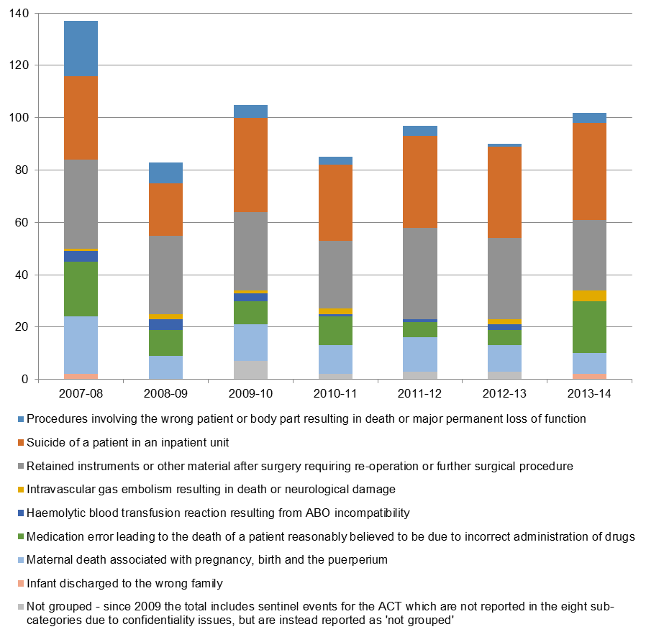

**Sources:** 2007‑08 to 2008‑09, ACSQHC, *Windows into safety and quality in health care*

2009‑10 to 2013‑14, Productivity Commission (2016), *Report on government services*

**Note:** The definition of the sentinel event for procedures involving the wrong patient / wrong body part was revised in 2009 to limit reporting to only those procedures resulting in death or major permanent loss of function.

### 11.5.3 Policy context of pricing and funding models to reduce sentinel events

A policy of not paying for sentinel events already exists in some parts of the Australian health system, as well as in other countries including:

* In 2011‑12 Queensland Health introduced a ‘no payment for never events’ policy that covers six never events, five of which are included on the national agreed list of sentinel events[[12]](#endnote-12);
* In 2013 Healthscope and Bupa agreed that Healthscope would forego payment if any of 14 defined never events occurred in Healthscope hospitals[[13]](#endnote-13);
* In 2007 the US Centers for Medicare and Medicaid Services advised that it would not pay for the additional costs associated with many preventable errors including never events. In 2009 the US Centers expanded this policy to not pay for any costs associated with wrong‑site surgeries. Similar policies are in place across many American states and private insurers.[[14]](#endnote-14)
* In its 2015 policy framework, the English National Health Service indicates that ‘Commissioners should seek to withhold payment for the cost of the episode of care in which a never event has occurred and any subsequent costs involved in treating the consequences of a never event’. [[15]](#endnote-15)

Following the 2016 Heads of Agreement, IHPA has been directed to provide advice on:

A comprehensive and risk‑adjusted model to determine how funding and pricing can be used to improve patient outcomes and reduce the amount the Commonwealth pays for sentinel events… that occur in public hospitals.

### 11.5.4 Approaches to pricing and funding of sentinel events

The approach to pricing and funding of sentinel events is driven by their very low prevalence.

Beginning with pricing approaches, the option of removing episodes with sentinel events from the calculation of the NEP was considered but rejected. This approach would result in a negligibly small reduction in the NEP across all public hospital services. However it would not be transparent or send a meaningful price signal due to the very low prevalence of sentinel events.

Instead, the most fitting approach to sentinel events is a funding approach. IHPA is proposing that, commencing on 1 July 2017, any episode of care (admitted or otherwise) with a sentinel event would not be funded in its entirety (that is, the episode would be an assigned a National Weighted Activity Unit of zero).

IHPA is not proposing to risk adjust for sentinel events. There is no justification for risk adjustment linked to any patient‑based factors such as age and complexity of care. Sentinel events have serious consequences for patients and are regarded as wholly preventable.

The proposal to not pay for sentinel events would apply to all episodes in both activity based funding and block funded hospitals.

| Consultation question  * Do you support the proposal to not fund episodes that include a sentinel event? If not, what are the alternatives and how could they be applied consistently? |
| --- |

IHPA is also seeking feedback on the data source that is used to identify sentinel events. Currently, sentinel events are manually collected and reported by jurisdictions. There is a two‑year time delay in reporting of sentinel events by the Productivity Commission (the 2016 Report on Government Services includes sentinel events data for 2013‑14) with, as noted in the Report on Government Services, variable definitions across jurisdictions of individual sentinel events.

There is currently no reporting of sentinel events in the Admitted Patient Care National Minimum Data Set. IHPA has undertaken preliminary mapping of the national list of eight sentinel events to ICD-10-AM codes in the Admitted Patient Care National Minimum Data Set to investigate whether this might provide an alternative approach to their measurement. A previous study has examined this approach using Victorian inpatient data.[[16]](#endnote-16)

Some issues identified through both IHPA’s analysis and the 2009 Victorian study include:

* Not all sentinel events are able to be captured in the Admitted Patient Care National Minimum Data Set. IHPA could not identify ‘infant discharged to the wrong family’ or ‘retained instruments or other material after surgery requiring re‑operation or further surgical procedure’ (return to operating theatre is not a mandatory data item in the Data Set).
* There are variations in the number of sentinel events identified through the Admitted Patient Care National Minimum Data Set compared with those reported in the Report on Government Services (these variations include both potential ‘under‑counts’ and potential ‘over‑counts’ for individual sentinel events and individual jurisdictions).
* Several factors might explain these variations including: the difficulty in attributing a causal relationship between the incident and the outcome in the Admitted Patient Care National Minimum Data Set; and the time delays associated with coronial declarations of a suicide.

Given the delays and incomplete nature of reporting on sentinel events through the Report on Government Services, IHPA is proposing that jurisdictions be required to apply a flag to any episode including a sentinel event. These episodes would be compared to the sentinel events identified by IHPA using ICD-10-AM codes. IHPA would consult with jurisdictions to ensure that all sentinel events are captured, prior to providing advice to the Administrator for funding purposes.

The Australian Commission on Safety and Quality in Health Care is reviewing the national sentinel events on behalf of all national jurisdictions to enable the development of options for national sentinel events reporting for the future. The review includes:

* oversight by a Sentinel Events Review Steering Committee and working groups as required;
* a literature review and environmental scan;
* consultation with working groups and stakeholders; and
* a final report to be submitted to the Australian Health Ministers Advisory Council in mid-2017.

| Consultation question  * Do you support the proposal to include a sentinel events flag to improve the timeliness and consistency of data that is used for funding purposes? |
| --- |

IHPA’s assessment of the funding option for sentinel events against the criteria is shown below.

**IHPA assessment: No funding for episodes with a sentinel event**

| Criteria | Assessment |
| --- | --- |
| Preventability | Yes |
| Equitable risk adjustment | Yes |
| Proportionality | Partial – there would be no Commonwealth funding for the whole episode including care provided before the sentinel event |
| Transparency | Yes |
| Ease of implementation | Partial – there would be some initial work to flag and agree episodes with a sentinel event |
| The estimated national funding reduction is estimated at approximately $5 million, based on the 102 events reported in the Report on Government Services. | |

| Consultation question  * Do you agree with IHPA’s assessment of this option (not funding episodes with a sentinel event)? |
| --- |

## 11.6 Hospital acquired complications

### 11.6.1 Scope and definition of HACs

Hospital acquired complications (HACs) are complications which occur during a hospital stay and for which clinical risk mitigation strategies may reduce (but not necessarily eliminate) the risk of that complication occurring.[[17]](#endnote-17)

**Table 2** provides the final Australian list of HACs that was developed over the last three years through a clinician‑led process. A detailed specification of the final list of 16 HACs, which includes the relevant ICD-10-AM codes, is available on the [Commission](http://www.safetyandquality.gov.au/?attachment_id=26063)’s website.

**Table 2: List of Hospital Acquired Complications**

| Complication | Identifying diagnoses |
| --- | --- |
| Pressure injury | Stage III ulcer  Stage IV ulcer  Unspecified decubitus ulcer and pressure area |
| Falls resulting in fracture or intracranial injury | Intracranial injury  Fractured neck of femur  Other fractures |
| Healthcare associated infection | Urinary tract infection  Surgical site infection  Pneumonia  Blood stream infection  Central line and peripheral line associated bloodstream infection  Multi‑resistant organism  Infection associated with prosthetics / implantable devices  Gastrointestinal infections |
| Surgical complications requiring unplanned return to theatre | Post‑operative haemorrhage/haematoma requiring transfusion and/or return to theatre  Surgical wound dehiscence  Anastomotic leak  Vascular graft failure  Other surgical complications requiring unplanned return to theatre |
| Unplanned Intensive Care Unit admission | Unplanned admission to intensive care unit |
| Respiratory complications | Respiratory failure including acute respiratory distress syndrome requiring ventilation  Aspiration pneumonia |
| Venous thromboembolism | Pulmonary embolism  Deep vein thrombosis |
| Renal failure | Renal failure requiring haemodialysis or continuous veno‑venous haemodialysis |
| Gastrointestinal bleeding | Gastrointestinal bleeding |
| Medication complications | Drug related respiratory complications/depression  Haemorrhagic disorder due to circulating anticoagulants  Hypoglycaemia |
| Delirium | Delirium |
| Persistent incontinence | Urinary incontinence |
| Malnutrition | Malnutrition |
| Cardiac complications | Heart failure and pulmonary oedema  Arrhythmias  Cardiac arrest  Acute coronary syndrome including unstable angina, ST‑elevation myocardial infarction and Non‑ST‑elevation myocardial infarction |
| Third and fourth degree perineal laceration during delivery | Third and fourth degree perineal laceration during delivery |
| Neonatal birth trauma | Neonatal birth trauma |

While preventability was one of the criteria used in selecting these HACs, the Commission has stressed that a HAC refers to a complication for which clinical risk mitigation strategies may reduce (but not necessarily eliminate) the risk of that complication occurring. The Clinical Reference Group (which had a key role in the development of the HAC list) has similarly noted that some patients will have a high predisposition to the onset of certain complications.

The above factors have implications for the design of pricing and funding options and for two of the assessment criteria (namely, preventability and equitable risk adjustment):

* **Preventability**: As not all HACs are completely preventable in all cases, this suggests that pricing and funding options should result in funding adjustments that are less than 100 per cent of the additional costs incurred in episodes with HACs in some cases. In other words, the preventability assessment criterion would be met in options that do not fully discount or remove all the additional costs of HACs.
* **Equitable risk adjustment**: The increased predisposition of some patients to experiencing a HAC suggests that this has to be allowed for through suitable risk adjustment in developing pricing and funding models.

HACs are generally identified through the use of the Condition Onset Flag (COF, see **Box 3**). The COF is not required in measuring two of the 16 HACs, namely third and fourth degree perineal laceration during birth and neonatal birth trauma.

The COF has been collected in a standardised way on a national basis since 2008 and provides a basis for examining HACs. Several jurisdictions had already implemented this flag, or a similar version, prior to 2008.

In 2014-15, nationally, 92 per cent of acute admitted episodes had a valid reported COF, with reporting improving over recent years. As part of coding audits, some hospitals and jurisdictions also examine the application of the COF to ensure coding is accurate.

The proof of concept study which informed the development of the list of HACs involved a review of medical records across a number of hospitals to determine whether the COF was correctly applied to the medical record. The study founded that the coding was sufficiently accurate to support implementation of measurement and monitoring of HACs.

Notwithstanding this, analysis presented in this section is limited to hospitals that report the COF well, to ensure that the prevalence of HACs is accurately calculated.

As part of the implementation of pricing and funding approaches to safety and quality, IHPA recommends that mechanisms are put in place locally and nationally to audit the recording of HACs and the COF in medical records to continue to drive improvements in accuracy.

**Box 3: The Health Care Record and the Condition Onset Flag**

| When a patient is admitted to hospital, a health care (or medical) record is created. The health care record provides the main source of information about the patient including medical and therapeutic treatment and intervention for the health and wellbeing of the patient during the hospital stay and informs the nature of their on- going health care beyond the hospital stay.  Health care records promote patient safety, continuity of care across time and care settings, and support the transfer of information when the care of a patient is transferred (for example at clinical handover, during escalation of care for a deteriorating patient and transfer of a patient between settings).  At the completion of a patient episode of care, a clinical coder reviews the patient’s health care record. Drawing on documentation from all clinicians who have contributed to the record, including medical, nursing and allied health professionals, clinical coders are responsible for translating the narrative descriptions of diseases, injuries and interventions in a patient’s health care record into standard codes using ICD-10-AM and the Australian Classification of Health Interventions standards.  The coded health care record provides an important source of data for activity based funding and for safety and quality improvement.  A key piece of information is the principal diagnosis code, defined as the diagnosis established to be chiefly responsible for the episode of admitted patient care. The coder may also assign additional diagnoses codes on the basis of information provided by clinicians in the health care record.  An additional diagnosis may be a pre-existing comorbidity or related health problem, or it may be a complication or condition which arises during the patient’s stay in hospital. Each diagnosis code is assigned a Condition Onset Flag (COF) which indicates whether the diagnosis was present on admission to hospital or occurred during the patient’s episode of care. While some diagnoses may not be clearly evident at the time of admission, they are nonetheless coded as being present on admission when it is clear they did not develop after admission (e.g. chronic conditions).  Most HACs are identified through the use of a COF in a patient’s health care record. The COF is a means of differentiating between those conditions that arise during, and those arising before, an admitted patient episode of care. |
| --- |

### 11.6.2 Policy context of pricing and funding models to reduce HACs

Many studies have identified the significant impact for patients and for the Australian health system of HACs. Some examples include:

* Using the Classification of Hospital Acquired Diagnoses, a 2011 study estimated that hospital acquired diagnoses increased the costs of inpatient care by about 17 per cent in Victorian and Queensland public hospitals.[[18]](#endnote-18)
* A 2013 analysis (that was part of the collaborative work program between IHPA and the Commission), also using the Classification of Hospital Acquired Diagnoses, estimated that a hospital acquired diagnosis increased the average costs of a hospital admission by about $9,200, while the incremental impact on length of stay was 5.3 days.[[19]](#endnote-19)

Internationally, similar impacts have been found. A 2016 US study found that US Medicare spent $2,698 less on the average risk- and hospital-adjusted standardised payment at thirty days for patients at high quality hospitals than for patients at low quality hospitals. High quality hospitals were defined as those with low surgical mortality rates and high patient satisfaction scores, and low quality hospitals were defined as the opposite. The findings suggest that when patients receive care at better hospitals, not only is their better care related to fewer deaths and greater patient satisfaction, but that it also may translate into lower costs.[[20]](#endnote-20)

In its 2012‑13 Pricing Framework, IHPA noted that other countries were implementing a range of approaches to incorporating quality into pricing including not paying for the costs of HACs. Approaches to reducing HACs include providing data to clinicians on comparative rates of HACs as well as adjusting the price for episodes including a HAC. Some examples of such policies include:

* In 2008 US Medicare implemented a policy of not paying for any of eight HACs. Under this policy, Medicare pays for the costs associated with the original diagnosis for which the patient was admitted, but does not pay for the extra costs of the HACs.[[21]](#endnote-21) The *Patient Protection and Affordable Care Act* introduced a separate program to reduce HACs under which hospitals that rank in the worst‑performing quartile with respect to risk‑adjusted HAC quality measures have their payments reduced.[[22]](#endnote-22) As part of the HAC Reduction Program, hospital‑specific information on HACs is publicly reported on the government’s Hospital Compare [website](https://www.medicare.gov/hospitalcompare/search.html).
* In 2016 the Royal Australasian College of Surgeons (in association with Medibank) released a report on surgical variance that included rates of HACs per 1,000 separations for selected surgical procedures.[[23]](#endnote-23) This report drew on the Commission’s initial list of high‑priority complications. The report showed variations in the HAC rate (unadjusted for casemix) across surgeons that provided care to Medibank‑funded patients in private hospitals across Australia.

IHPA is similarly proposing a mix of strategies to reduce HACs including:

* providing data through its National Benchmarking Portal on hospital‑specific rates of HACs for information and action by clinicians and managers in public hospitals; and
* implementing pricing or funding models that result in payment reductions for HACs.

### 11.6.3 Incidence and patterns of HACs

IHPA has analysed the incidence of HACs in public hospitals across a range of variables, as well as examining differences in episodes with and without HACs.

The analysis spans acute, subacute and non-acute care for hospitals which report the COF well. Same-day chemotherapy and dialysis episodes have been excluded due to jurisdictions’ differing admission policies for these types of care (noting that there are very few HACs present in chemotherapy and dialysis episodes – 58 in a total of 1,145,712 episodes nationally in 2014-15). Since complications relating to mental health care are not included in the current HAC list, this patient cohort has also been removed from the following analysis.

One of the 16 HACs on the national list – unplanned ICU admissions – is not included in the following analyses as this measure is not able to be captured in existing data. However, work is underway to enable it to be captured and reported in the future, and therefore included in future iterations of a pricing and/or funding approach. In 2015, a definition of unplanned admission to ICU not following surgery was included in the [High priority hospital complications (patient clinical deterioration) National best practice data set (NBPDS)](http://meteor.aihw.gov.au/content/index.phtml/itemId/586966) with work ongoing to include it within the National Minimum Data Set.

In 2014‑15 key findings in relation to HACs included:

* There were 107,828 acute admitted episodes with at least one HAC, equivalent to a HAC rate of 2.91 HACs per 100 acute admitted episodes.
* There were also 13,315 subacute admitted episodes with at least one HAC, equivalent to a rate of 9.58 HACs per 100 subacute admitted episodes.

The average length of stay is about 1.2 days longer in acute admitted episodes with a HAC than in acute admitted episodes without a HAC after adjusting for age and complexity, using Australian Refined-Diagnosis Related Groups.

**Figure 2** shows raw HAC rates in acute admitted episodes by age group. HAC rates clearly increase with patient age. For example, the HAC rate per 100 acute admitted episodes in 80‑84 year olds is 5.87, about double the average population rate of 2.91. The type of HACs experienced also varies with age; birth‑related HACs occur among women of child‑bearing age, while the rates of pressure injuries rise significantly with increasing age.

**Figure 3** shows raw HAC rates in acute admitted episodes by hospital peer group. Rates are highest in principal referral hospitals (3.35 HACs per 100 episodes) and large regional and remote hospitals (2.43).

However, the pattern of total HACs among acute admitted episodes reflects the volume of patients treated in different types of hospitals. In 2014‑15 principal referral hospitals accounted for 71.8 per cent of all acute admitted episodes with a HAC.

Rehabilitation hospitals have been excluded from this graph given the very small number of acute admitted patients in these services.

**Figure 2: Raw HAC rates per 100 acute admitted episodes by age group, public hospitals, subset of the Admitted Patient Care National Minimum Data Set, 2014‑15**

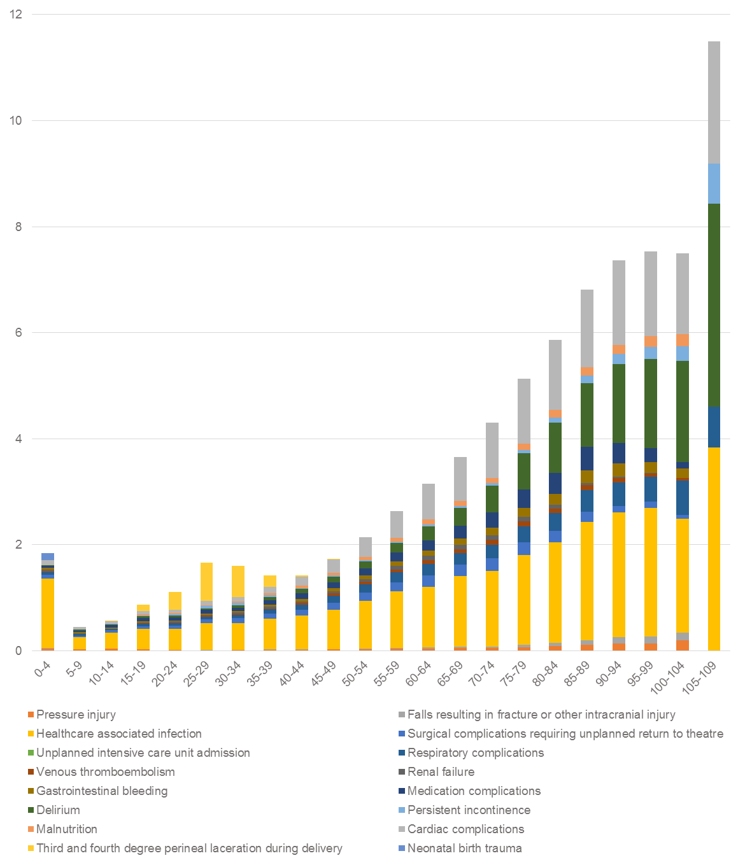

**Figure 3: Raw HAC rates per 100 acute admitted episodes by hospital peer group, public hospitals, subset of the Admitted Patient Care National Minimum Data Set, 2014‑15**

**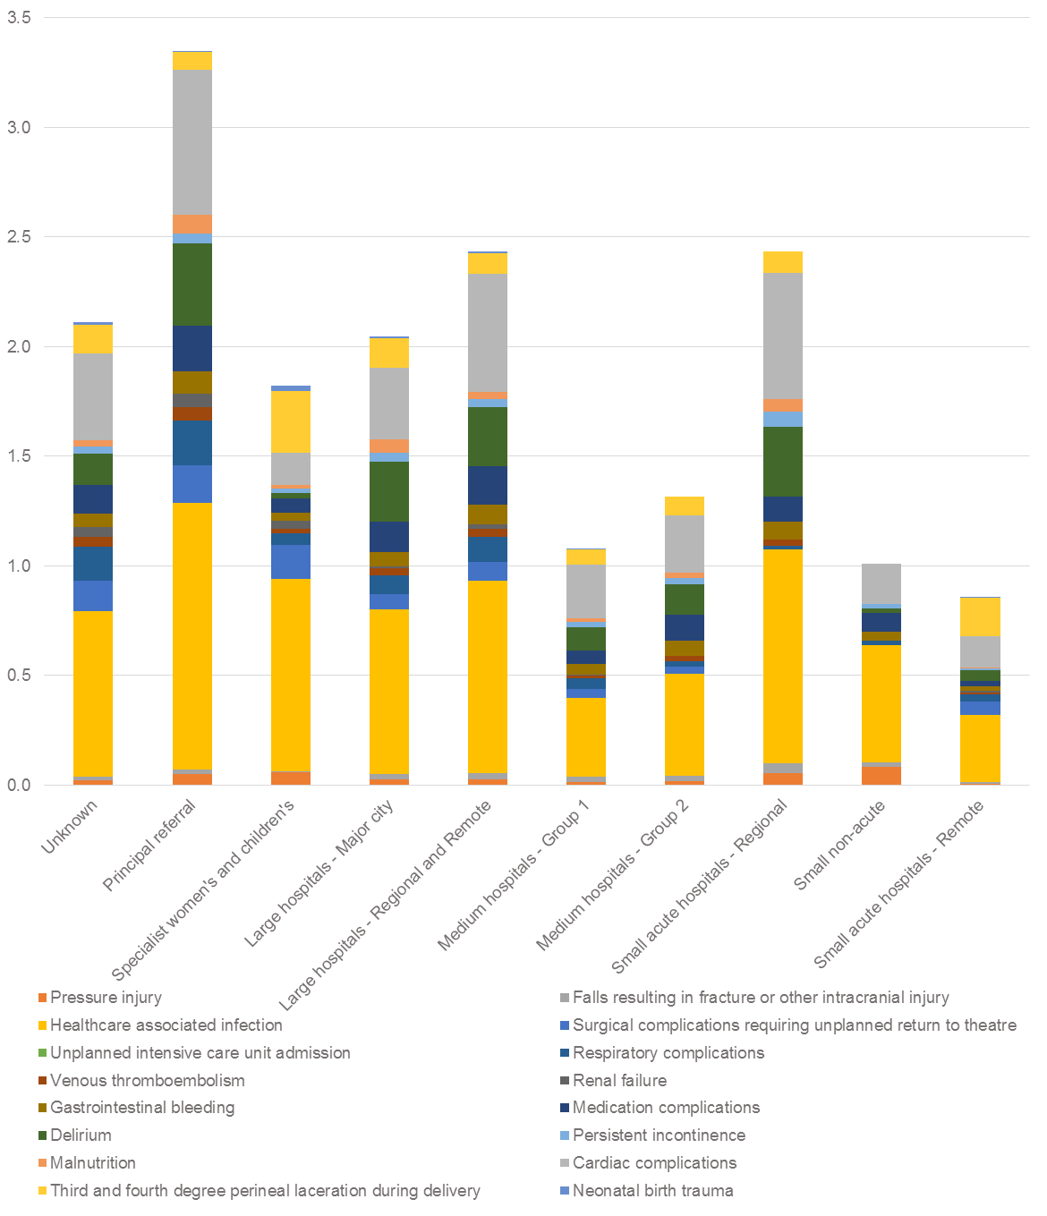**

### 11.6.4 Overview of approaches to pricing and funding of HACs

The above analysis confirms that HACs are much more prevalent than sentinel events (with sentinel events, by definition, comprising only the most serious adverse events).

The higher prevalence of HACs compared to sentinel events supports the development of options that adjust funding based on comparing rates of HACs across hospitals. Such options are not suitable for low volume events such as sentinel events, where the only possible approach is to adjust funding for individual episodes. The prevalence of HACs allows the development of options at both the hospital‑level and episode‑level.

Pricing approaches result in changes to the NEP. In the case of HACs, an obvious pricing option would be to remove all episodes with a HAC from the cost and activity data prior to calculating the NEP. The removal of these high‑cost HAC episodes would result in a lower NEP. This reduced NEP would then impact on the funding received by all public hospital services, regardless of the presence or absence of a HAC.

However, this on its own does not meet at least four of the assessment criteria – preventability, equitable risk adjustment, proportionality and transparency. The reduced funding that applies to all public hospital services is not transparently linked to the lower quality of some episodes, nor is it proportional to the costs of individual episodes with and without a HAC. Moreover, removing the whole episode activity and costs for all episodes with a HAC does not adequately respond to the preventability and equitable risk adjustment criteria. Accordingly, IHPA is not putting forward a stand‑alone pricing approach for HACs.

Turning to funding approaches, it was previously noted that funding approaches do not affect the level of the NEP but they change its implementation. What this means in practice is that funding approaches can be used directly to target adjustments to the funding received for individual episodes with a HAC or hospitals with higher than expected rates of HACs. This can be achieved through adjustments that change the assignment or calculation of the National Weighted Activity Unit for individual episodes or calculate funding adjustments that apply at the level of hospitals.

The targeting afforded by funding approaches, together with the flexibility to consider both episode‑level and hospital‑level funding adjustments, allows the development of more options that can potentially satisfy the assessment criteria. As a result, IHPA is putting forward two funding options for HACs for consultation purposes.

Finally, IHPA has also considered approaches that combine pricing and funding within an option.

### 11.6.5 Episode‑level, funding approaches to HACs

Episode-level funding approaches are implemented at the individual patient level.

Consideration of episode-level options has been shaped by the much higher prevalence and costs of HACs than sentinel events. For sentinel events, it was possible to develop an option that involved not paying for episodes with a sentinel event (an estimated national funding impact of less than $5 million). In contrast, the national funding impact of not paying for episodes with a HAC would be about $3.1 billion. Such an approach would not meet the proportionality assessment criterion as it would result in hospitals being penalised for costs that are greater than the actual costs of HACs. Accordingly, the next option limits the funding adjustment so that it is, more closely, commensurate with the additional costs of HACs.

Consideration was also given to a funding option in which episodes containing a HAC with a length of stay that resulted in a long stay per diem payment no longer receiving this payment. This was considered on the basis that acute admitted episodes with at least one HAC have, on average, a longer length of stay than episodes with no HACs.

However, analysis of these episodes showed that they are clustered in a small number of DRGs, with half of the potential funding impact affecting just 25 DRGs. Implementing this approach would therefore have a skewed impact on a small number of DRGs, and therefore would not meet IHPA’s assessment criterion of proportionality.

#### Option 1: Remove the HAC so that it does not contribute to DRG assignment

In some cases a HAC can lead to a more complex Diagnosis Related Group (DRG) being assigned to a patient, and as a result the hospital receives increased funding. For example, the presence of a hospital acquired pressure injury for a patient receiving a hip replacement may result in a more complex DRG being assigned, leading to increased funding of $8,314 in 2016‑17.

Under Option 1, the HAC‑related diagnoses would be ignored during the DRG assignment process, ensuring that a HAC does not result in a higher complexity DRG being assigned. By removing the HAC and regrouping, the expectation is that some episodes will be grouped to a lower complexity DRG and therefore not receive additional funding due to the occurrence of a HAC.

Of the 107,828 acute admitted episodes with at least one HAC in 2014‑15, 21,416 (or 20 per cent) lie within the lowest complexity DRG and therefore cannot change DRG assignment. 15 per cent were assigned to a less complex DRG (within an Adjacent DRG) following the removal of the HAC‑related diagnoses, which results in reduced funding. The remaining 85 per cent did not change DRG. Removing HAC‑related diagnoses does not change the DRG assignment for all episodes with a HAC as there are likely to be other complications or comorbidities contributing to DRG assignment. This issue is well‑documented in both Australian and international studies. [[24]](#endnote-24),[[25]](#endnote-25),[[26]](#endnote-26) It has prompted debate on alternative approaches including withholding outlier payments or not paying for subsequent procedures in the same admission that are causally linked to the HAC diagnosis. Conversely, this means that currently in 85 per cent of cases there is no direct increase in the funding paid to hospitals for episodes containing a HAC despite additional costs being incurred by the hospital.

**IHPA assessment: Option 1 (remove the HAC so that it does not contribute to DRG assignment)**

| Criteria | Assessment |
| --- | --- |
| Preventability | Yes |
| Equitable risk adjustment | Yes – patient risk adjustment is not required as the HAC funding reduction only applies to a minority of episodes |
| Proportionality | Partial – reduction in Commonwealth funding only applies to some episodes with a HAC |
| Transparency | Yes |
| Ease of implementation | Yes |
| The estimated national funding impact is $148 million. | |

| Consultation questions  * What are the advantages and disadvantages of Option 1 which reduces funding for some acute admitted episodes with a HAC? * Do you agree with IHPA’s assessment of this option? |
| --- |

### 11.6.6 Hospital‑level, funding approaches to HACs

The next approach is a funding option that is calculated at the hospital‑level, rather than through making changes to individual episodes.

#### Option 2: Funding adjustments made on the basis of differences in HAC rates across hospitals

Option 2 involves measuring HAC rates (number of episodes containing one or more HACs per 100 admitted episodes) for each hospital, with adjustments to funding determined on the basis of differences in HAC rates between hospitals.

Although this type of approach has not previously been used by IHPA, it is explicitly mentioned in the 2016 Heads of Agreement and the Direction (in relation to avoidable hospital readmissions).

IHPA has considered whether HAC rates should be measured at the hospital or LHN level. IHPA is proposing to measure HAC rates at the hospital level for the following reasons:

* **Transparency**: Hospital‑level benchmarking of HAC rates will provide an enhanced opportunity for hospital staff (including clinicians) to benchmark and understand the factors underpinning differences in HAC rates. Hospital‑level approaches are more ‘direct’ and therefore more transparent and actionable, than measuring differences in HAC rates at the level of LHNs.
* **Equitable risk adjustment**: Risk adjusting at the hospital level ensures that differences in patient cohort risk profiles are fully accounted for in the risk adjustment model.

Funding adjustments could then be calculated by considering a funding reduction for hospitals that exceed a specified HAC rate. For example, funding reductions could be targeted to the quartile of hospitals with the highest HAC rates or to all hospitals with HAC rates above the national average rate.

In terms of risk adjustment, there are a variety of approaches that could be used within Option 2 including:

* no risk‑adjustment – each hospital is compared against all other hospitals on the basis of their ‘raw’ HAC rates;
* stratification of hospitals within states – hospitals are compared on raw HAC rates but are ranked within states;
* stratification of hospitals within peer groups – hospitals are compared on raw HAC rates but are ranked within peer groups;
* risk adjustment – each hospital is compared nationally against all other hospitals on the basis of HAC rates that are risk‑adjusted for age and patient complexity.

IHPA is undertaking analysis to test the statistical validity of these different approaches. As noted earlier, the purpose of risk adjustment would be to ensure that hospitals treating a higher share of patients who are at high‑risk of developing HACs are not disadvantaged.

**IHPA assessment: Option 2 (funding adjustments made on the basis of differences in HAC rates across hospitals)**

| Criteria | Assessment |
| --- | --- |
| Preventability | Yes |
| Equitable risk adjustment | Yes |
| Proportionality | Partial – requires an estimation of the quantum of the funding adjustment and how it will be applied |
| Transparency | Yes |
| Ease of implementation | Yes |
| The estimated national funding impact of this option depends on where the threshold is set and how much is deducted.  For example, if ten per cent of the NWAU associated with HAC episodes in hospitals with risk adjusted rates in the top quartile is deducted, the estimated national funding impact is approximately $275 million. Alternatively, if a deduction is made from any hospital with a HAC rate above the median, the estimated national funding impact is approximately $289 million. | |

| Consultation questions  * What are the advantages and disadvantages of Option 2 that adjusts funding to hospitals on the basis of differences in their HAC rates? * Do you agree with IHPA’s assessment of this option? * What are the advantages and disadvantages of the approaches to risk adjustment? |
| --- |

### 11.6.7 Combined pricing and funding approaches to HACs

As previously noted, IHPA is not putting forward a stand‑alone pricing option that would remove HACs from the calculation of the NEP. In isolation, this option is a very blunt approach that fails to meet most of the assessment criteria used by IHPA to design and review the options.

However, IHPA is considering approaches that blend pricing and funding options to take advantage of the relative strengths of these quite different options.

#### Option 3: A quality‑adjusted NEP with funding incentives for hospitals with the lowest HAC rates

This option has two main components that correspond to the pricing approach and the funding approach.

First, a ‘quality‑adjusted NEP’ is calculated that is based on removing all episodes with HACs so that these episodes do not feed into the determination of the NEP. This means that the amount paid by the Commonwealth for all public hospital services (irrespective of whether the service includes a HAC or not) is adjusted downwards.

Second, this funding reduction is used (either fully or partially) to provide positive funding adjustments (incentives) directly to hospitals that have the best performance on HAC rates. A variation on this approach would see the funding returned to individual states that could then choose to invest the funding on safety and quality programs.

This option incorporates a mix of positive and negative incentives. The system‑wide reduction in the NEP across all public hospital services signals that the additional costs of poor quality care should not be inbuilt in the NEP, with the ‘quality‑adjusted NEP’ reflecting the average cost of good quality care. The impact of the reduction in the NEP is experienced across all types and settings of public hospital services. This is consistent with a view that quality improvement requires senior clinical and management leadership across the whole LHN.

However, the absence of a targeted funding reduction that applies to episodes with a HAC might be considered unfair by some stakeholders. In this option, this is balanced by the capacity for hospitals to achieve positive funding adjustments if their performance on HAC rates is better than other hospitals.

**IHPA assessment: Option 3 (a quality‑adjusted NEP with funding incentives for hospitals with the lowest HAC rates)**

| Criteria | Assessment |
| --- | --- |
| Preventability | Yes |
| Equitable risk adjustment | Yes |
| Proportionality | Yes |
| Transparency | Yes |
| Ease of implementation | Yes |
| The estimated national funding impact of this option depends on the proportion of the pool to be redistributed.  For example, if 50 per cent of the pool determined by quality adjusting the NEP is redistributed then the estimated national funding impact is approximately $243 million. | |

| Consultation questions  * What are the advantages and disadvantages of Option 3 that combines funding incentives and penalties? * Do you agree with IHPA’s assessment of this option? * Are there any other pricing or funding options that IHPA should consider in relation to HACs? |
| --- |

### 11.6.8 Responding to Condition Onset Flag data quality issues

In assessing these options, one important issue is that the quality of COF reporting is substandard for some hospitals. This means that it is not possible to accurately measure HAC rates for a small number of hospitals.

The exclusion of some hospitals with poor quality COF data from the measurement of HAC rates creates potential inequities across hospitals. Hospitals that report the COF accurately are potentially subject to a reduction in funding, while hospitals with poor quality COF data could potentially be exempt from funding adjustments.

IHPA notes that a national standard for reporting of the COF has existed since 2008 and there has also been significant recent improvement in rates of COF reporting. In that context, and in order not to create incentives for under‑reporting of the COF, IHPA is proposing that hospitals with poor quality COF reporting would be subject to funding reductions that would be the same as hospitals (with good quality COF data) that had HAC rates in excess of the threshold for funding adjustments.

| Consultation question  * How should IHPA treat hospitals with poor quality COF reporting? |
| --- |

### 11.6.9 National Benchmarking Portal

IHPA recently launched the National Benchmarking Portal which currently allows users to compare costs and activity data from public hospitals across the country. It provides the ability, for the first time, to compare differences in activity, costs and efficiency at similar hospitals, using the National Weighted Activity Unit.

Much of the collaborative work between IHPA and the Commission over the last four years highlighted the value of providing comparative information on safety and quality back to clinicians. Accordingly, information on HACs for each hospital will be included in the National Benchmarking Portal.

This will enable comparison of HACs by jurisdiction, LHN and hospital at the DRG, principal diagnosis and procedure level, as well comparisons using Service Related Groups.

## 11.7 Avoidable hospital readmissions

The third safety and quality measure on which IHPA has been requested to provide advice on pricing and funding models is avoidable hospital readmissions. The commitments in the 2016 Heads of Agreement are as follows:

The Parties agree to work together to reduce avoidable readmissions to hospital within 28 days of discharge, with a particular focus on avoidable readmissions within 5 days of discharge, for conditions arising from complications of the management of the original condition that were the reason for the patient’s original hospital stay.

The Parties, in conjunction with the ACSQHC and the IHPA, will develop a comprehensive and risk‑adjusted strategy and funding model that will adjust the funding to hospitals that exceed a predetermined avoidable readmission rate for agreed conditions and the circumstances in which they occur by 1 July 2017.

The Direction further specifies the Parties intention ‘to focus only on avoidable hospital readmissions within 5 days of discharge’.

### 11.7.1 Policy context of pricing and funding models to reduce avoidable hospital readmissions

Unplanned hospital readmissions can be a signal of issues with the effectiveness, continuity and integration of care provided to patients. In 2009 Australian Health Ministers agreed that hospitals should routinely monitor a set of ‘hospital‑based outcome indicators’.[[27]](#endnote-27) One of these indicators was unplanned or unexpected hospital readmission of patients discharged following management of acute myocardial infarction, knee replacement, hip replacement, or paediatric tonsillectomy and adenoidectomy. The Commission has highlighted the value in undertaking report‑review‑act cycles for indicators such as unplanned readmissions to improve the safety and quality of care.

Another policy context for reviewing readmissions is to improve the management and outcomes of care for patients with chronic diseases. Some of the focus is on potentially preventable hospitalisations and ensuring that patients access adequate primary health care in the community. Measuring and understanding variation in readmissions is also relevant to improving care pathways for patients who are at high risk of admission to hospital (such as patients with chronic obstructive pulmonary disease or poorly managed heart failure).[[28]](#endnote-28)

A third factor driving interest in measuring and reducing avoidable readmissions is to align funding models and incentives with the goal of high quality care for patients. The implementation of activity based funding may elicit concerns about the potential for premature discharge of patients. Strategies in response to these concerns include extending responsibility through the use of ‘readmission windows’ and developing bundled funding models.

Strategies to tackle avoidable hospital readmissions are of keen interest to public and private healthcare providers, private health insurers and governments. Health insurers and governments have introduced programs (such as heath coaching, telephone support, case management and other tools) to reduce unplanned hospital readmissions.

### 11.7.2 Definition of avoidable hospital readmissions

The first issue for advice and consultation is the definition of avoidable hospital readmissions. Putting the issue of timeframes to one side, there are likely to be many different views about how to determine what constitutes an avoidable hospital readmission.

Starting with the broadest possible interpretation and moving to narrower definitions, avoidable hospital readmissions comprise at least three options:

1. **All unplanned readmissions:** this approach requires the ability to distinguish between planned (or expected) readmissions and unplanned readmissions. Examples of planned readmissions that could be readily identified in existing data include chemotherapy, dialysis and birth‑related admissions. While admitted episodes include assignment of an urgency code (emergency, elective, not assigned, not known), this concept does not equate to unplanned (or avoidable) readmissions.

*Status*: There is currently no agreement on a comprehensive definition, or listing of conditions, that constitute unplanned readmissions. The further specification of this concept would require clinical input and would require changes to national minimum data sets to capture this information consistently.

1. **Unplanned hospital readmissions for selected surgical procedures:** Governments committed through the *National Healthcare Agreement 2012* to report on the performance indicator of ‘unplanned hospital readmission rates’. The subsequent development of this indicator defined it more narrowly to comprise ‘unplanned and unexpected hospital readmissions to the same public hospitals within 28 days for selected surgical procedures’.

This indicator limits the count of the number of avoidable hospital admissions in two ways. First, it constrains the count of readmissions to only those which followed an original admission that included one of the following surgical procedures (knee replacement, hip replacement, tonsillectomy and adenoidectomy, hysterectomy, prostatectomy, cataract surgery, appendectomy). Second, it limits the count of readmissions following these surgical procedures to only readmissions where the principal diagnosis indicates an adverse event. These diagnosis codes are not the same as those used in the HAC list. Instead, they include diagnoses such as post‑procedural disorders, complications of devices, implants and grafts and other complications of procedures.

*Status*: This indicator is currently being measured and reported by the AIHW. It clearly represents a subset of avoidable hospital admissions as it is limited only to those following a surgical procedure and it excludes all readmissions after medical admissions.

1. **Readmissions that are causally related to an initial admission, where the initial admission involved a hospital acquired complication:** Using this approach, the initial admission must involve a HAC and the readmission must include a diagnosis that is related to the HAC experienced during the first admission.

*Status*: This indicator is not currently being measured. There is agreement on the HAC list that could be used to define the initial admission. IHPA has undertaken some preliminary work to identify the principal or secondary diagnosis in the readmission that could be associated with the occurrence of a HAC in the first admission. The specification of the causally related readmissions would benefit from clinical input.

These three approaches do not represent the whole universe of options for defining avoidable hospital admissions. However Options 2 and 3 relate to existing developmental work, while the first option represents a common understanding of the concept.

### 11.7.3 Timeframe for measuring avoidable hospital readmissions

The most suitable timeframe in which avoidable hospital readmissions should be measured is likely to vary depending on which definition of avoidable hospital readmissions is accepted. For example, readmissions subsequent to a HAC in the original admission may occur within different timeframes than readmissions following a surgical procedure.

The 2016 Heads of Agreement identifies two timeframes (within five days or within 28 days of discharge) as the basis for measuring avoidable hospital readmissions. However, the Direction is more specific indicating that the focus should be on readmissions within five days.

The Direction also requires that the advice on options provided by IHPA should prioritise patient outcomes and be evidence‑based. In general, IHPA notes that there is limited evidence to support the use of fixed timeframes for measuring readmissions. Anecdotally, most Australian jurisdictions have used either 28 days or 30 days in measuring hospital readmission rates.

An alternative to using fixed timeframes across all readmissions is to vary the measurement period according to the clinical condition and any supporting evidence as to the timeframe in which complications relating to the original admission might be expected to occur. Condition‑specific readmission periods have been proposed, or are being used, in a range of situations including:

* In NSW the unplanned hospital readmission indicator which is included in Local Health Network (LHN) service agreements is based on 28 days from discharge. However, the NSW Bureau of Health Information has proposed that it is preferable to separately assess the results for patients with particular conditions and patients undergoing specific procedures to focus on the clinically relevant acute phases of patient care. The Bureau has developed risk‑adjusted readmission measures with a follow‑up period of 30 days for five clinical conditions (acute myocardial infarction, ischaemic stroke, congestive heart failure, pneumonia and hip fracture surgery), while it uses a longer follow‑up period of 60 days for two elective surgery procedures (hip replacement and knee replacement).[[29]](#endnote-29)
* In the US several groups of researchers have examined readmission rates subsequent to initial admissions that included a HAC.[[30]](#endnote-30),[[31]](#endnote-31) A critical element was seeking clinical review on readmission windows, the time frames within which condition‑specific readmissions could plausibly occur as a result of complications in the initial admissions. Examples of condition‑specific readmission windows identified by US clinicians were:
* one day for acute complications of poor inpatient glycemic control;
* seven days for air emboli arising from a medical or surgical procedure; incompatible blood transfusion; catheter‑associated urinary tract infections; and vascular catheter‑associated infections;
* 30 days for deep vein thrombosis or pulmonary emboli following hip or knee joint replacement surgery; and
* 183 days for foreign object retained after surgery; mediastinitis following coronary artery bypass graft surgery, fractures and other physical injuries sustained during inpatient care; infections arising from specific orthopaedic joint procedures or bariatric procedures; and Stages III & IV pressure ulcers.

| Consultation questions  * What approach is supported for setting timeframes within which avoidable hospital readmissions are measured? * Is there Australian evidence (including guidelines or recommendations) that could be used to implement condition specific readmission timeframes? |
| --- |

### 11.7.4 Readmissions to the same hospital or other hospitals

In the absence of unique patient identifiers, most existing measurement and reporting focusses on readmissions to the same hospital. For example, AIHW reporting against the National Healthcare Agreement indicator of readmissions for selected surgical procedures is limited to readmissions to the same hospital. Even with this limitation, the AIHW reported that it was not possible to identify readmissions for WA in the dataset.

An expanded set of readmissions could be identified through use of the Medicare PIN (a de‑identified unique identifier derived from the Medicare number). This could allow identification of readmissions to other hospitals within the same LHN or other LHNs.

However the measurement of readmissions to hospitals outside the LHN (where the original admission occurred) could be problematic from a pricing and funding model perspective. It would create additional complexity in the calculation of readmission rates and in determining adjustments to pricing and funding across different hospitals and different LHNs.

Accordingly, IHPA is proposing that avoidable hospital readmissions (for the purposes of pricing and funding models) will be measured through the Medicare PIN on the basis of readmissions to any hospital within the same LHN.

| Consultation question  * Is there support for pricing and funding models to be based on avoidable hospital readmissions within the same LHN? |
| --- |

### 11.7.5 Incidence of avoidable hospital readmissions

The volume of identified avoidable hospital admissions will differ according to decisions made about each of the elements discussed above, namely:

* the breadth of scope of what is defined as an avoidable hospital admission and whether it is based upon subsets of the populations of both original and subsequent admissions;
* the timeframes used to capture readmissions; and
* whether readmissions are defined as being to the same hospital, the same LHN or other hospitals and LHNs.

Pending consultation feedback on these issues, IHPA is not able to accurately quantify the number of episodes and the pricing and funding impact. The requirement to consult and gain consensus on these issues also means that pricing and funding options for avoidable hospital readmissions are less fully‑developed at the moment than is the case for pricing and funding options for sentinel events and HACs. As a result, IHPA has not assessed pricing and funding options for avoidable hospital readmissions using the assessment criteria specified previously. This will occur in the future once there is greater clarity on each of the above identified elements.

For now, some indicative estimates on the incidence of avoidable hospital readmissions (and the consequential funding impact) are as follows:

* For Option 2 (measuring readmissions for complications related to any of seven selected surgical procedures) and within 28 days and to the same hospital, the AIHW has reported a total of 2,374 such readmissions in 2014‑15.[[32]](#endnote-32) IHPA identified 2,512 such readmissions in 2013‑14 data, with an estimated $13.2 million in total funding.
* For Option 3 (measuring readmissions where the initial admission involved a HAC) and within 28 days and to the same hospital, IHPA has identified a total of 12,864 readmissions in 2013‑14. 625 were for readmissions where the principal diagnosis was directly associated with the HAC in the initial admission. These 625 episodes account for approximately $5.3 million in potential funding. If the readmission window is limited further to five days, 289 episodes are identified, with approximately $2.3 million in potential funding.

### 11.7.6 Risk adjustment and approach to pricing and funding of avoidable hospital readmissions

The final element is the approach to pricing and funding of avoidable hospital readmissions including the basis of any risk adjustment. The 2016 Heads of Agreement identified an approach where funding would be adjusted for any hospitals that exceed a predetermined rate of avoidable hospital readmissions.

There are two broad approaches to pricing and funding of avoidable hospital readmissions:

1. to reduce funding at the level of hospitals which exceed a predetermined rate of avoidable hospital readmissions; or
2. to reduce funding for each episode in which an avoidable hospital readmission occurs.

The first approach (specified in the 2016 Heads of Agreement) would be most suitable if avoidable hospital readmissions were broadly defined, resulting in a high volume of such admissions. In this situation, the funding adjustment would be related to variations in the rates of these readmissions across hospitals. Such variation suggests that there is scope for hospitals with above average rates of avoidable hospital readmissions to reduce their rate.

If this first approach is adopted, IHPA’s proposal (subject to further analysis following agreement on the definition of avoidable hospital readmissions) would be to include a funding adjustment at relevant hospitals for admissions in excess of the average rate across all hospitals.

However, if avoidable readmissions are limited to those directly associated with HAC in the initial admission, then the small number of episodes (289 if the readmission window is limited to five days) means that it would not be feasible to risk adjust.

### 11.7.7 Implementation of an approach for avoidable readmissions

Unlike sentinel events and HACs, the Heads of Agreement and Direction to IHPA are silent on an implementation timeframe for an approach for avoidable readmissions.

This consultation paper seeks views on the best approach for identifying avoidable readmissions. Noting responses, IHPA intends to provide advice to the Council of Australian Governments Health Council on the earliest timeframe that a pricing and funding approach could be implemented.

| Consultation question  * When should a pricing and funding approach for avoidable readmissions be implemented? |
| --- |

## 11.8 Implementing a pricing and funding approach

The Direction to IHPA to undertake this work requires that IHPA “must ensure that any option developed reflects the Parties’ intention to send a signal at the health system level of the need to reduce instances of preventable poor quality patient care, while supporting improvements in data quality and information available to inform clinicians’ practice”.

The Direction also requires that IHPA has regard to a number of design principles, including that “options are consistent with whole‑of‑system efforts to deliver improved patient outcomes”. This recognises that pricing and funding approaches need to complement, and be supported by, the work being undertaken by states and territories as system managers.

This is consistent with international experiences that note that any incentives need to be substantial enough to drive change, and need to be delivered to the level of the clinical department to focus efforts and effect this change, with local implementation, monitoring and information sharing needed.

Critically, the success of a safety and quality pricing mechanism is dependent on national, state, and local health systems working together to support implementation of the model and ensure that it is working to improve safety and quality across all services with clinicians and system managers working in partnership.

This includes efforts to ensure that any pricing and/or funding signal reaches the health system level, and that mechanisms are put in place locally and nationally to audit the recording of safety and quality issues to drive improvements in accuracy and ensure that there is no ‘gaming’ of the system. IHPA will also work with its Clinical Advisory Committee to monitor any impact that pricing and funding for safety and quality may have on hospitals willingness to admit cohorts of patients with higher risks of developing hospital acquired complications.

### 11.8.1 Back-casting the effect of changes

Finally, the National Health Reform Agreement requires that where IHPA makes any significant changes to activity based funding classification systems or costing methodologies, the effect of such changes must be back-cast to the year prior to their implementation for the purpose of the calculation of Commonwealth growth funding. IHPA is to consider transitional arrangements when developing new methodologies.

As the Commonwealth’s funding is based on both the change in volume of weighted services and growth in the National Efficient Price and the National Efficient Cost, it is imperative that the previous year’s pricing model accurately reflects the relevant year’s data.

In developing a pricing and funding approach for safety and quality, IHPA will give consideration to how the effect of these changes is back-cast.

### 11.8.2 Evaluation

In its advice to the Council of Australian Governments, IHPA will give consideration to an appropriate mechanism to evaluate the effectiveness of a pricing and funding approach.

| Consultation questions  * What do you think are the most important considerations for implementation of pricing and funding approaches for safety and quality? * Do you agree that IHPA would need to back-cast the impact of introducing new measures for safety and quality into the pricing and funding models? |
| --- |

# Appendix 1: Direction to IHPA

This is a PDF of the Direction from Sussan Ley, Minister for Health and Aged Care, to the Independent Hospital Pricing Authority on the performance of its functions under section 226 of the National Health Reform Act 2011 on 29 August 2016. 

(i) The Independent Hospital Pricing Authority, in relation to its functions under s. 131(1)(a) and (h) of the Act must advise the Commonwealth, the States and the Territories (the Parties) on an option or options for: 

(a) a comprehensive and risk-adjusted model to determine how funding and pricing can be used to improve patient outcomes and reduce the amount the Commonwealth pays for sentinel events, and a set of preventable hospital acquired conditions, defined by the Australian Commission on Safety and Quality in Health Care and agreed by the Parties, that occur in public hospitals; and

(b) a comprehensive and risk-adjusted strategy and funding model to reduce avoidable readmissions to hospital that will adjust the funding to hospitals that exceed a predetermined avoidable readmission rate for an agreed set of conditions and the circumstances in which they occur.

(ii) In performing the activity referred to in Item 1(i)(a), the Independent Hospital Pricing Authority must have regard to the Parties’ intention to:

(a) implement a model for sentinel events from 1 July 2017; and

(b) implement a model for an agreed set of preventable hospital acquired conditions not before 1 July 2018, with a preceding shadow year.

(iii) In performing the activity referred to in Item 1(i)(b), the Independent Hospital Pricing Authority must have regard to the Parties’ intention to focus only on avoidable hospital readmissions within 5 days of discharge for conditions referred to in Item 1(i)(b) arising from complications of the management of the original condition that was the reason for the patient’s original hospital stay.

(iv) In performing the activities referred to in Item 1(i), the Independent Hospital Pricing Authority must ensure that any option developed reflects the Parties’ intention to send a signal at the health system level of the need to reduce instances of preventable poor quality patient care, while supporting improvements in data quality and information available to inform clinicians’ practice.

(v) In performing the activities referred to in Item 1(i), the Independent Hospital Pricing Authority, should give consideration to any probable known costs and expected benefits.

(vi) The Independent Hospital Pricing Authority must provide the advice referred to in Item 1(i) of this Direction to COAG Health Council by 30 November 2016. 

2. Matters the Independent Hospital Authority is to have regard to

(i) In performing the activity described in Item 1 of this Schedule, the Independent Hospital Pricing Authority must have regard to the matters set out in s. 131(3) of the Act.

(ii) In addition, in relation to performing the activity described in Item 1 of this Schedule, the Independent Hospital Pricing Authority must, under section 132 of the Act, have regard to the Heads of Agreement on Public Hospital Funding, signed by the Parties on 1 April 2016. 

(iii) In providing the advice described in Item 1 of this Schedule, the Independent Hospital Pricing Authority is to have regard to the following design principles:

(a) Options prioritise patient outcomes and are evidence based:

i. Better patient health outcomes underpin the design and implementation of reform.

ii. The design and implementation of pricing and funding models for safety and quality, and reducing avoidable readmissions, are based on robust evidence.

iii. Adjustments are based on evidence of a causal link to the condition or complication, and are commensurate with the additional care required as a result of the complication.

iv. Adjustments relate to conditions or complications which clinicians and other health professionals are reasonably able to take action to reduce their incidence or impact.

v. Any models should add to the evidence base for strategies to address safety and quality, with robust monitoring of the effectiveness of implementation and ultimately, their impact on patient outcomes.

(b) Options are consistent with whole-of-system efforts to deliver improved patient health outcomes:

i. Adjustments complement existing national and state measures to improve patient health outcomes and reduce avoidable hospital demand, including but not limited to the Australian Commission on Safety and Quality in Health Care’s goals, national benchmarking, data reporting, and accreditation

ii. The design and implementation of pricing and funding models acknowledges that mechanisms other than pricing and funding have a role in achieving the reform intention and that complementarity of all mechanisms is desirable.

iii. The design and implementation of pricing and funding models should not compromise state system financial sustainability and quality and should therefore be focused on system level performance improvement.

(c) Options are transparent and comparable:

i. As far as practicable, the financial levers are designed to ensure there is transparency between the approach and the intended outcome

ii. The model uses an appropriate risk adjustment methodology to consider different patient complexity levels or specialisation across jurisdictions and hospitals.

(iv) In addition, in relation to performing the activity described in Item 1 of this Schedule, the Independent Hospital Pricing Authority is to have regard to submissions from the Australian Commission on Safety and Quality in Health Care, the National Health Funding Body, the Commonwealth, states and territories, and other parties deemed relevant by the Independent Hospital Pricing Authority.

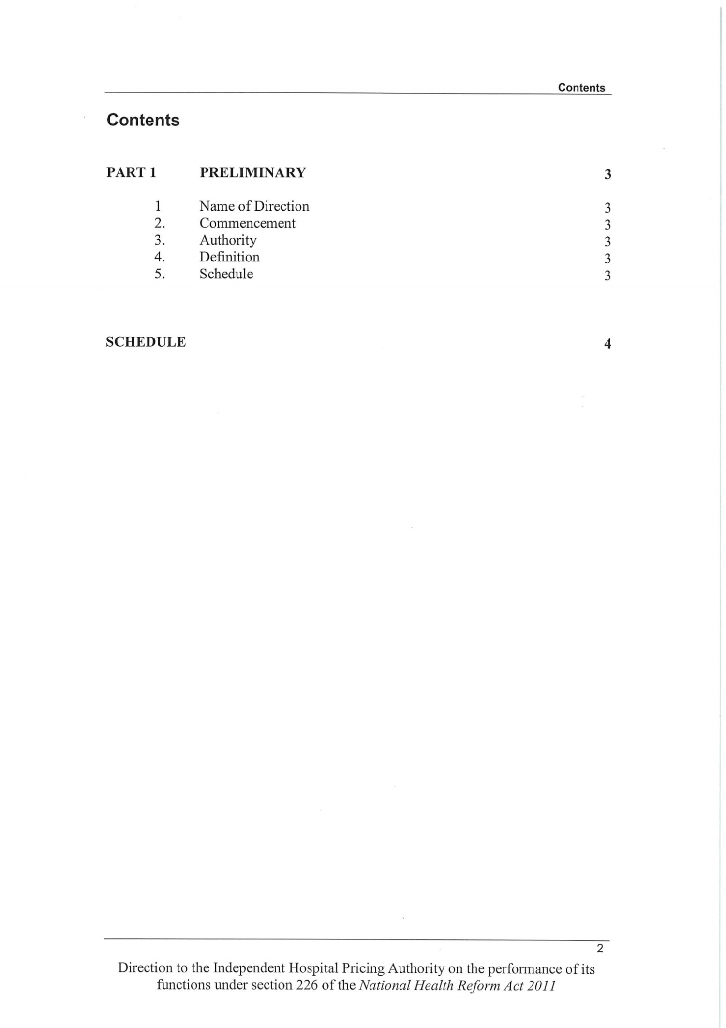

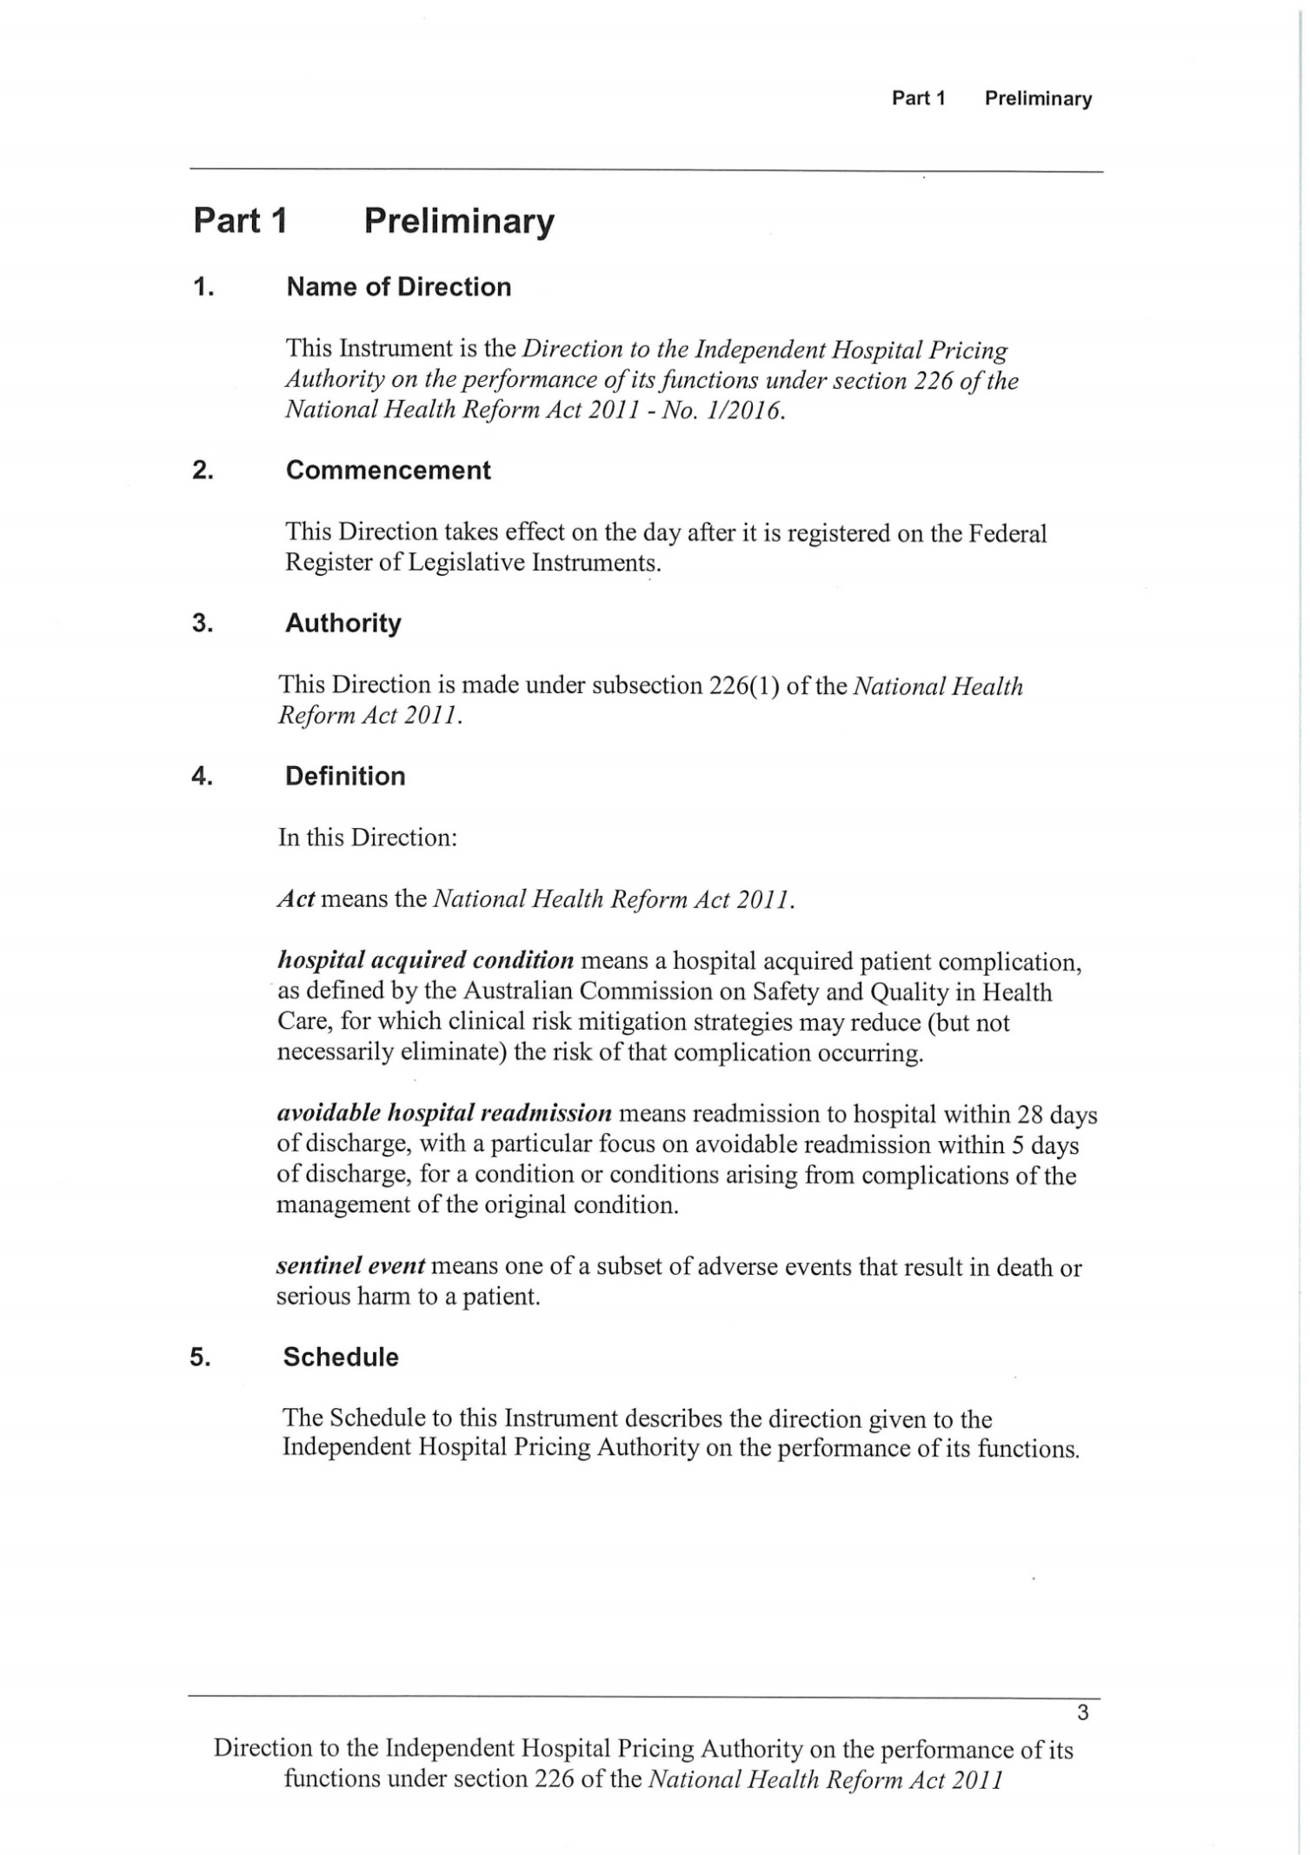

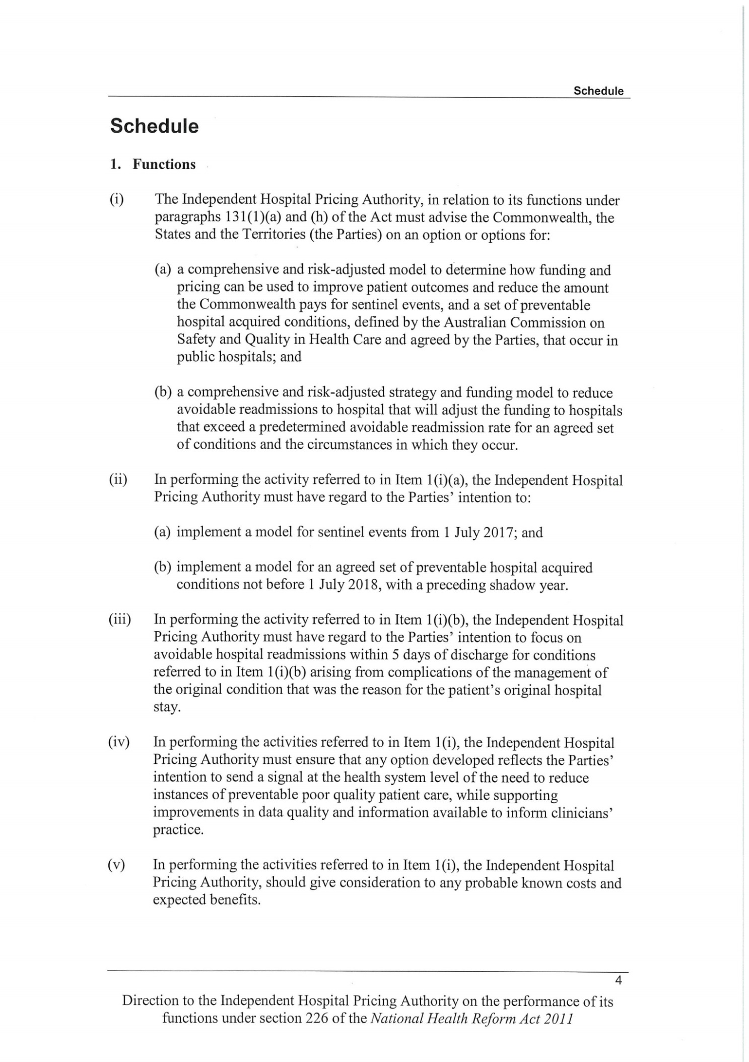

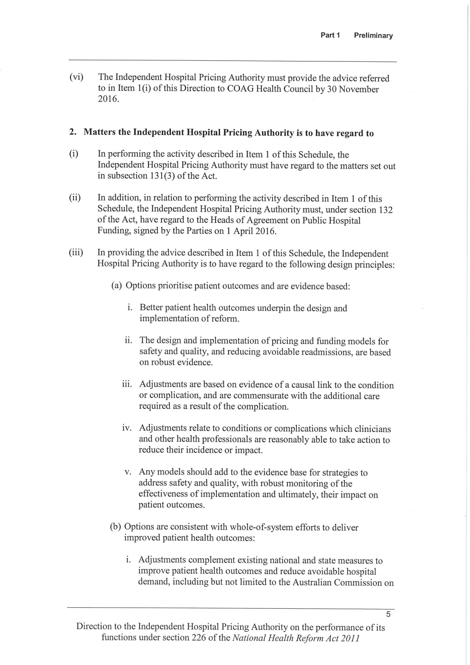

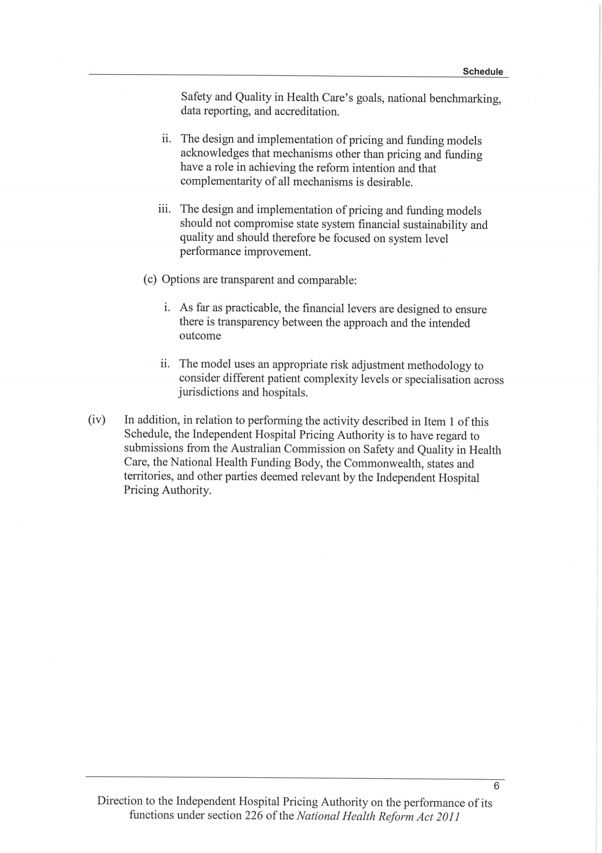

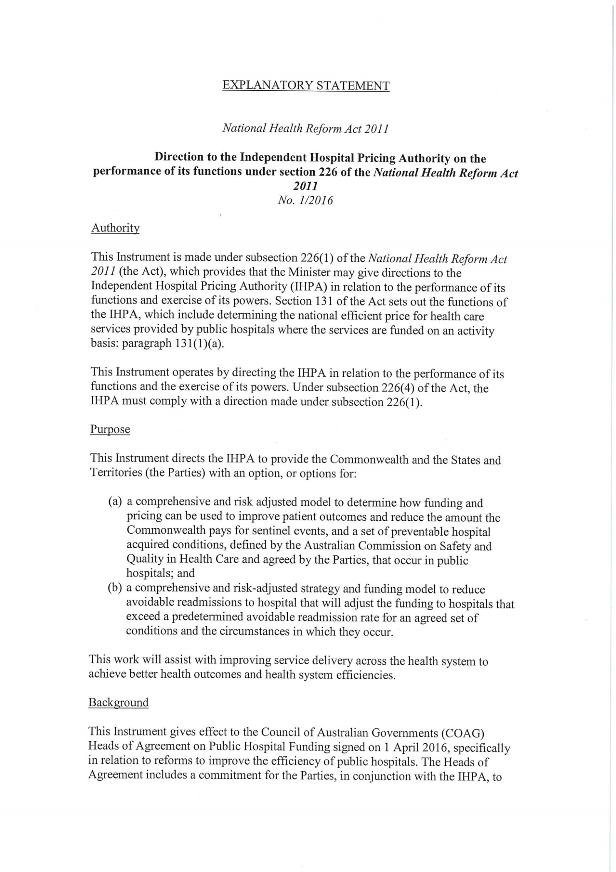

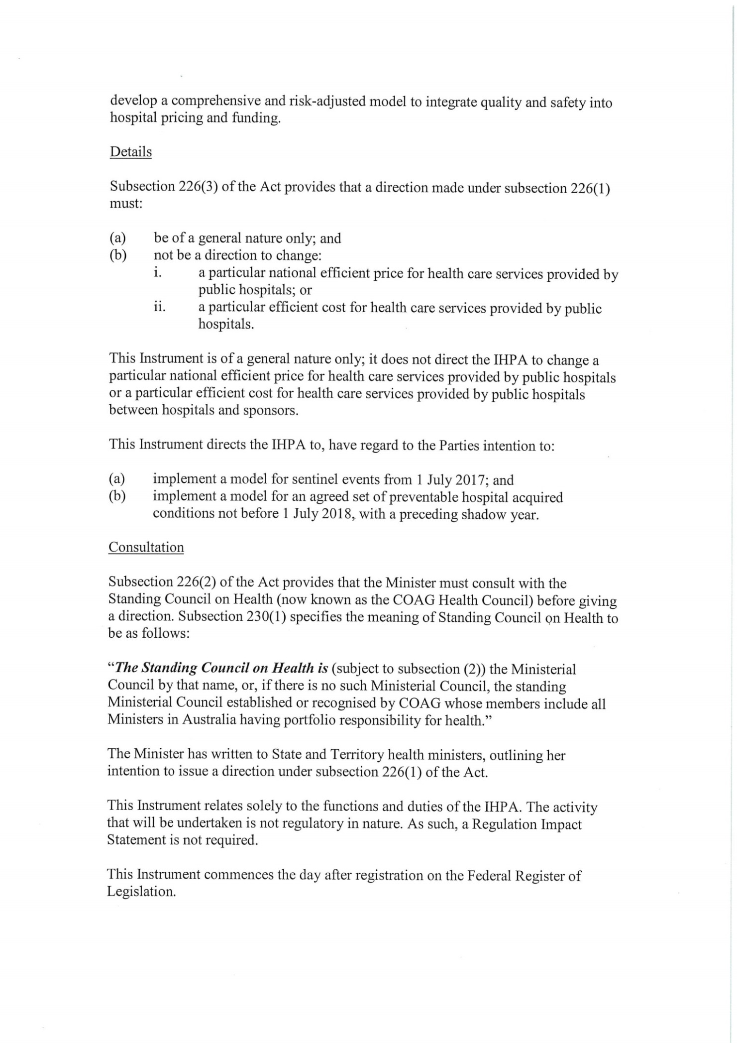



# Appendix 2: Outcomes of the Joint Working Party

The Joint Working Party was established by IHPA and the Commission in 2012. The following is a summary of the outcomes of its four‑year work program.

### Literature review and updates

The initial literature review (early 2013) found limited and equivocal evidence for the impact of pricing models in improving the safety and quality of health care, related to factors including the lack of published research data, limited evaluation and weaknesses in research design. The strongest evidence was that the provision of timely clinical information to clinicians and managers leads to improved patient outcomes.

Ongoing updates and review of the literature in the intervening three years have identified some promising evidence of the potential contribution of pricing and funding models to improving the quality and productivity of care processes and, in some cases, patient outcomes, for example:

* A 2014 Nuffield Trust report on the emerging evidence of a range of payment systems in the English National Health Service identified that factors associated with success in payment systems included: a clear evidence basis, clinical engagement and support, sufficient longevity to encourage investment in change by providers, feasibility in practice and simplicity.[[33]](#endnote-33) For example, clinicians supported best practice tariffs as being more evidence‑based, having fairer payment structures and a clear, top‑down design. The best practice tariff for management of patients with hip fractures has resulted in improvements in both process quality and outcomes.
* A 2015 report from the US Agency for Healthcare Research and Quality identified a 17 per cent reduction, from 2010 to 2014, in the number of hospital acquired conditions in US hospitals participating in the Partnership for Patients initiative.[[34]](#endnote-34) This was estimated to be equivalent to 2.1 million fewer hospital acquired complications experienced by hospital patients, almost 87,000 fewer deaths and about $19.8 billion (US) savings in health costs over the four years. The report identified the likely contribution to this progress of financial incentives by government and other payers of hospital services, as well as the importance of public reporting of hospital‑level data on hospital acquired conditions, the implementation and use of electronic health records in hospitals and investment in research, tools, training and data to support hospital staff in quality improvement.

### Environmental scan of the use of hospital administrative data

A 2013 study reviewed the use of patient clinical data to drive safety and quality improvement. It found that patient clinical data can be used as a screening tool to indicate areas of concern, or in need of attention, with regard to safety improvement. It concluded that the use of patient clinical data provides a useful first step in identifying potential safety issues, but it should not be the only method used.

### Analysis of hospital acquired complications

This 2013 review examined the additional costs and the impact on length of stay associated with hospital acquired complications (HACs) for a subset of high volume and high priority conditions and interventions. Modelling suggested that HACs potentially explained between 12.0 and 16.5 per cent of total costs within the sample hospitals for the high volume and high priority episodes analysed.

In identifying the substantial impact of conditions acquired during hospital admissions, this review set the scene for the development and testing of an agreed Australian list of HACs. It also provides supporting justification for the development of pricing and funding models focussed on HACs.

### Development, field‑testing and refinement of a list of hospital acquired complications

The development of the national list of HACs was, as previously noted, a clinician‑led process. It comprised three main stages that were undertaken from 2013 to 2016.

The first stage (initial development) identified a set of HACs that were selected using the criteria of preventability, patient impact (severity), health service impact and clinical priority. Clinicians reviewed HACs that had been identified through a review of safety literature and incident reporting systems and assessed them against the selection criteria. Analysis of hospital inpatient morbidity data allowed identification of the materiality of each of the HACs.

The second stage (proof of concept field‑testing) took place in selected public and private hospitals. It confirmed that hospital inpatient morbidity data are sufficiently accurate to support implementation of the HACs list. It also identified the value of monitoring and reporting on HACs at the hospital level to improve patient safety, with clinician support linked to confidence in the measures and access to suitable analytical tools.

The third stage (refinement) involved including some additional HACs from specific clinical domains that had not been represented in the initial set and removing others that were not considered suitable.

**Independent Hospital Pricing Authority**

Level 6, 1 Oxford Street

Sydney NSW 2000

Phone: 02 8215 1100

Email: [enquiries.ihpa@ihpa.gov.au](file:///D:\Users\GREETH\AppData\Local\Microsoft\Windows\Temporary%20Internet%20Files\Content.Outlook\1WQEDX0D\enquiries.ihpa@ihpa.gov.au)

Twitter: @IHPAnews

[www.ihpa.gov.au](http://www.ihpa.gov.au)



1. # References

   Ministry of Health 2007, [Section 88: Primary Maternity Services Notice 2007](http://www.health.govt.nz/publication/section-88-primary-maternity-services-notice-2007); Wellington, New Zealand, Ministry of Health. [↑](#endnote-ref-1)
2. Ministry of Health 2016, [MSC Preamble and Payment Schedule: Midwifery Services](http://www2.gov.bc.ca/assets/gov/health/practitioner-pro/midwifery-payment-schedule-preamble.pdf); British Colombia, Canada, Ministry of Health. [↑](#endnote-ref-2)
3. Centers for Medicare & Medicaid Services 2016, [Bundled Payments for Care Improvement (BPCI) Initiative: General Information](https://innovation.cms.gov/initiatives/bundled-payments/); Baltimore, United States of America, Centers for Medicare & Medicaid Services. [↑](#endnote-ref-3)
4. Monitor & National Health Service England 2016, [Annex B2: Technical guidance for currencies with national prices](https://www.gov.uk/government/uploads/system/uploads/attachment_data/file/499472/Annex_B2_Technical_guidance_for_currencies_with_national_prices.pdf), London, England, National Health Service England. [↑](#endnote-ref-4)
5. Bertko J & Effros R 2010, ‘[Analysis of Bundled Payments](http://www.rand.org/pubs/technical_reports/TR562z20/analysis-of-bundled-payment.html)’, *Technical Report*, RAND Corporation. [↑](#endnote-ref-5)
6. Agency for Healthcare Research and Quality, 2012, [Closing the Quality Gap: Revisiting the State of the Science Series: Bundled Payment: Effects on Health Care Spending and Quality](http://www.ncbi.nlm.nih.gov/books/NBK107229/). [↑](#endnote-ref-6)
7. ACSQHC 2010, [Australian Safety and Quality Framework for Health Care](https://www.safetyandquality.gov.au/wp-content/uploads/2012/04/Australian-SandQ-Framework1.pdf)*,* Sydney: ACSQHC. [↑](#endnote-ref-7)
8. AIHW and ACSQHC 2007, *Sentinel events in Australian public hospitals 2004‑05*, Cat. No. HSE 51, Canberra, AIHW. [↑](#endnote-ref-8)
9. ACSQHC (various years), *Windows into safety and quality in health care* (Annual reports, 2008, 2009, 2010, 2011), Sydney: ACSQHC. [↑](#endnote-ref-9)
10. Productivity Commission (various years), *Report on government services*, Melbourne: Productivity Commission. [↑](#endnote-ref-10)
11. AIHW 2015, *Australia’s hospitals 2013‑14: at a glance*, Cat. No. HSE 157, Canberra, AIHW. [↑](#endnote-ref-11)
12. Queensland Health 2013, *Health funding principles and guidelines 2013‑14*, Brisbane: Queensland Health. [↑](#endnote-ref-12)
13. Healthscope 2014, ‘Building upon a shared commitment to quality health care’, *The Pulse*, Winter 2014. [↑](#endnote-ref-13)
14. Agency for Healthcare Research and Quality (Updated July 2016), [Never events (Patient safety primer)](https://psnet.ahrq.gov/primers/primer/3/never%20events) [↑](#endnote-ref-14)
15. NHS England 2015, [Revised never events policy and framework](https://www.england.nhs.uk/wp-content/uploads/2015/04/never-evnts-pol-framwrk-apr.pdf). [↑](#endnote-ref-15)
16. Jackson, T., C Moje, J. Shepheard and A. McMillan 2009, ‘Monitoring sentinel events using routine inpatient data’, *Australian Journal of Health Management* 4 (2): 39‑45. [↑](#endnote-ref-16)
17. ACSQHC (undated), [Hospital acquired complications](http://www.safetyandquality.gov.au/our-work/information-strategy/indicators/hospital-acquired-complications/) [↑](#endnote-ref-17)
18. Jackson, T., H. S. Nghiem, D. Rowell, C. Jorm and J. Wakefield 2011, ‘Marginal costs of hospital‑acquired conditions: information for priority‑setting for patient safety programmes and research’, *Journal of Health Services Research and Policy*, 16(3): 141‑146. [↑](#endnote-ref-18)
19. Health Policy Analysis 2013, *Analysis of hospital‑acquired diagnoses and their effect on case complexity and resource use*, Sydney: ACSQHC. [↑](#endnote-ref-19)
20. Tsai, C., Greaves, F., Zheng, J et al. 2016, ‘Better Patient Care at High Quality Hospitals May Save Medicare Money and Bolster Episode-Based Payment Models,’ *Health Affairs*, 35(9): 1681-1689. [↑](#endnote-ref-20)
21. US Centers for Medicare and Medicaid Services 2016, [Hospital‑acquired conditions](https://www.cms.gov/medicare/medicare-fee-for-service-payment/hospitalacqcond/hospital-acquired_conditions.html) [↑](#endnote-ref-21)
22. US Centers for Medicare and Medicaid Services, [Hospital‑acquired condition reduction program](https://www.cms.gov/Medicare/Medicare-Fee-for-Service-Payment/AcuteInpatientPPS/HAC-Reduction-Program.html) [↑](#endnote-ref-22)
23. RACS and Medibank 2016, *Surgical variance report: General surgery*, Melbourne: RACS. [↑](#endnote-ref-23)
24. McNair, P., T. Jackson and D. Borovnicar 2010, ‘The US Medicare policy of not reimbursing hospital‑acquired conditions: what impact would such a policy have in Victorian hospitals’, *Medical Journal of Australia* 193(1): 22‑25. [↑](#endnote-ref-24)
25. Health Policy Analysis 2013, *Analysis of hospital‑acquired diagnoses and their effect on case complexity and resource use*, Sydney: ACSQHC. [↑](#endnote-ref-25)
26. McNair, P. D., H. S. Luft and A. B. Bindman 2009, ‘Medicare’s policy not to pay for treating hospital‑acquired conditions: the impact’, *Health Affairs* 28(2): 1485‑1493. [↑](#endnote-ref-26)
27. ACSQHC (undated), [Core, hospital‑based outcome indicators](http://www.safetyandquality.gov.au/our%20work/information%20strategy/indicators/core%20hospital%20based%20outcome%20indicators/) [↑](#endnote-ref-27)
28. ACSQHC 2015, *Australian atlas of healthcare variation*, Sydney: ACSQHC. [↑](#endnote-ref-28)
29. NSW Bureau of Health Information 2015, *Return to acute care following hospitalisation: Spotlight on readmissions*, Sydney: NSW Bureau of Health Information. [↑](#endnote-ref-29)
30. McNair P.D., and H.S. Luft 2012, ‘Enhancing Medicare’s hospital‑acquired conditions policy to encompass readmissions’, *Medicare & Medicaid Research Review* 2(2): E1=E14. [↑](#endnote-ref-30)
31. Averill, R.F., E.C. McCullough, J.S. Hughes et al. 2009, ‘Redesigning the Medicare inpatient PPS to reduce payments to hospitals with high readmission rates’, *Health Care Financing Review* 30(4): 1‑15. [↑](#endnote-ref-31)
32. AIHW 2016, *Admitted patient care 2014‑15: Australian hospital statistics*, Cat. No. HSE 172, Canberra: AIHW. [↑](#endnote-ref-32)
33. Marshall, L., A. Charlesworth and J. Hurst 2014, *The NHS payment system: evolving policy and emerging evidence*, London: Nuffield Trust. [↑](#endnote-ref-33)
34. Agency for Healthcare Research and Quality 2016, [Saving lives and saving money: Hospital‑acquired conditions update (Interim data from national efforts to make care safer, 2010‑2014](http://www.ahrq.gov/professionals/quality-patient-safety/pfp/interimhacrate2014.html). [↑](#endnote-ref-34)